**FinRL Ecosystem: Using Reinforcement Learning to Efficiently Automate Trading**

by [AI4Finance Foundation](https://github.com/AI4Finance-Foundation)

An open-source community sharing AI tools for finance.

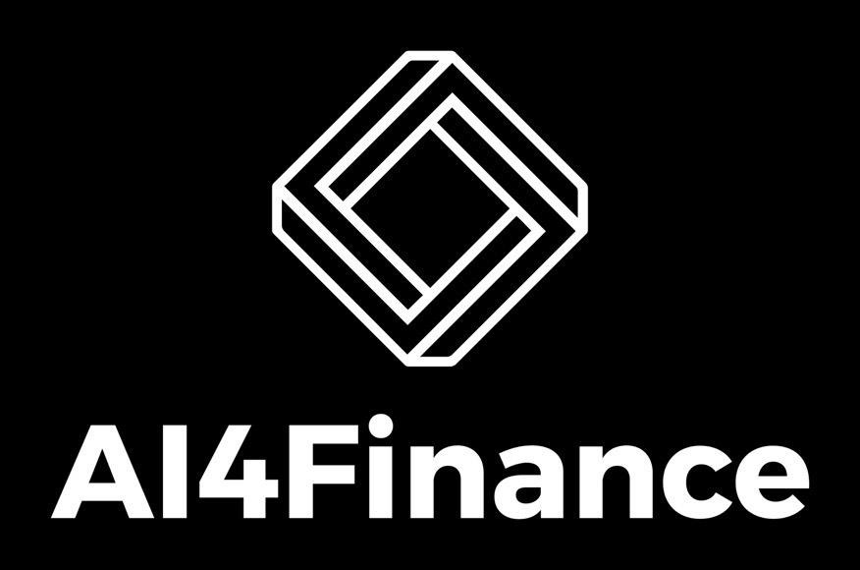

*“Finance serves a purpose. … Investors are lured to gamble their wealth on wide hunches originated by charlatans and encouraged by mass media. One day in the near future, ML will dominate finance, science will curtail guessing, and investing will not mean gambling.”*

*—-By Marcos Lopes De Prado Advanced in Financial Machine Learning*

**Our Mission**: *to efficiently automate trading. We continuously develop and share codes for finance.*

**Our Vision**: *AI community has accumulated an open-source code ocean over the past decade. We believe applying these intellectual and engineering properties to finance will initiate a paradigm shift from the conventional trading routine to an automated machine learning approach, even RLOps in finance.*

***Materials****:*

[*AI4Finance Foundation*](https://github.com/AI4Finance-Foundation)*:*

[*FinRL*](https://github.com/AI4Finance-Foundation/FinRL)*,* [*FinRL-Meta*](https://github.com/AI4Finance-Foundation/FinRL-Meta)*, and* [*Website*](https://finrl.readthedocs.io/en/latest/index.html)

[*ElegantRL*](https://github.com/AI4Finance-Foundation/ElegantRL) *and* [*Website*](https://elegantrl.readthedocs.io/en/latest/index.html)*.*

[*FinRL Ecosystem*](https://github.com/AI4Finance-Foundation/FinRL/blob/master/FinRL_QES_Wolfe%20Research.pdf)*: Deep Reinforcement Learning to Automate Trading in Quantitative Finance. Talk at Wolfe Research 5th Annual Virtual Global Quantitative and Macro Investment Conference, Nov. 08, 2021.*

[Awesome_DRL4Finance_List](https://github.com/AI4Finance-Foundation/FinRL/blob/master/Awesome_DRL4Finance_List.md): *Awesome Deep Reinforcement Learning in Finance*

**Textbooks**:

De Prado, M.L., 2018. *Advances in financial machine learning*. John Wiley & Sons. Assessing this file on Google Doc at:

<https://docs.google.com/document/d/1FxfdiwJ8L8xJeObPMIVFxi9ozykC9HujMuxYVYEmR5g/edit>

**Contributors: (Please add your information)**

**Jiechao Gao Xiao-Yang Liu Bruce Yang**

**Christina Dan Wang Roberto Fray da Silva Astarag Mohapatra Marc Hollyoak Jingyang Rui**

**Ming Zhu Dan Yang Mao Guan**

**Markus Kefeder Ziyi Xia**

**Shixun Wu Momin Haider David Wilt Berend Gort**

**Educational Usage of This Doc:**

1. Research credit course at Columbia University.
2. Capstone projects at NYU.
3. Senior projects at Northwestern University.

**Summary**

Deep reinforcement learning (DRL) has been recognized as an effective approach in quantitative finance, thus getting hands-on experiences is attractive to beginners. However, training a profitable DRL trading agent that ***decides where to trade, at what price*, and *what quantity*** involves error-prone and arduous code development and debugging. This proposal is based on the first open-source DRL framework, *FinRL,* that facilitates beginners to expose themselves to quantitative finance.

This project proposal consists of three parts:

* 1. ***Introduction to FinRL Ecosystem***: We give an introduction to the FinRL library and help students understand the framework.
  2. ***Tutorials and Examples***: We provide tutorials and examples:

***FinRL:* Multiple Stock Trading** is based on our paper: *FinRL: A Deep Reinforcement Learning Library for Automated Stock Trading in Quantitative Finance*, Deep RL Workshop, NeurIPS 2020. For more information, please visit the [website](https://github.com/AI4Finance-Foundation/FinRL)

***Explainable FinRL:* An Empirical Approach** is based on our paper: *Explainable Deep Reinforcement Learning for Portfolio Management: An Empirical Approach*, 2nd ACM International Conference on AI in Finance. For more information, please visit the [website](https://github.com/AI4Finance-Foundation/FinRL) ***ElegantRL***: Our examples contain step-by-step tutorials from problem definition to backtesting. In Google Collab files, each step includes a detailed explanation to help students understand the code. For more information, please visit the [website](https://github.com/AI4Finance-Foundation/ElegantRL)

***FinRL-Meta:*** is a universe of market environments for data-driven financial reinforcement learning. Users can use FinRL-Meta as the metaverse of their financial environments. FinRL- Meta is based on our paper: *FinRL-Meta: A Universe of Near-Real Market Environments for Data-Driven Deep Reinforcement Learning in Quantitative Finance.* Data-Centric AI Workshop, NeurIPS 2021. For more information, please visit the [website](https://github.com/AI4Finance-Foundation/FinRL-Meta)

* 1. ***Senior/capstone Projects***: We would like to propose tens of senior/capstone projects based on our ongoing projects: ***FinRL, ElegantRL*** and ***FinRL-Meta***.
     + [**FinRL**](https://github.com/AI4Finance-Foundation/FinRL)**:** use FinRL to pipeline your own trading strategy.
     + [**ElegantRL**](https://github.com/AI4Finance-Foundation/ElegantRL)**:** develop and optimize deep reinforcement learning algorithms.
     + [**FinRL-Meta**](https://github.com/AI4Finance-Foundation/FinRL-Meta)**:** apply to different markets.

Along with easily-reproducible tutorials, FinRL allows users to streamline their developments and compare with existing schemes. Within FinRL, virtual environments are configured with market data, trading agents are trained with neural networks, and extensive backtesting is analyzed via trading performance. Moreover, it incorporates essential trading constraints such as transaction cost, market liquidity, and investor’s degree of risk-aversion.

FinRL is featured with *completeness*, *hands-on tutorials* and *reproducibility* that favor beginners: (i) at multiple levels of time granularity, FinRL simulated trading environments across various markets, including NASDAQ-100, S&P 500, HSI, SSE 50, and CSI 300; (ii) organized in a layered architecture

with modular structure, FinRL provides fine-tuned state-of-the-art DRL algorithms (DQN, DDPG, PPO, SAC, A2C, TD3, etc.), commonly used reward functions and standard evaluation baselines to alleviate the debugging workloads and promote the reproducibility, and (iii) being highly extendable, FinRL reserves a complete set of user-import interfaces.

### Introduction to FinRL

**FinRL** is the first **open-source** framework to help practitioners establish the development pipeline of trading strategies using **deep reinforcement learning (DRL)**.

Moreover, as a proof-of-concept, FinRL is designed specifically with an effort for **educational and demonstrative purposes**.

###### Target Audience

* + - **Students** who want to get hands-on experience on a real-life end-to-end project that joins the fields of AI and Finance.
    - **Data Scientists** who want to learn best practices of financial big data processing, utilize open- source data engineering tools for financial big data, and catch up with the most recent state-of- the-art DRL algorithms.
    - **Software Developers** who want to step into machine learning and reinforcement learning.
    - **Quantitative Researchers** who want to design and deploy their deep reinforcement learning strategy into paper trading, and learn cloud-native solutions for high performance and high scalability training.

###### Project Overview

**Guideline and how to approach this project**

This project is mainly separated into three parts: FinRL, FinRL-Meta, and ElegantRL. Each part serves a particular purpose in the FinRL ecosystem. A brief overview of each part is given in terms of goals, designing principles and overall framework.

1. ***FinRL***
   * **Goals of FinRL**

The design of a deep reinforcement learning trading strategy includes:

1. preprocessing market data,
2. building a training environment,
3. managing trading states,
4. and backtesting trading performance.

It is a very tedious debugging and error-prone programming process. The end-to-end pipeline is also pretty comprehensive.

**FinRL’s Goal**:

1. FinRL has a **full pipeline** to help quantitative traders overcome the **steep learning curve**.
2. FinRL implements fine-tuned state-of-the-art DRL algorithms and common reward functions, while **alleviating the debugging workloads**.
3. FinRL framework **automatically streamlines** the development of trading strategies, so as to help researchers and quantitative traders to **iterate their strategies at a high turnover rate**.
   * **Designing Principles**
4. **Full-stack framework**. To provide a full-stack DRL framework with finance-oriented optimizations, including **market data APIs, data preprocessing, DRL algorithms, and automated backtesting**. Users can transparently make use of such a development pipeline.
5. **Customization**. To maintain modularity and extensibility in development by including **state-of- the-art DRL algorithms** and supporting design of new algorithms. The DRL algorithms can be used to construct trading strategies by simple configurations.
6. **Reproducibility and hands-on tutoring**. To provide tutorials such as **step-by-step Jupyter notebooks** and user guides to help users walk through the pipeline and reproduce the use cases.
   * **Framework of FinRL**

The FinRL framework has three layers: application layer, agent layer, and environment layer.

1. For the **application layer**, FinRL aims to provide **hundreds of demonstrative trading tasks**, serving as stepping stones for users to develop their strategies.
2. For the **agent layer**, FinRL supports fine-tuned DRL algorithms from **DRL libraries in a plug- and-play** manner, following the unified workflow.
3. For the **environment layer,** FinRL aims to wrap **historical data and live trading APIs** of hundreds of markets into training environments, following the de facto standard Gym.
4. ***FinRL-Meta***
   * **Goals of FinRL-Meta**

To support different trading tasks, we need to train multiple agents using various environments. This requires a diverse RL-based market environment. The current work targets developing trading strategies instead of market simulation.

Yet, no prior work focuses on building the **financial market RL environments** as OpenAI Gym did for Atari games RL environments.

**Fin****RL-Meta’s Goal**:

1. FinRL-Meta separates **financial data processing** from the design pipeline of DRL-based strategy and provides open-source data engineering tools for **financial big data**.
2. FinRL-Meta provides hundreds of **market environment simulations** for various trading tasks.
3. FinRL-Meta enables **multiprocessing simulation** and training by exploiting thousands of GPU cores.
   * **Designing Principles**
4. **DataOps for Data-Driven DRL in Finance**. The DataOps paradigm is adopted to the data engineering pipeline, providing agility to agent deployment.
5. **Layered Structure & Extensibility**. A layered structure specialized for RL in finance. This specialized structure realizes the extensibility of FinRL-Meta.
6. **Plug-and-Play**. Any DRL agent can be directly plugged into the environments, then trained and tested. Different agents can run on the same benchmark environment for fair comparison.
   * **Framework of FinRL-Meta**

FinRL-Meta consists of three layers: data layer, environment layer, and agent layer. Each layer executes its functions and is relatively independent.

1. For the **data layer**, we use a **unified data processor** to access data, clean data, and extract features.
2. For the **environment layer**, we incorporate trading constraints and model market frictions to

**reduce the simulation -to -reality gap**.

1. For the **agent layer**, three DRL libraries (**ElegantRL, RLlib, Stable--Baselines3**) are directly supported, while others can also be plugged in.
2. ***ElegantRL***
   * **Goals of ElegantRL**

ElegantRL is designed for researchers and practitioners with finance-oriented optimizations.

1. ElegantRL implements **state-of-the-art DRL algorithms** from scratch, including both discrete and continuous ones, and provides user-friendly tutorials in Jupyter Notebooks.
2. The ElegantRL performs DRL algorithms under the **Actor-Critic framework**
3. The ElegantRL library enables researchers and practitioners to pipeline the disruptive “design, development and deployment” of DRL technology.
   * **Designing Principles**
4. **Lightweight**: core codes have less than 1,000 lines, less dependable packages, only using PyTorch (train), OpenAI Gym (env), NumPy, Matplotlib (plot),
5. **Efficient**: in many testing cases, we find it more efficient than Ray RLlib. ElegantRL provides a cloud-native solution for RLOps in finance.
6. **Stable**: much more stable than Stable Baselines 3. Stable Baselines 3 can only use a single GPU, but ElegantRL can use 1~8 GPUs for stable training.
   * **Framework of ElegantRL**

ElegantRL implements the following model-free deep reinforcement learning (DRL) algorithms:

* + - DDPG, TD3, SAC, PPO, PPO (GAE),REDQ for continuous actions
    - DQN, DoubleDQN, D3QN, SAC for discrete actions
    - QMIX, VDN; MADDPG, MAPPO, MATD3 for multi-agent environment

For the details of DRL algorithms, please check out the educational webpage [OpenAI Spinning](https://spinningup.openai.com/en/latest/) Up.

###### Requirements

**Python**:

* Confidence with Python programming, and familiar with Jupyter notebook, and Pycharm
* Familiar with Python scripts and executing them from the command line interface
* Familiar with numerical computing libraries: Numpy, and pandas.

**Git and Github**:

* Knowledge of basic Git commands
* Clone,fork, branch creation and checkout
* Git status, git add, git commit, git pull and git push

**Software**:

* Python and Anaconda Installation
* Git installation or Github desktop

**Account**:

* Github account
* Cloud: AWS account or Google Account
* Paper trading account: alpaca, binance

###### Install and Setup

Check this blog: [**FinRL Install and Setup Tutorial for Beginners**](https://ai4finance.medium.com/finrl-for-quantitative-finance-install-and-setup-tutorial-for-beginners-1db80ad39159) for detailed instructions. It includes instructions for:

* Mac OS
* AWS Ubuntu
* Windows 10
* Google Colab

###### Project materials

* The codes:
* Datasets: APIs
* Presentations: PPT
* AI & RL Knowledge
* Finance & Trading Knowledge

###### Additional materials

1. Overview and Tutorials

We demonstrate three existing works as tutorials and examples: **FinRL: Multiple Stock Trading, ElegantRL, and FinRL-Meta.**

**FinRL: Multiple Stock Trading** is based on our paper: [**FinRL: A Deep Reinforcement Learning**](https://arxiv.org/abs/2011.09607) **Library for Automated Stock Trading in Quantitative Finance, Deep RL Workshop, NeurIPS 2020.**

**ElegantRL** is based on our [**blog and Github**](https://github.com/AI4Finance-Foundation/ElegantRL).

**FinRL-Meta** is based on our paper: [**FinRL-Meta: A Universe of Near-Real Market Environments for**](https://arxiv.org/abs/2112.06753) **Data-Driven Deep Reinforcement Learning in Quantitative Finance. Data-Centric AI Workshop, NeurIPS 2021.**

* 1. **FinRL Overview**

Deep reinforcement learning (DRL), which balances exploration (of uncharted territory) and exploitation (of current knowledge), has been recognized as a promising approach for automated trading. DRL algorithms are powerful in solving dynamic decision-making problems by learning through interactions with an unknown environment, thus providing two significant advantages - *portfolio scalability* and *market model independence*. In quantitative finance, trading is essentially making dynamic decisions, namely ***to decide where to trade, at what price, and what quantity***, over a highly stochastic and complex market. As a result, DRL provides a natural toolkit for automated trading. Taking many complex financial factors into account, DRL trading agents build a multi-factor model and provide algorithmic trading strategies, which are difficult for human traders.

However, implementing a DRL-driven trading strategy is nowhere near as easy. The code development and debugging processes are arduous and error-prone. Training environments, managing intermediate trading states, organizing market data, and standardizing outputs for evaluation metrics - these steps are standard in implementation yet time-consuming, especially for beginners. Therefore, we created a beginner-friendly library with fine-tuned standard DRL algorithms.

FinRL has been developed under three primary principles:

* + - **Completeness:** Our library shall cover components of the DRL framework completely, which is a fundamental requirement;
    - **Hands-on tutorials:** We aim for a library that is friendly to beginners. Tutorials with detailed walk-throughs will help users explore the functionalities;
    - **Reproducibility:** Our library shall guarantee reproducibility to ensure transparency and provide users with confidence in what they have done.

We present a three-layered **FinRL** library that streamlines the development of trading strategies. FinRL provides standard building blocks that allow strategy builders to configure market datasets as virtual environments, train deep neural networks as trading agents, analyze trading performance via extensive backtesting, and incorporate essential market frictions.

On the lowest level is an *environment layer*, which simulates the financial market environment using actual historical data from major indices with various environmental attributes such as closing price, shares, trading volume, technical indicators etc.

The *agent layer* in the middle provides fine-tuned standard DRL algorithms such as DQN, DDPG, Adaptive DDPG, Multi-Agent DDPG, PPO, SAC, A2C, and TD3, etc.), commonly used reward functions and standard evaluation baselines to alleviate the debugging workloads and promote the reproducibility. The agent interacts with the environment through properly defined reward functions on the state and action spaces.

The top is an *application layer* that includes various finance applications, here we demonstrate three use cases, namely *multiple stock trading*, *portfolio allocation,* and *cryptocurrency trading*.

1. ***Architecture of FinRL Framework***

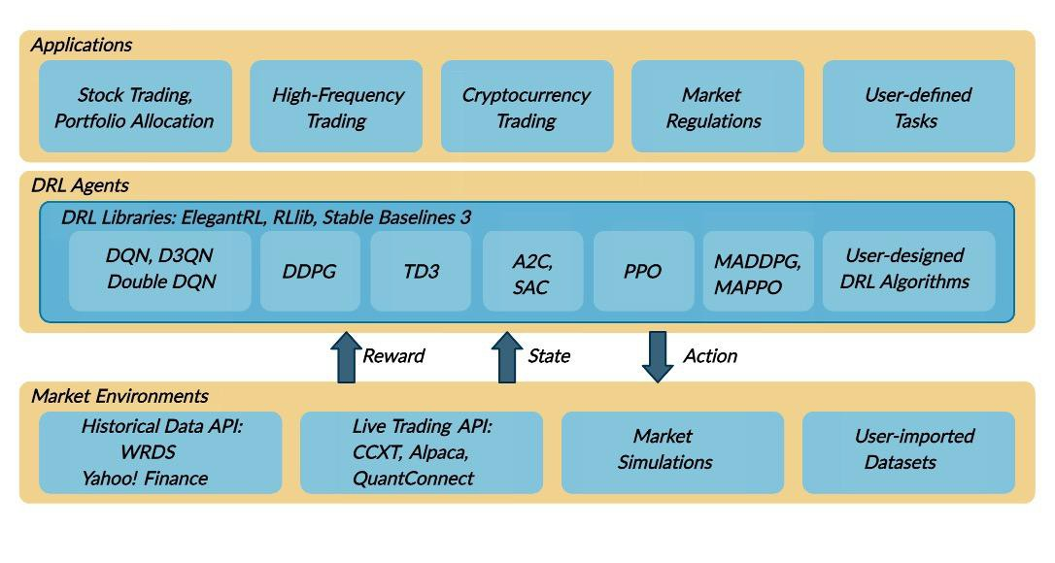

Figure 1: An overview of the FinRL framework. It consists of three layers: application layer, DRL agent layer, and environment layer for various finance markets

An overview of the FinRL library is shown in Fig. 1, and its features are summarized as follows:

* + **Three-layer architecture:** The three layers of the FinRL library are market environments, DRL trading agent, and trading applications. The agent layer interacts with the environment layer in an exploration-exploitation manner, whether to repeat prior working-well decisions or to make new actions hoping to get greater rewards. The lower layer provides APIs for the upper layer, making the lower layer transparent to the upper layer.
  + **Modularity:** Each layer includes several modules, and each module defines a separate function. One can select specific modules from any layer to implement their trading task. Furthermore, updating existing modules is possible.
  + **Simplicity, Applicability and Extendibility:** Specifically designed for automated trading, FinRL presents DRL algorithms as modules. In this way, FinRL is made accessible yet not demanding. FinRL provides three trading tasks as use cases that can be easily reproduced. Each layer includes reserved interfaces that allow users to develop new modules.
  + **Better Market Environment Modeling:** We build a market simulator that replicates the market and provides backtesting support that incorporates market frictions such as transaction cost, market liquidity and the investor’s degree of risk-aversion. All of those are crucial among key determinants of net returns.

#### *Environment: Market Simulator*

Due to the stochastic and interactive nature of the automated trading tasks, a financial task is modeled as a Markov Decision Process (MDP) problem. The training process involves observing price change, taking action, and calculating the reward to have the agent adjust its strategy accordingly. The trading agent will derive a trading strategy with the maximized rewards as time proceeds by interacting with the market environment.

Our trading environments, based on OpenAI Gym, simulate the markets with real market data, using time-driven simulation. FinRL library strives to provide trading environments constructed by datasets across many stock exchanges.

In the **Tutorials and Examples** section, we will illustrate the detailed MDP formulation with the components of the reinforcement learning environment.

**Standard and User-Imported Datasets**

The application of DRL in finance is different from that in other fields, such as playing chess and card games; the latter inherently have clearly defined rules for environments. Various finance markets require different DRL algorithms to get the most appropriate automated trading agent. Realizing that setting up a training environment is time-consuming and laborious work, FinRL provides market environments based on representative listings, including NASDAQ-100, DJIA, S&P 500, SSE 50, CSI 300, and HSI, plus a user-defined environment. Thus, this library frees users from tedious and time-consuming data pre- processing workload.

We know that users may want to train trading agents on their own data sets. FinRL library provides convenient support to user-imported data and allows users to adjust the granularity of time steps. We specify the format of the data. According to our data format instructions, users only need to pre-process their data sets.

#### *DRL Agents: ElegantRL*

One sentence summary of reinforcement learning (RL): in RL, an agent learns by continuously interacting with an unknown environment, in a trial-and-error manner, making sequential decisions under uncertainty and achieving a balance between exploration (new territory) and exploitation (using knowledge learned from experiences).

Deep reinforcement learning (DRL) has great potential to solve real-world problems that are challenging to humans, such as self-driving cars, gaming, natural language processing (NLP), and financial trading. Starting from the success of AlphaGo, various DRL algorithms and applications are emerging in a disruptive manner. The [ElegantRL](https://elegantrl.readthedocs.io/en/latest/index.html) library enables researchers and practitioners to pipeline the disruptive “design, development and deployment” of DRL technology.

The library to be presented is featured with “elegant” in the following aspects:

* Lightweight: core codes have less than 1,000 lines, e.g., [helloworld](https://github.com/AI4Finance-Foundation/ElegantRL).
* Efficient: the performance is comparable with [Ray RLlib](https://github.com/ray-project/ray).
* Stable: more stable than [Stable Baseline 3](https://github.com/DLR-RM/stable-baselines3).

ElegantRL supports state-of-the-art DRL algorithms, including discrete and continuous ones, and provides user-friendly tutorials in Jupyter notebooks. The ElegantRL implements DRL algorithms under the Actor-Critic framework, where an Agent (a.k.a, a DRL algorithm) consists of an Actor network and a Critic network. Due to the completeness and simplicity of code structure, users are able to easily customize their own agents.

Overall, the **Contributions of FinRL** are summarized as follows:

* FinRL is an open source library specifically designed and implemented for quantitative finance. Trading environments incorporating market frictions are used and provided.
* Trading tasks accompanied by hands-on tutorials with built-in DRL agents are available in a beginner-friendly and reproducible fashion using Jupyter notebook. Customization of trading time steps is feasible.
* FinRL has good scalability, with fine-tuned state-of-the-art DRL algorithms. Adjusting the implementations to the rapid changing stock market is well supported.
* Typical use cases are selected and used to establish a benchmark for the quantitative finance community. Standard backtesting and evaluation metrics are also provided for easy and effective performance evaluation.

With FinRL Library, implementation of powerful DRL driven trading strategies is made an accessible, efficient and delightful experience.

###### FinRL Tutorials

***FinRL: Multiple Stock Trading***

To begin with, we would like to explain the logic of stock trading using Deep Reinforcement Learning. We use Dow 30 constituents as an example throughout this tutorial, because they are popular stocks.

A lot of people are terrified by the word “Deep Reinforcement Learning”, actually, you can just think of it as a “Smart AI” or “Smart Stock Trader” or “R2-D2 Trader” if you want, and just use it. Suppose that we have a well trained DRL agent “DRL Trader”, we want to use it to trade multiple stocks in our portfolio.

* Assume we are at time t, at the end of day at time t, we will know the open-high-low-close price of the Dow 30 constituents stocks. We can use this information to calculate technical indicators such as [MACD](https://zulbahrigb.medium.com/macd-indicator-what-is-macd-indicator-how-to-use-it-from-the-graph-372858754569), [RSI](https://medium.com/%40priceinaction/the-rsi-indicator-explained-e92210d9ffdd), [CCI](https://medium.com/datadriveninvestor/commodity-channel-index-cci-2989f46da3e4), [ADX](https://medium.com/mudrex/adx-trading-strategy-22cc1b53f93b). In Reinforcement Learning, we call these data or features as “states”.
* We know that our portfolio value V(t) = balance (t) + dollar amount of the stocks (t).
* We feed the states into our well-trained DRL Trader, the trader will output a list of actions, the action for each stock is a value within [-1, 1], we can treat this value as the trading signal, 1 means a strong buy signal, -1 means a strong sell signal.
* We calculate k = actions * h_max, where h_max is a predefined parameter that is set as the maximum amount of shares to trade. So we will have a list of shares to trade.
* The dollar amount of shares = shares to trade * close price (t).
* Update balance and shares. These dollar amounts of shares are the money we need to trade at time t. The updated balance = balance (t) − amount of money we pay to buy shares + amount of money we receive to sell shares. The updated shares = shares held (t) − shares to sell + shares to buy.
* So we take actions to trade based on the advice of our DRL Trader at the end of day at time t (time t’s close price equals time t+1’s open price). We hope that we will benefit from these actions by the end of day at time t+1.
* Take a step to time t+1, at the end of day, we will know the close price at t+1, the dollar amount of the stocks (t+1)= sum(updated shares * close price (t+1)). The portfolio value V(t+1)=balance (t+1) + dollar amount of the stocks (t+1).
* So the step reward by taking the actions from the DRL Trader at time t to t+1 is r =

v(t+1) − v(t). The reward can be positive or negative in the training stage. But of

course, we need a positive reward in trading to say that our DRL Trader is effective.

* Repeat this process until termination.

Fig. 2 shows the logic chart for multiple stock trading and an example for demonstration purpose:

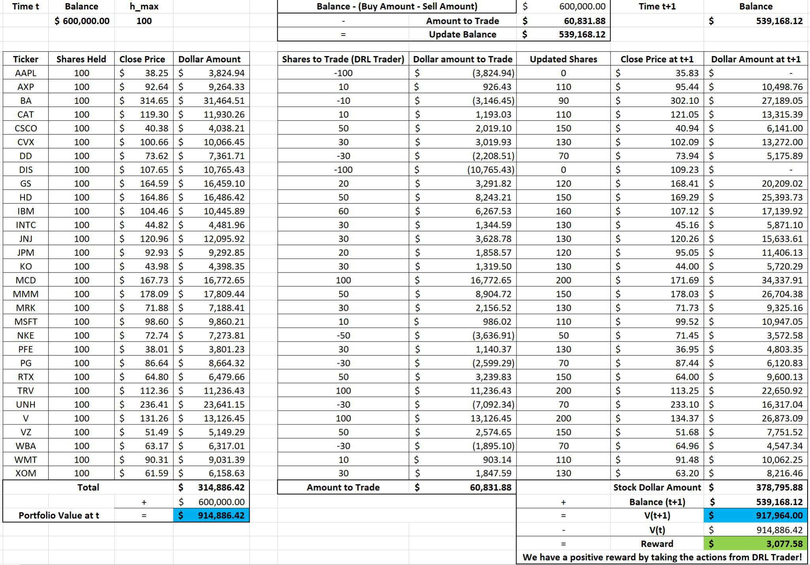

Figure 2: An example of the logic chart for multiple stock trading

**Multiple stock trading**: as the number of stocks increase, the dimension of the data will increase, the state and action space will grow exponentially. So stability and reproducibility are very essential.

This tutorial is focusing on one of the use cases in our paper: **Multiple Stock Trading**. We use one Jupyter notebook to include all the necessary steps. For more details and code about this example, [**please**](https://github.com/AI4Finance-Foundation/FinRL/blob/master/FinRL_StockTrading_NeurIPS_2018.ipynb) **visit here.**

**Part 1. Problem Definition**

This problem is to design an automated solution for stock trading. We model the stock trading process as a Markov Decision Process (MDP). We then formulate our trading goal as a maximization problem.

The algorithm is trained using Deep Reinforcement Learning (DRL) algorithms and the components of the reinforcement learning environment are:

* Action: The action space describes the allowed actions that the agent interacts with the environment. Normally, a ∈ A includes three actions: a ∈ {−1, 0, 1}, where −1, 0, 1 represent selling, holding, and buying one stock. Also, an action can be carried upon multiple shares. We use an action space {−k, ..., −1, 0, 1, ..., k}, where k denotes the number of shares. For example, "Buy 10 shares of AAPL" or "Sell 10 shares of AAPL" are 10 or −10, respectively
* Reward function: r(s, a, s′) is the incentive mechanism for an agent to learn a better action. The change of the portfolio value when action a is taken at state s and arriving at new state s', i.e., r(s, a, s′) = v′ − v, where v′ and v represent the portfolio values at state s′ and s, respectively
* State: The state space describes the observations that the agent receives from the environment. Just as a human trader needs to analyze various information before executing a trade, so our trading agent observes many different features to better learn in an interactive environment.
* Environment: Dow 30 constituents

The data of the stocks for this case study is obtained from Yahoo Finance API. The data contains Open- High-Low-Close price and volume.

**Part 2. Getting Started- Load Python Packages**

Install the unstable development version of FinRL:

# Install the unstable development version in Jupyter notebook:

**!pip install git+https://github.com/AI4Finance-Foundation/FinRL-Library.git**

[Import Packages:](https://gist.github.com/BruceYanghy/e2e7a70d8a6169a11d95777eff36c705)

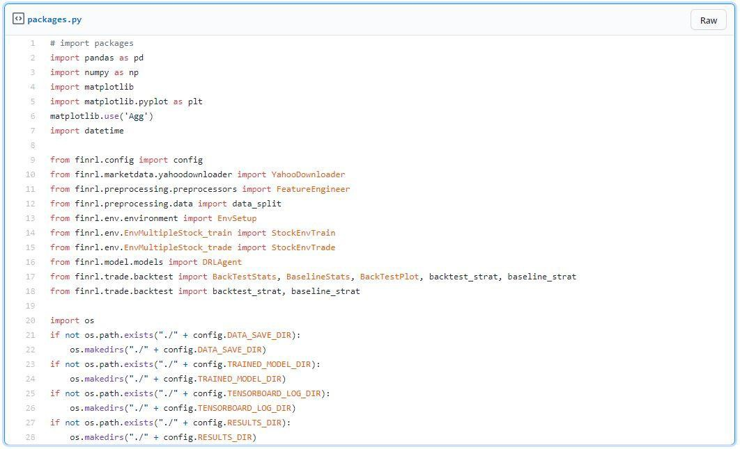

**Part 3. Download Data**

FinRL uses several data processors, e.g., **YahooDownloader** class to extract data.

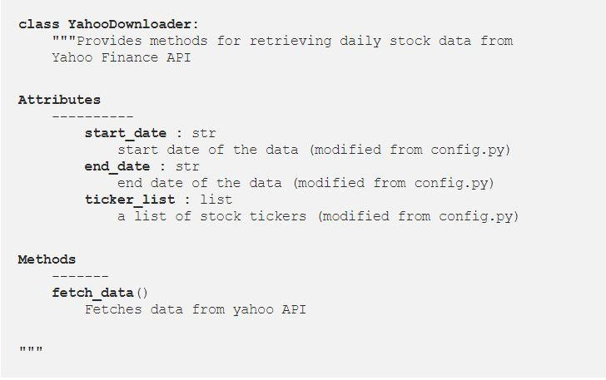

[Download and save the data in a pandas DataFrame:](https://gist.github.com/BruceYanghy/6c37022257cfe765d551c1b173570bd4#file-downloaddata-py)

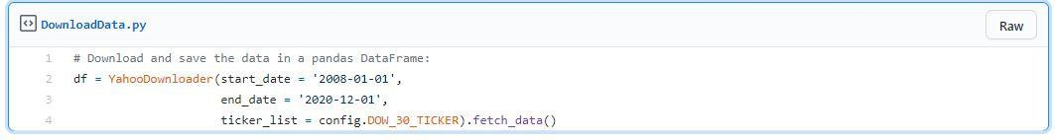

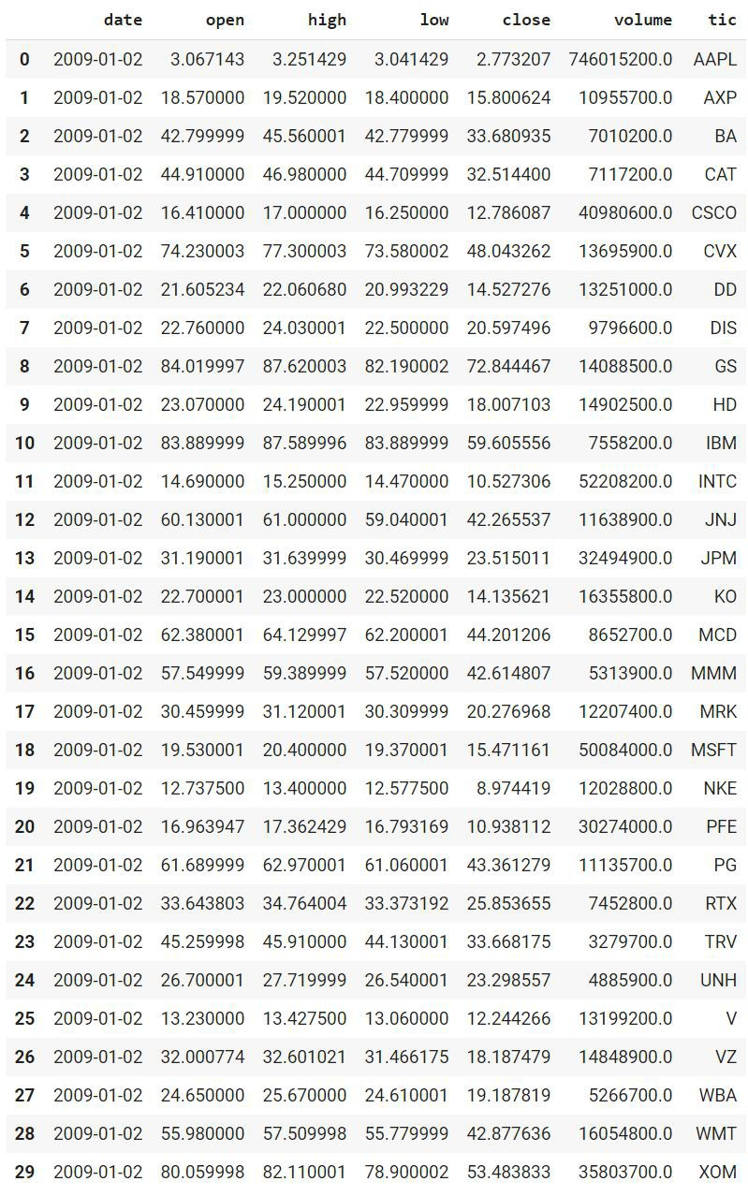

**Part 4. Preprocess Data**

FinRL uses a **FeatureEngineer** class to preprocess data.

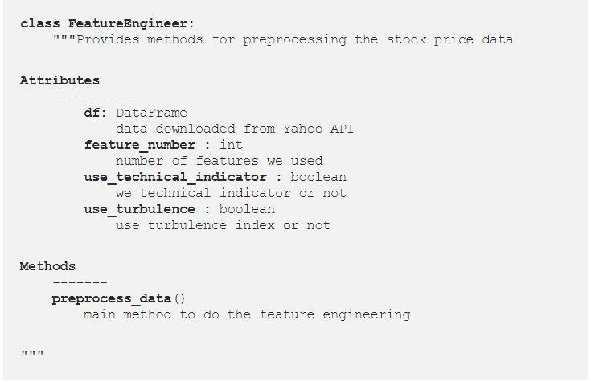

[**Perform Feature Engineering:**](https://gist.github.com/BruceYanghy/793e38394013395b3f9bc70606a16b29#file-featureengineer-py)

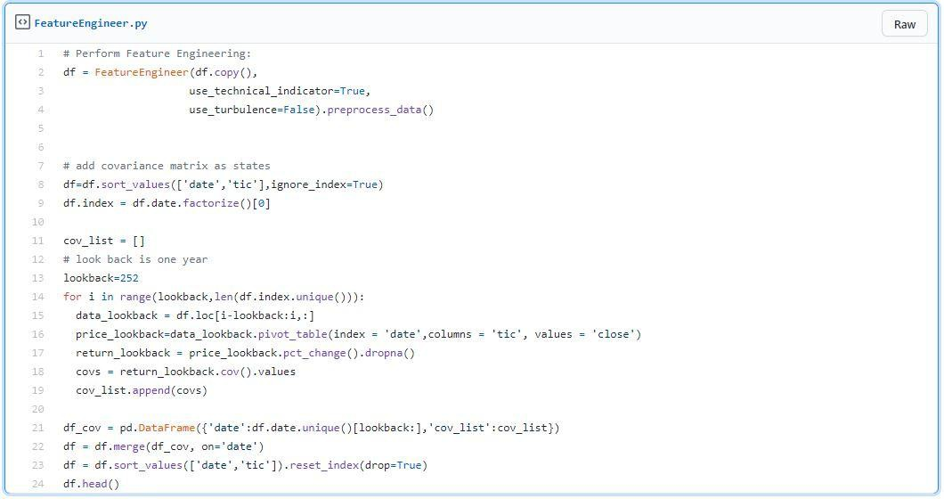

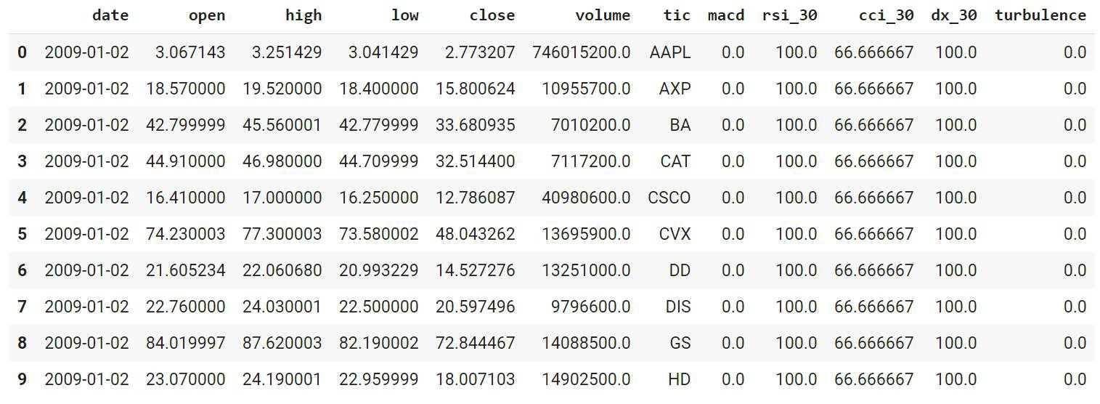

Users can add their technical indicators: 'macd', 'boll_ub', 'boll_lb', 'rsi_30', 'dx_30', 'close_30_sma', 'close_60_sma'

**Train & Trade Data Split**: In real life trading, the model needs to be updated periodically using rolling windows. In this article, we just split the data into train and trade sets.

**Part 5. Build Environment**

FinRL uses a **EnvSetup** class to set up an environment.

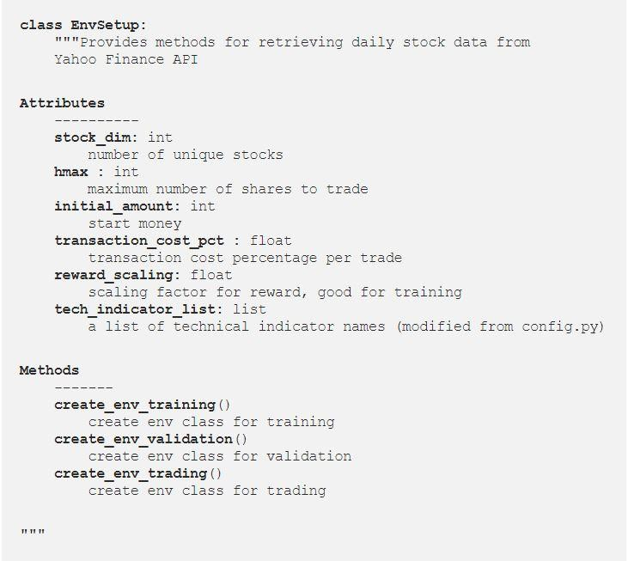

State Space and Action Space Calculation:

[The action space](https://gist.github.com/BruceYanghy/3f86ea14aefb5c77c3872ac501fc1805#file-calculate-_space-py) is just the number of unique stocks **30**. The state space is **181** in this example.



[Initialize an environment class](https://gist.github.com/BruceYanghy/b66545c194237f3c9b5f41bdf03bc5d6#file-initializeenv-py):

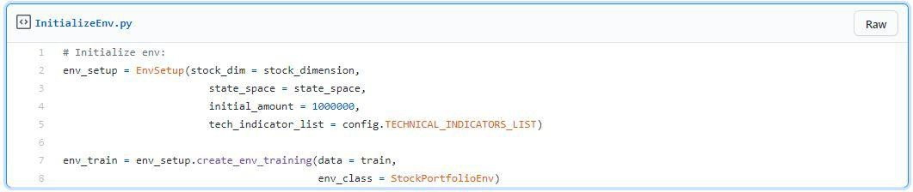

**Use****r-defined Environment**: a simulation environment class.The environment for training and trading is different from that in the multiple stock trading case.

Training v.s. Trading: turbulence index is used as a risk aversion signal after the actions generated by the DRL algorithms. Turbulence index should not be included in training, because it is not a part of model training, so only a trading environment should include the risk aversion signal.

FinRL provides a blueprint for **training and trading** environments in multiple stock trading.

**Part 6. Implement DRL Algorithms**

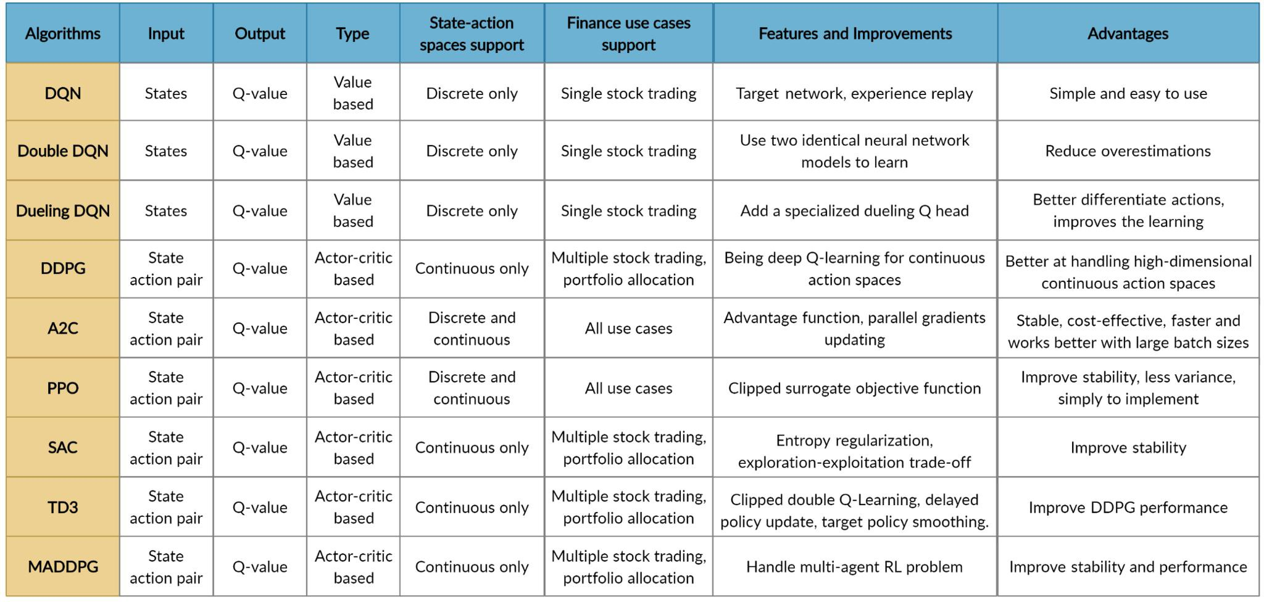

FinRL uses a **DRLAgent** class to implement the algorithms.

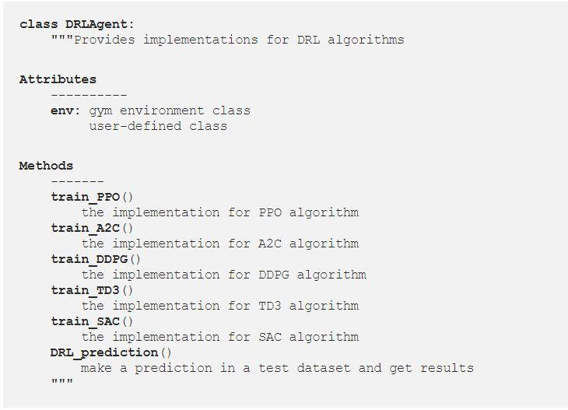

[**Model Training:**](https://gist.github.com/BruceYanghy/9d7522e5593fbb773e169cbb8566461d#file-modeltraining-py)

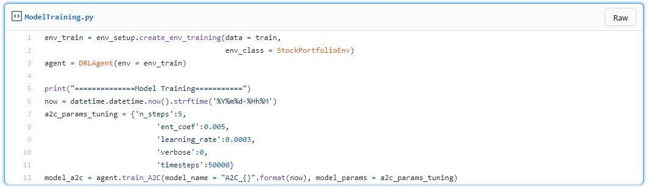

We use Soft Actor-Critic ([SAC](https://arxiv.org/pdf/1801.01290.pdf)) for multiple stock trading, because it is one of the most recent state-of-art algorithms. SAC is characterized by its stability.

[**Tra****ding:**](https://gist.github.com/BruceYanghy/873b3ea0b98bb9b06098c2a5632eafe5#file-tradingenv-py)

Assume that we have $1,000,000 initial capital at 2019/01/01. We use the SAC model to trade the Dow 30 stocks.

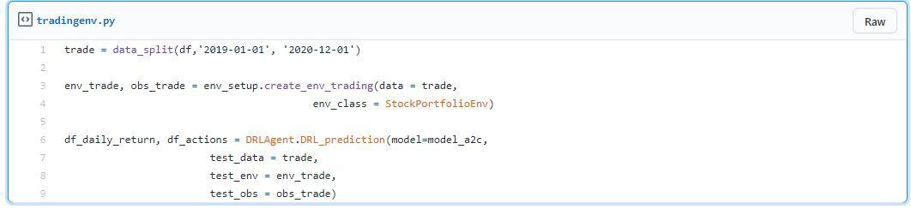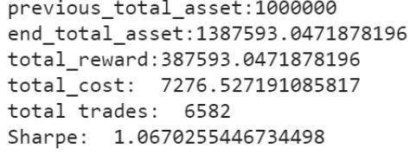

**Part 7. Backtesting Performance**

FinRL uses a set of functions to do the [backtesting](https://gist.github.com/BruceYanghy/3c38bdf8ef8ce6e4ec55decf83d358bb#file-backtest-py) with [Quantopian pyfolio.](https://github.com/quantopian/pyfolio)

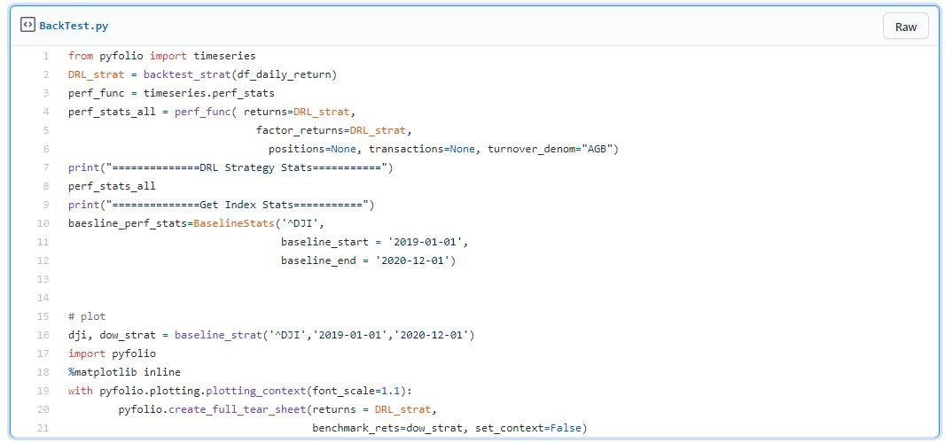

The left table is the stats for **backtesting performance**, the right table is the stats for **Index (DJIA) performanc**e.

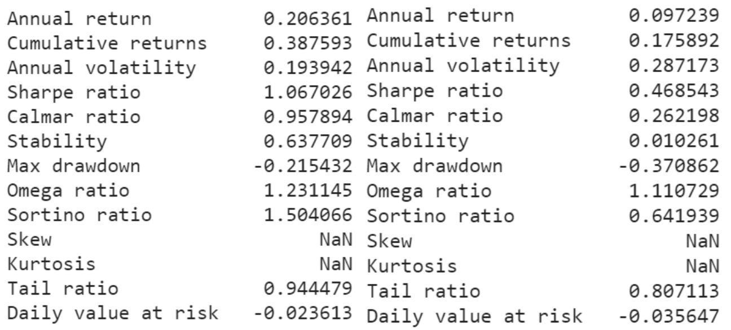

**Plots:**

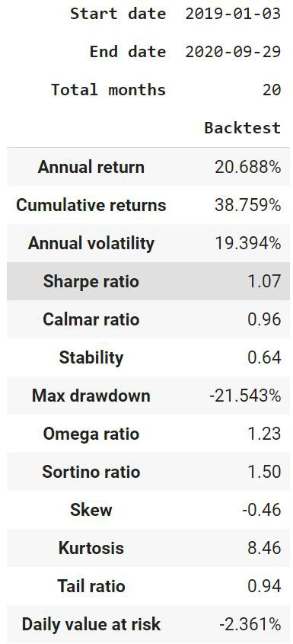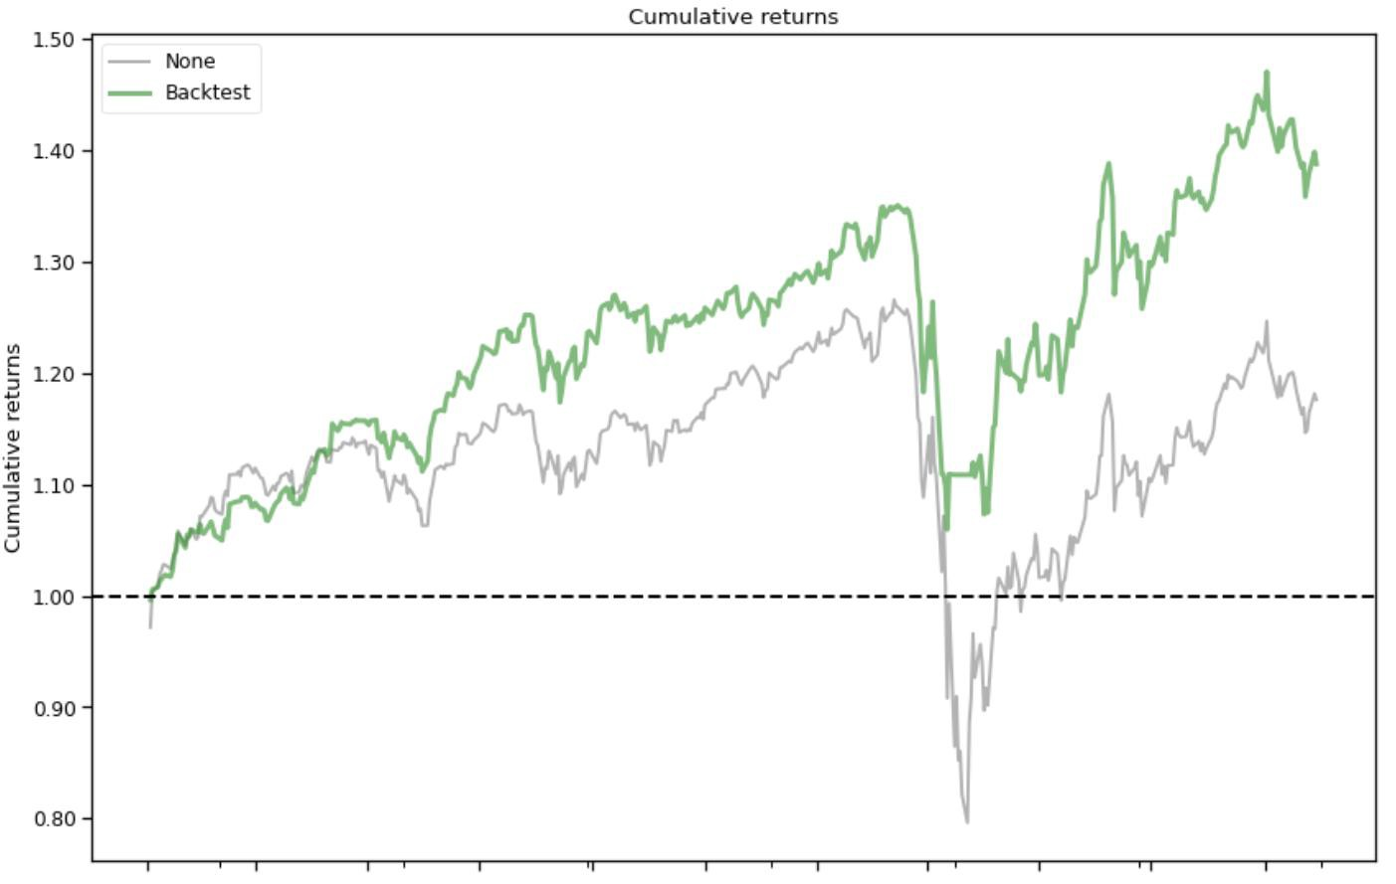

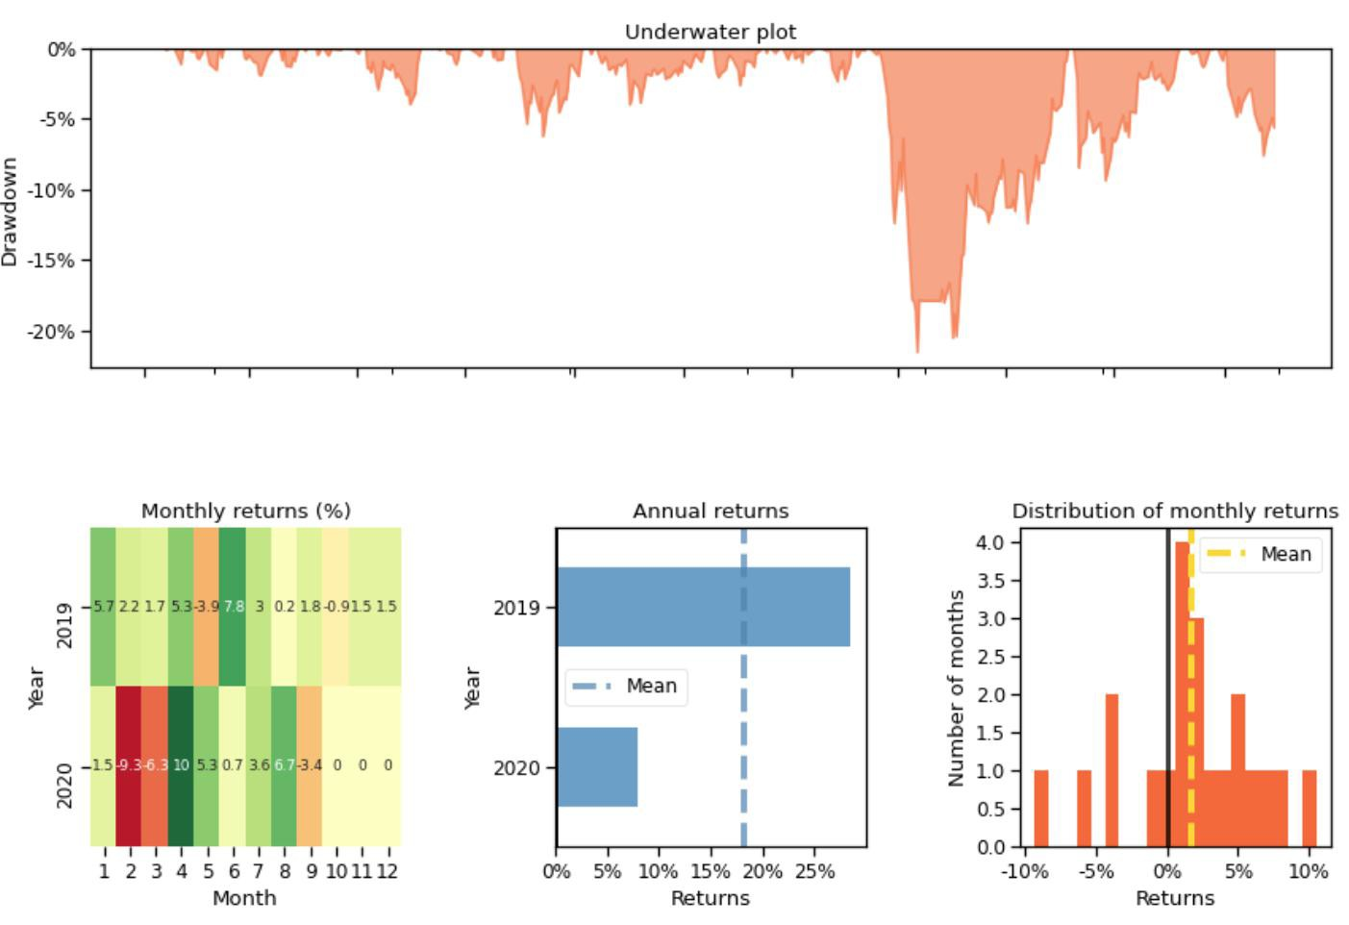

**Conclusion**

For more details about **Multiple Stock Trading,** please visit [**Blog**](https://towardsdatascience.com/finrl-for-quantitative-finance-tutorial-for-multiple-stock-trading-7b00763b7530) and [**Code**](https://github.com/AI4Finance-Foundation/FinRL/blob/master/FinRL_StockTrading_NeurIPS_2018.ipynb).

We also developed examples and tutorials for **Portfolio Allocation.** For more details about **Portfolio Allocation,** please visit [**Blog**](https://towardsdatascience.com/finrl-for-quantitative-finance-tutorial-for-portfolio-allocation-9b417660c7cd) and [**Code**](https://github.com/AI4Finance-Foundation/FinRL/blob/master/FinRL_Explainable_DRL_For_Portfolio_Management_An_Empirical_Approach.ipynb).

#### *Explainable FinRL: An Empirical Approach*

First of all, our work aims to provide an empirical approach to explain the portfolio management task on the basis of FinRL settings.

We propose an empirical approach to explain the strategies of DRL agents for the portfolio management task:

* First, we study the portfolio management strategy using **feature weights**, which quantify the relationship between the reward (say, portfolio return) and the input (say, features). In particular, we use the coefficients of **a linear model in hindsight** as the **reference feature weights**.
* Then, for the deep reinforcement learning strategy, we use **integrated gradients** to define the **feature weights**, which are the coefficients between reward and features under a linear regression model
* Finally, we quantify the **prediction power** by calculating the **linear correlations** between the coefficients of a DRL agent and the reference feature weights, and similarly for conventional machine learning methods. Moreover, we consider both the single-step case and multiple-step case.

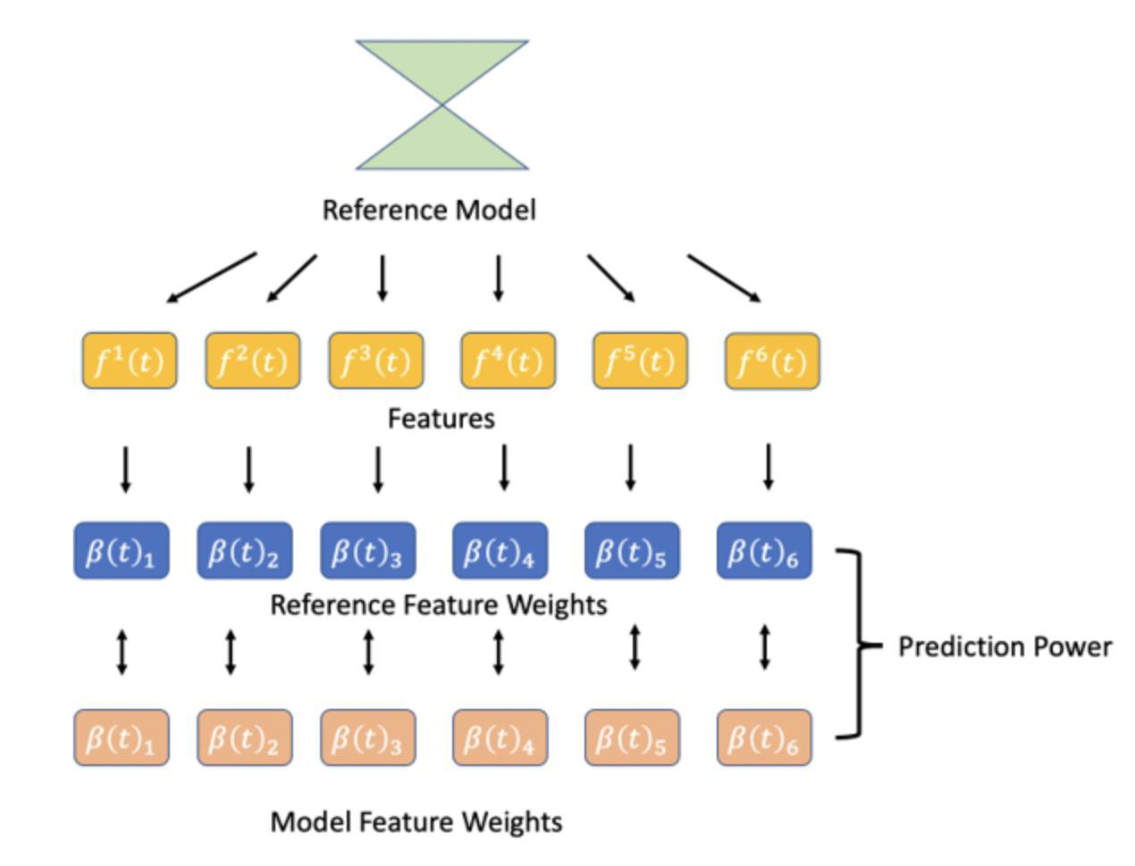

**Part 1. Portfolio Management Task**

Consider a portfolio with y risky assets over d time slots, the portfolio management task aims to maximize profit and minimize risk.

* The price relative vector *y*() ∈ *RN* is defined as the element-wise division of *p*() by p(-1): *y*() ≜

*[* ***p****1(t)*

*, p2(t)* , … , *pN(t)*

*]T*, = 1, ....d , where *p*(0) ∈ *RN* is the vector of opening prices at = 1

*p1(t−1)*

*p2(t−1)*

*pN(t−1)*

and *p*(t) ∈ *RN* denotes the closing prices of all assets at time slot = 1, ...,d .

* Let *w(0)* ∈ *RN* denotes the portfolio weights, which is updated at the beginning of time slot .
* The rate of portfolio return is *w(t)Ty(t)*− 1, and the logarithmic rate of portfolio return is ln(*w(t)Ty(t)*).
* The risk of a portfolio is defined as the variance of the rate of portfolio return: *w(t)T* Σ*(t) w(t)*,

where Σ*(t)* = Cov(*y*()) ∈ *RN* × *N* is the covariance matrix of the stock returns at the end of time slot t.

* Our goal to find a portfolio weight vector *w∗(t)* ∈ *RN* such that

*w∗(t)* ≜argma*xw() w(t)Ty(t)* − (: *w(t)T* Σ*(t) w(t)*, s.t. Σ*Ni=1* ***wi*** () = 1, ***wi*** () ∈ [0, 1], = 1, ..., T, where (: is the risk aversion parameter

**Part 2. The DRL Agent Settings For Portfolio Management Task**

Similar to the tutorial FinRL: Multiple Stock Trading, we model the portfolio management process as a Markov Decision Process (MDP). We then formulate our trading goal as a maximization problem. The algorithm is trained using Deep Reinforcement Learning (DRL) algorithms and the components of the reinforcement learning environment are:

* Action: The action space describes the allowed actions an agent can take at a state. In our task, the action *w(t)* ∈ *RN* corresponds to the portfolio weight vector decided at the beginning of time

slot and should satisfy the constraints: firstly, the each element is between 0 and 1, secondly the summation of all elements is 1.

* Reward function: The reward function (*s(t)*,*w(t), s(t + 1)*) is the incentive for an agent to learn a

profitable policy. We use the logarithmic rate of portfolio return: ln( *w(t)Ty(t)* ).as the reward, where *y(t)* ∈ *RN* is the price relative vector.

* State: describes an agent’s perception of a market. The state at the beginning of time slot is *s(t)* = [*f1*(), ..., *fK*(), ΣA *(t)* ] ∈ *RN*× *(N+K)* , = 1, ...,d .
* DRL Algorithms: We use two popular deep reinforcement learning algorithms: Advantage Actor Critic (A2C) and Proximal Policy Optimization (PPO).
* Environment: Dow Jones 30 constituent stocks during 01/01/2009 to 09/01/2021

**Part 3. The Data Preparation**

The data preparation step includes importing python packages, downloading data and feature engineering. Our work is based on the tutorial FinRL: Multiple Stock Trading, we use the same settings with it.

**Part 4. The Reference Model & Feature Weights**

We use a linear model in hindsight as a reference model. For a linear model in hindsight, a demon would optimize the portfolio with actual stock returns and the actual sample covariance matrix. It is the upper bound performance that any linear predictive model would have been able to achieve.

We use the regression coefficients to define the **reference feature weights** as

β(t) := *[*β*(t)1,* β*(t)2, . . . ,* β*(t)K]*  *RK*, where β*(t)k =* Σ*Ni=1* β*k(t)*  *fk(t)i* , β*k(t)* is the coefficient in the linear model:

*w∗(t)* ⊙ *y(t) =* β*0(t)*   *[1, . . . , 1]T +* β*1(t)*  *f1(t) + . . . +* β*K(t)*  *fK(t) + ϵ(t)*

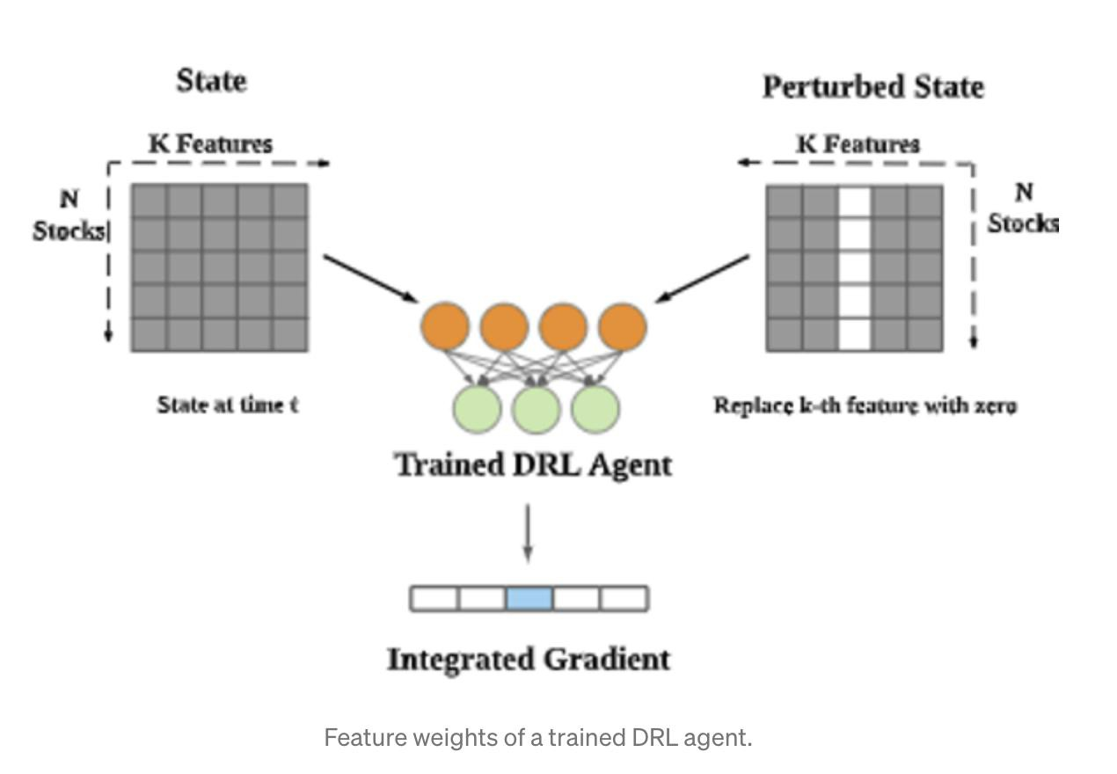

**Part 5. The Feature Weights For DRL Agents**

We use integrated gradients to define the feature weights for DRL agents in portfolio management tasks.

*IG(x)i : = (xi − x'i)* × f

*1*

*z=0*

*∂F(x' + z (x − x'))*

*∂xi*

*dz*,

where *x*  *RN* is the input and *F(*  *)* is the DRL model. Likewise, we use linear regression coefficients to help understand DRL agents:

*wDRL(t)* ⊙ *y(t) = c0(t)*   *[1, . . . , 1]T + c1(t)*  *f1(t) + . . . + cK(t)*  *fK(t) + ϵ(t)*.

Lastly, we define the feature weights of DRL agents in portfolio management task using integrated gradients and the regression coefficients.

*M*π *(t) : = [ M*π *(t)1, . . . , M*π *(t)K ]*,

where *M*π *(t) : =* Σ*N k N k* ∞ *l ∂E[wDRL(t+l)Ty(t+l) | sk,i(t), w(t)]*

*k i=1 IG(f (t))i* ≈ Σ *i=1f (t)i*  Σ *i=1*γ

*∂fk(t)i*

*=* Σ*Ni=1fk(t)i*  Σ∞ *i=1*γ*lE[ck(t + l)*

*∂fk(t+l)i*

*∂fk(t)i*

*| sk,i(t), w(t)]*

**Part 6. The Feature Weights For Machine Learning Methods**

We use conventional machine learning methods as comparison.

* Firstly, it uses the features as input to predict the stock returns vector.
* Secondly, it builds a linear regression model to find the relationship between the portfolio return vector q and features.
* Lastly, it uses the regression coefficients b to define the feature weights as follows.

We define the feature weights for machine learning methods as

b(t) := *[b(t)1, b(t)2, . . . , b(t)K]*  *RK*, where *b(t)k =* Σ*Ni=1 bk(t)*  *fk(t)i* , *bk(t)* is the coefficient in the linear model:

*wML(t)* ⊙ *y(t) = b0(t)*   *[1, . . . , 1]T + b1(t)*  *f1(t) + . . . + bK(t)*  *fK(t) + ϵ(t)*

**Part 7. The Prediction Power**

Both the machine learning methods and DRL agents take profits from their prediction power. We quantify the prediction power by calculating the **linear correlations** between the feature weights of a DRL agent

and the reference feature weights and similarly for machine learning methods. Furthermore, the machine learning methods and DRL agents are different when predicting the future. The machine learning methods rely on single-step prediction to find portfolio weights. However, the DRL agents find portfolio weights with a long-term goal. Then, we compare two cases, **single-step prediction** and **multi-step prediction**.

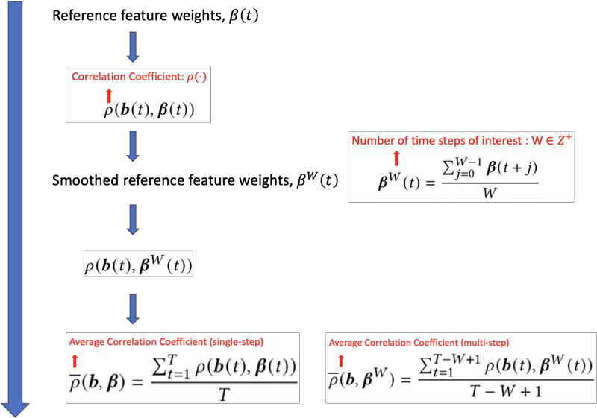

**Part 8. Experiment & Conclusions**

Our experiment environment is as follows:

* Algorithms: PPO, A2C, SVM, Decision Tree, Random Forest, Linear Regression
* Data: Dow Jones 30 constituent stocks, accessed at 7/1/2020. We used the data from 1/1/2009 to 6/30/2020 as a training set and the data from 7/1/2020 to 9/1/2021 as a trading set.
* We used four technical indicators as features: MACD, CCI, RSI, ADX
* Benchmark: Dow Jones Industrial Average (DJIA) The experiment result shows below:

We firstly compare the portfolio performance among the algorithms

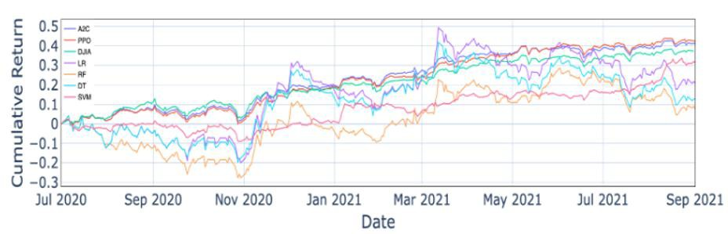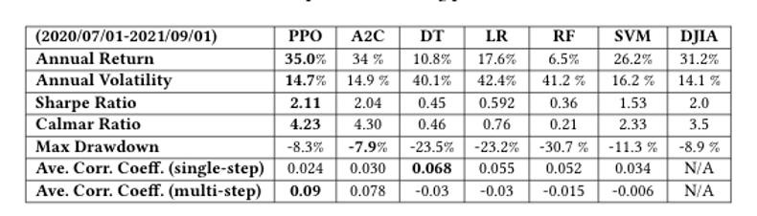

We find that the DRL methods performed best among all and we seek to explain this empirically using our proposed method. So we measured the prediction power and showed their histogram as below.

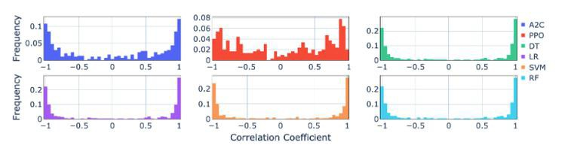

Single-Step Prediction

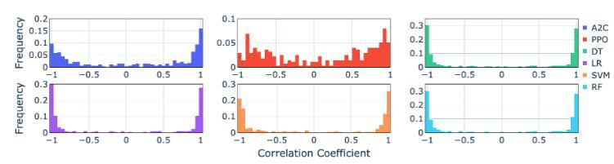

Multi-Step Prediction

To understand the pattern in the histogram, we use the statistical test to measure it.

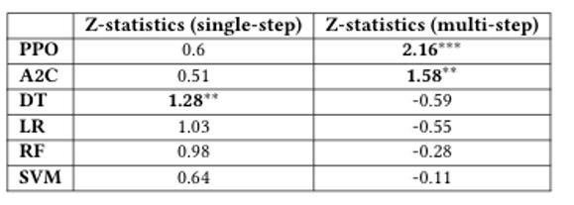

We found that the DRL agents showed the most significant prediction multi-step power. We proposed to use it to empirically explain the difference in portfolio performance by comparing it with Sharpe ratio.

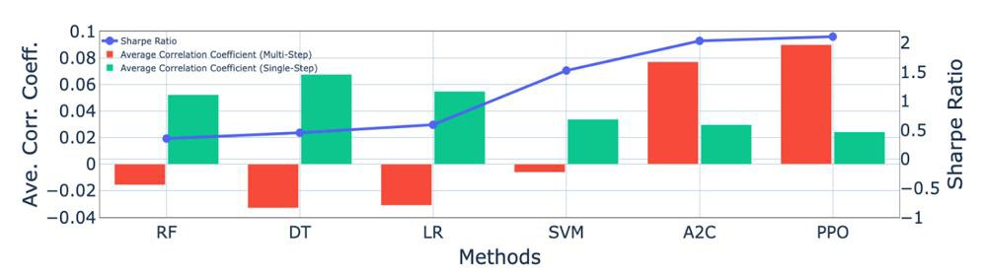

We find that:

* + The DRL agent using PPO has the highest Sharpe ratio:2.11 and highest average correlation coefficient (multi-step): 0.09 among all the others.
  + The DRL agents’ average correlation coefficients (multi-step) are significantly higher than their average correlation coefficients (single-step).
  + The machine learning methods’ average correlation coefficients (single-step) are significantly higher than their average correlation coefficients (multi-step).
  + The DRL agents outperform the machine learning methods in multi-step prediction power and fall behind in single-step prediction power.

Overall, a higher mean correlation coefficient (multi-step) empirically indicates a higher Sharpe ratio. For more details**,** please visit [**Blog**](https://medium.com/mlearning-ai/an-empirical-approach-to-explain-deep-reinforcement-learning-in-portfolio-management-task-e65a42225d9d) and [**Code**](https://github.com/AI4Finance-Foundation/FinRL/blob/master/FinRL_Explainable_DRL_For_Portfolio_Management_An_Empirical_Approach.ipynb).

* 1. **FinRL-Meta Overview**

**FinRL-Meta** is a universe of market environments for data-driven financial reinforcement learning. Users can use FinRL-Meta as the metaverse of their financial environments.

1. FinRL-Meta separates financial data processing from the design pipeline of DRL-based strategy and provides open-source data engineering tools for financial big data.
2. FinRL-Meta provides hundreds of market environments for various trading tasks.
3. FinRL-Meta enables multiprocessing simulation and training by exploiting thousands of GPU cores.

Also called **Neo_FinRL**: **N**ear real-market **E**nvironments f**o**r data-driven **F**inancial **R**einforcement **L**earning.

This part is based on our paper: **FinRL-Meta: Data-Driven Deep Reinforcement Learning in Quantitative Finance**, presented at [NeurIPS Workshop on Data-Centric AI](https://datacentricai.org/). Our codes are available on [**Github**](https://github.com/AI4Finance-Foundation/FinRL-Meta) and our paper is available on [**arXiv**](https://arxiv.org/abs/2112.06753)**.**

**Part 1. Overview**

In quantitative finance, market simulators play important roles in studying the complex market phe-nomena and investigating financial regulations. Compared to traditional simulation models, deep reinforcement learning (DRL) has shown huge potential in building financial market simula-tors through multi--agent systems. However, due to the highly complex and dynamic nature of real-world markets, **raw historical financial data** often involve **large noise** and may not **reflect the future of markets**, degrading the fidelity of DRL-based market simulators.

To support different trading tasks, we need to train multiple agents using various environments. This requires a **diverse RL-based market environment**. The current work targets at **developing trading strategies** instead of **market simulation.** Yet, no prior work focuses on building the financial market RL environments like [OpenAI Gym](https://gym.openai.com/) did for Atari games RL environments.

We present a **FinRL-Meta framework** that builds a universe of market environments for data-driven financial reinforcement learning.

1. FinRL-Meta separates **financial data processing** from the design pipeline of DRL-based strategy

and provides **open-source data engineering tools** for financial big data.

1. FinRL-Meta provides **hundreds of market environments for various trading tasks.**
2. FinRL-Meta enables **multiprocessing simulation** and training by exploiting thousands of **GPU cores**.

**Part 2. Proposed FinRL--Meta Framework**

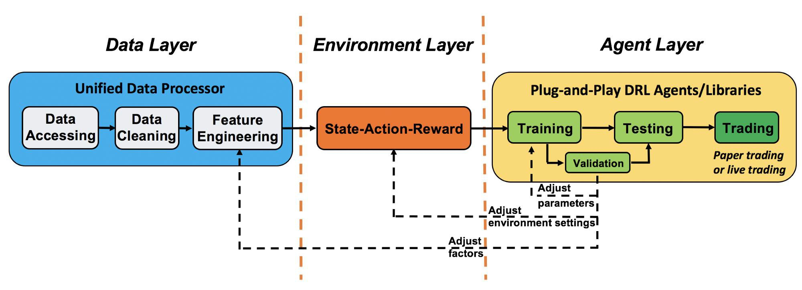

Overview of FinRL-Meta

We utilize a layered structure for DRL in finance. FinRL-Meta consists of three layers: **data layer, environment layer, and agent layer**. Each layer executes its functions and is relatively **independent**. Meanwhile, layers interact through end-to-end interfaces to implement the complete workflow of algorithm trading.

This specialized structure realizes the **extensibility** of FinRL-Meta. For updates and substitutes inside the layer, this structure minimizes the impact on the whole system. Moreover, **user-defined functions are easy to extend**, and algorithms can be updated fast to keep **high performance**.

**Part 3. DataOps for Data-Driven DRL in Finance**

[**DataOps**](https://link.springer.com/book/10.1007/978-1-4842-5104-1) is a series of principles and practices to improve the quality and reduce the cycle time of data science. It inherits the ideas of [**Agile development**](https://en.wikipedia.org/wiki/Agile_software_development)**,** [**DevOps**](https://en.wikipedia.org/wiki/DevOps)**,** and lean manufacturing and applies them to the data science and machine learning field. Many implementations of DataOps have been developed in companies and organizations to improve the **quality and efficiency** of data science, analytics and machine learning tasks.

However, the methodology of **DataOps has not been applied to DRL research in quantitative finance**. Most researchers in financial DRL access data, clean data, and extract factors in a **case-by-case manne**r, which involves **heavy manual work and may not guarantee the data quality.**

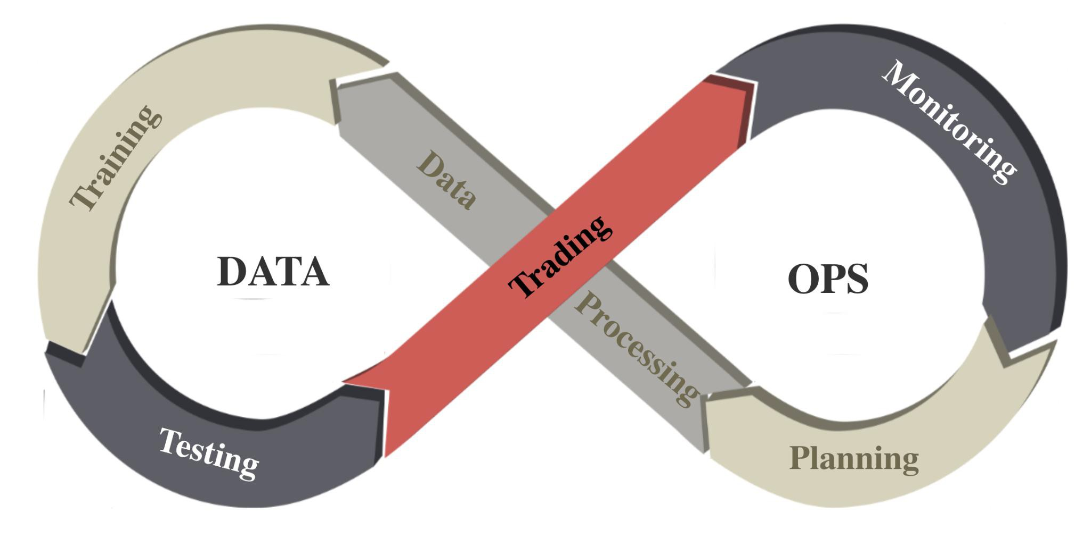

DataOps in FinRL-Meta We follow the [**DataOps paradigm**](https://www.oracle.com/a/ocom/docs/oracle-ds-data-ops-map-r.pdf) in the data layer.

1. We establish a standard pipeline for financial data engineering in RL, ensuring data of **different**

**formats** from different sources can be incorporated in **a unified framework**.

1. We automate this pipeline with a **data processor**, which can access data, clean data, and extract features from various data sources with high quality and efficiency. Our data layer provides agility to model deployment.
2. We employ a **training-testing-trading pipeline**. The DRL agent first learns from the training

environment and is then validated in the validation environment for further adjustment. Then the validated agent is tested in historical datasets. Finally, the tested agent will be deployed in paper trading or live trading markets. First, this pipeline solves the **information leakage problem** because the trading data are never leaked when adjusting agents. Second, a unified pipeline **allows fair comparisons** among different algorithms and strategies.

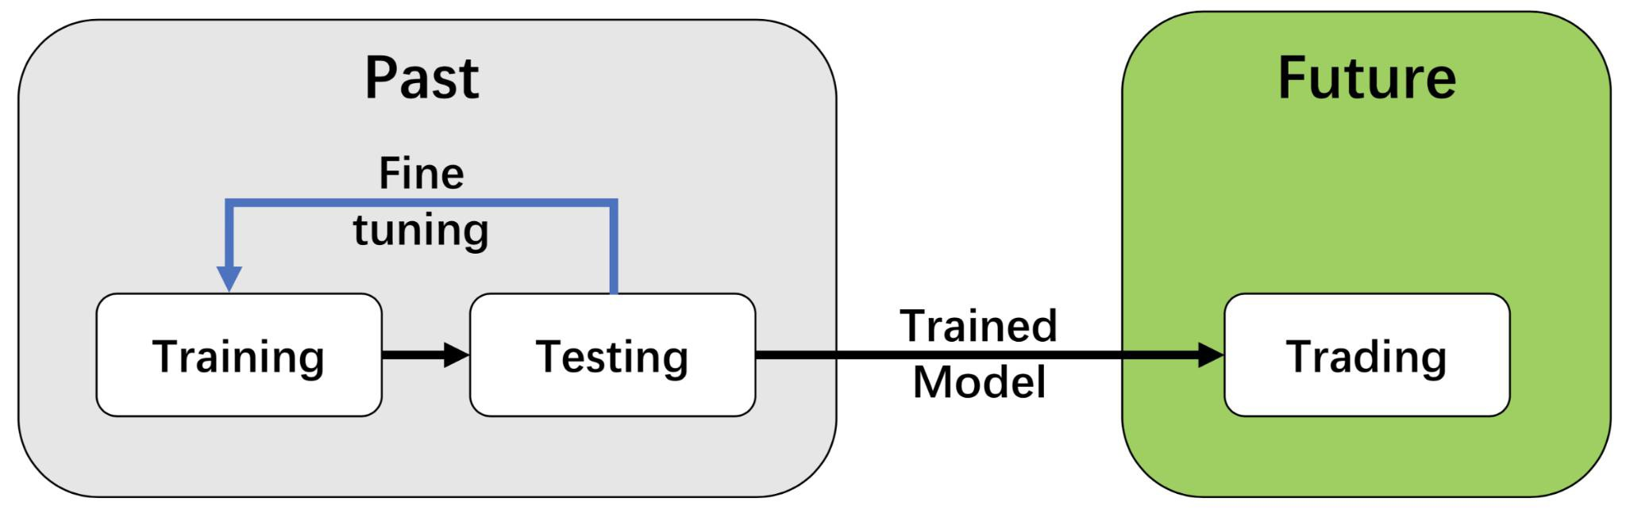

The training-testing-trading pipeline.

**Part 4.** [**Data-Centric AI**](https://datacentricai.org/) **and Unified Data Processor**

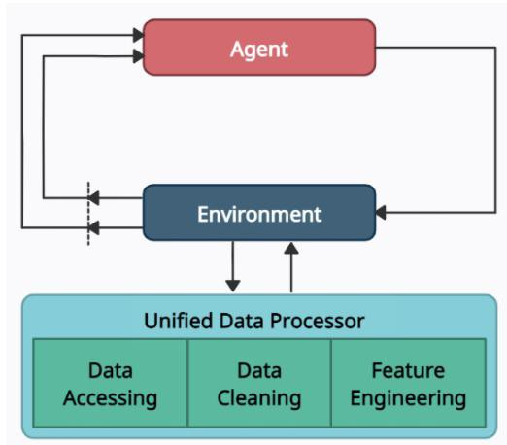

Overview of automated trading using deep reinforcement learning with DataOps paradigm

In the data layer, we use a unified data processor to access data, clean data, and extract features. The supported platforms and their attributes are shown in the following Table (actively updating):

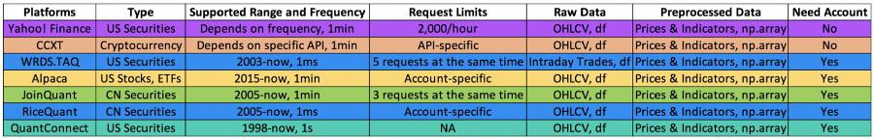

**Step 1: Data Accessing**

We connect data APIs of different platforms and unify them in the [**FinRL--Meta** data processor](https://gist.github.com/BruceYanghy/6ae884a781d3fd0c847784d08cb00b84). Users can access data from various sources given the start date, end date, stock list, time frequency, and so on.

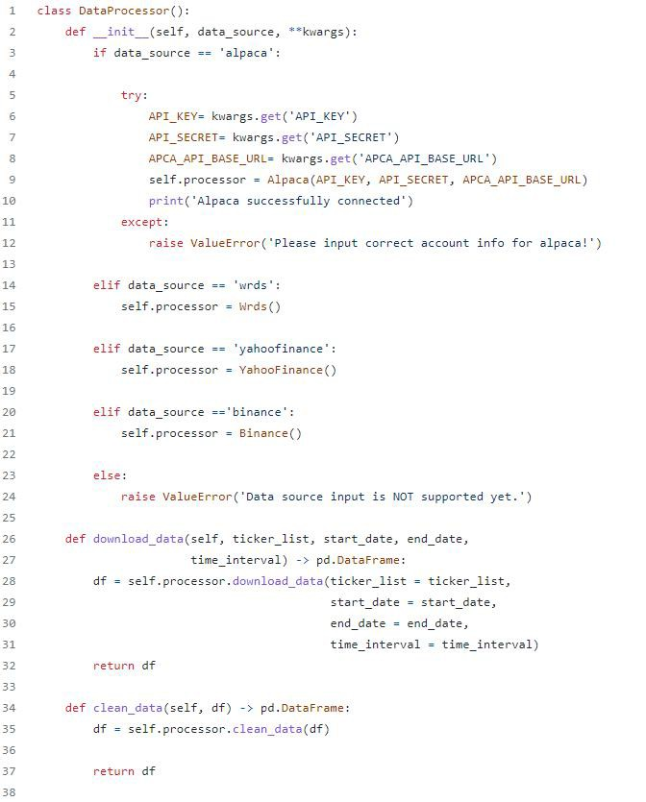

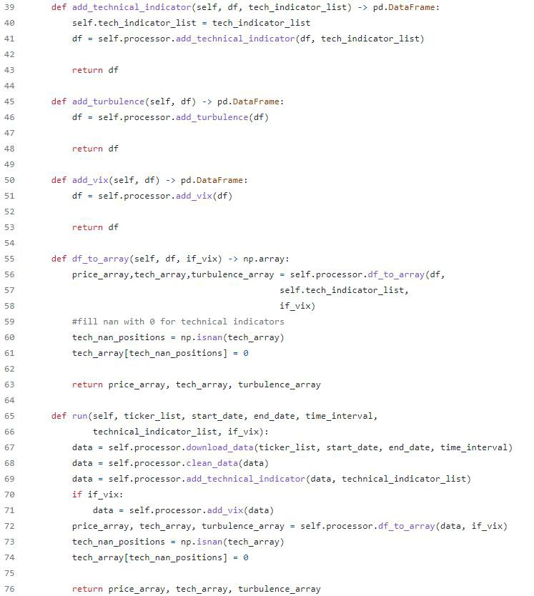

**Step 2: Data Cleaning**

Raw data retrieved from different data sources are usually of **various formats** and have **erroneous or NaN data (missing data)** to different extents, making data cleaning highly time-consuming. In the FinRL--Meta data processor, we automate the data cleaning process.

**The cleaning processes of NaN data** are usually different for various time frequencies. For **Low- frequency data**, except for a few stocks with extremely low liquidity, the few NaN values usually mean **suspension during that time interval**. While for **high-frequency data,** NaN values are **pervasive**, which usually **means no transaction during that time interval**. To reduce the simulation-to-reality gap considering data efficiency, we provide different solutions for these two cases.

In the low-frequency case, we directly **delete the rows with NaN values**, reflecting suspension in simulated trading environments. However, it is not suitable to directly delete rows with NaN values in high-frequency cases.

In our test of downloading **1-min OHLCV (open, high, low, and close prices; volume) data of DJIA 30 companies from Alpaca during 2021–01–01~2021–05–31**, there were **39736** rows for the raw data. However, after dropping rows with NaN values, only 3361 rows were left.

The low data efficiency of the dropping method is unacceptable. Instead, we take an improved **forward filling method**. We fill the open, high, low, close columns **with the last valid value of close price** and the volume column **with 0**, which is a standard method in practice.

Although this filling method sacrifices the authenticity of the simulated environments, it is acceptable compared to significantly improved data efficiency, especially under tickers with high liquidity. Moreover, this filling method can be further improved using **bid, ask prices** to reduce the simulation-to-reality gap.

**Step 3: Feature Engineering**

Feature Engineering is the last part of the data layer. In this part, we automate the calculation of technical indicators by connecting the [**Stockstats**](https://github.com/jealous/stockstats) or [**TA-Lib**](https://github.com/mrjbq7/ta-lib) library with our data processor. Users can quickly add indicators from the Stockstats library, or add user-defined features.

Common technical indicators including **Moving Average Convergence Divergence (MACD), Relative Strength Index (RSI), Average Directional Index (ADX), and Commodity Channel Index (CCI)**, and so on, are all supported. Users can also quickly add indicators from other libraries, or add other user- defined features directly.

###### FinRL-Meta Tutorials

***Stock Trading Task***

We select the 30 constituent stocks in Dow Jones Industrial Average (DJIA), accessed at the beginning of our testing period. We use the [Proximal Policy Optimization (PPO)](https://arxiv.org/abs/1707.06347) algorithm of [ElegantRL](https://github.com/AI4Finance-Foundation/ElegantRL), [Stable-](https://github.com/DLR-RM/stable-baselines3) baselines3 and [RLlib](https://github.com/ray-project/ray), respectively, to train agents and use the DJIA index as the baseline.

* **Backtesting:** We use 1-minute data from 06/01/2021 to 08/15/2021 for training and data from 08/16/2021 to 08/31/2021 for validation (backtesting).
* **Paper Trading:** Then we retrain the agent using data from 06/01/2021 to 08/31/2021 and

conduct paper trading from 09/03/2021 to 09/16/2021. The historical data and real-time data are accessed from the Alpaca’s database and paper trading APIs.

In the backtesting stage (plot in 5-minute), both ElegantRL agent and Stable-baselines3 agent outperform DJIA in annual return and Sharpe ratio. The ElegantRL agent achieves an **annual return of 22.425%** and a **Sharpe ratio of 1.457**. The Stable-baselines3 agent achieves an **annual return of 32.106%** and a **Sharpe ratio of 1.621**. In the paper trading stage, the results are **consistent** with the backtesting results.

Both the ElegantRL agent and the Stable-baselines3 agent **outperform the baseline.**

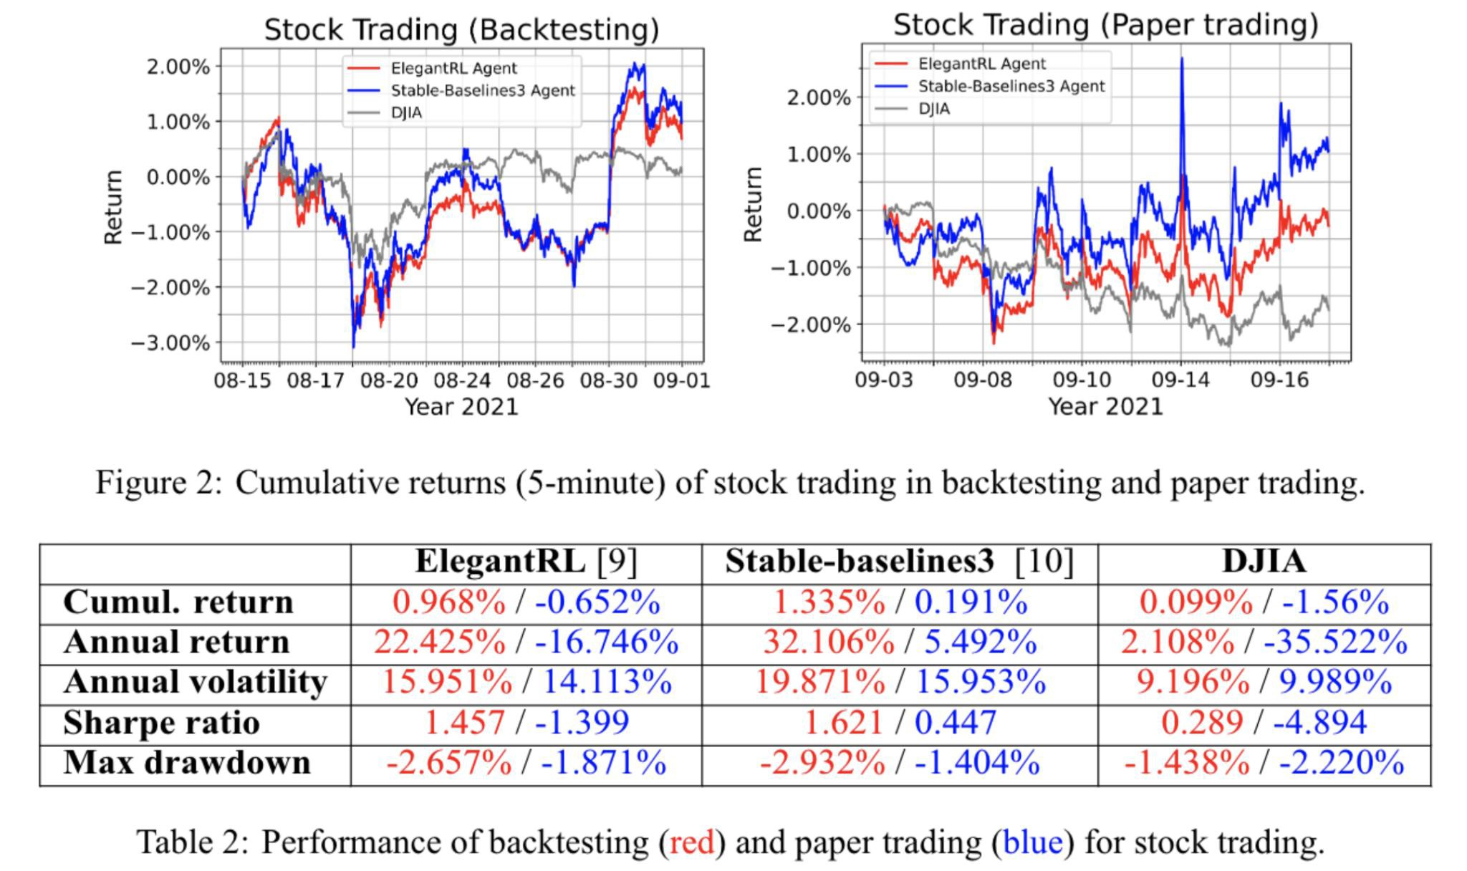

***Cryptocurrency Trading Task***

We select top 10 market cap cryptocurrencies, the top 10 market cap cryptocurrencies as of Oct 2021 are: Bitcoin (BTC), Ethereum (ETH), Cardano (ADA), Binance Coin (BNB), Ripple (XRP), Solana (SOL), Polkadot (DOT), Dogecoin (DOGE), Avalanche (AVAX), Uniswap (UNI). We use the PPO algorithm of ElegantRL to train an agent and use the Bitcoin (BTC) price as the baseline.

* **Backtesting:** We use 5-minute data from 06/01/2021 to 08/14/2021 for training and data from 08/15/2021 to 08/31/2021 for validation (backtesting).
* **Paper Trading:** Then we retrain the agent using data from 06/01/2021 to 08/31/2021 and conduct paper trading from 09/01/2021 to 09/15/2021. The historical data and real-time data are accessed from Binance.

In the backtesting stage (plot in 5-minute), the ElegantRL agent outperforms the benchmark (BTC price) in most performance metrics. It achieves an annual return of 360.823% and a Sharpe ratio of 2.992. The ElegantRL agent also outperforms the benchmark (BTC price) in the paper trading stage, which is consistent with the backtesting results.

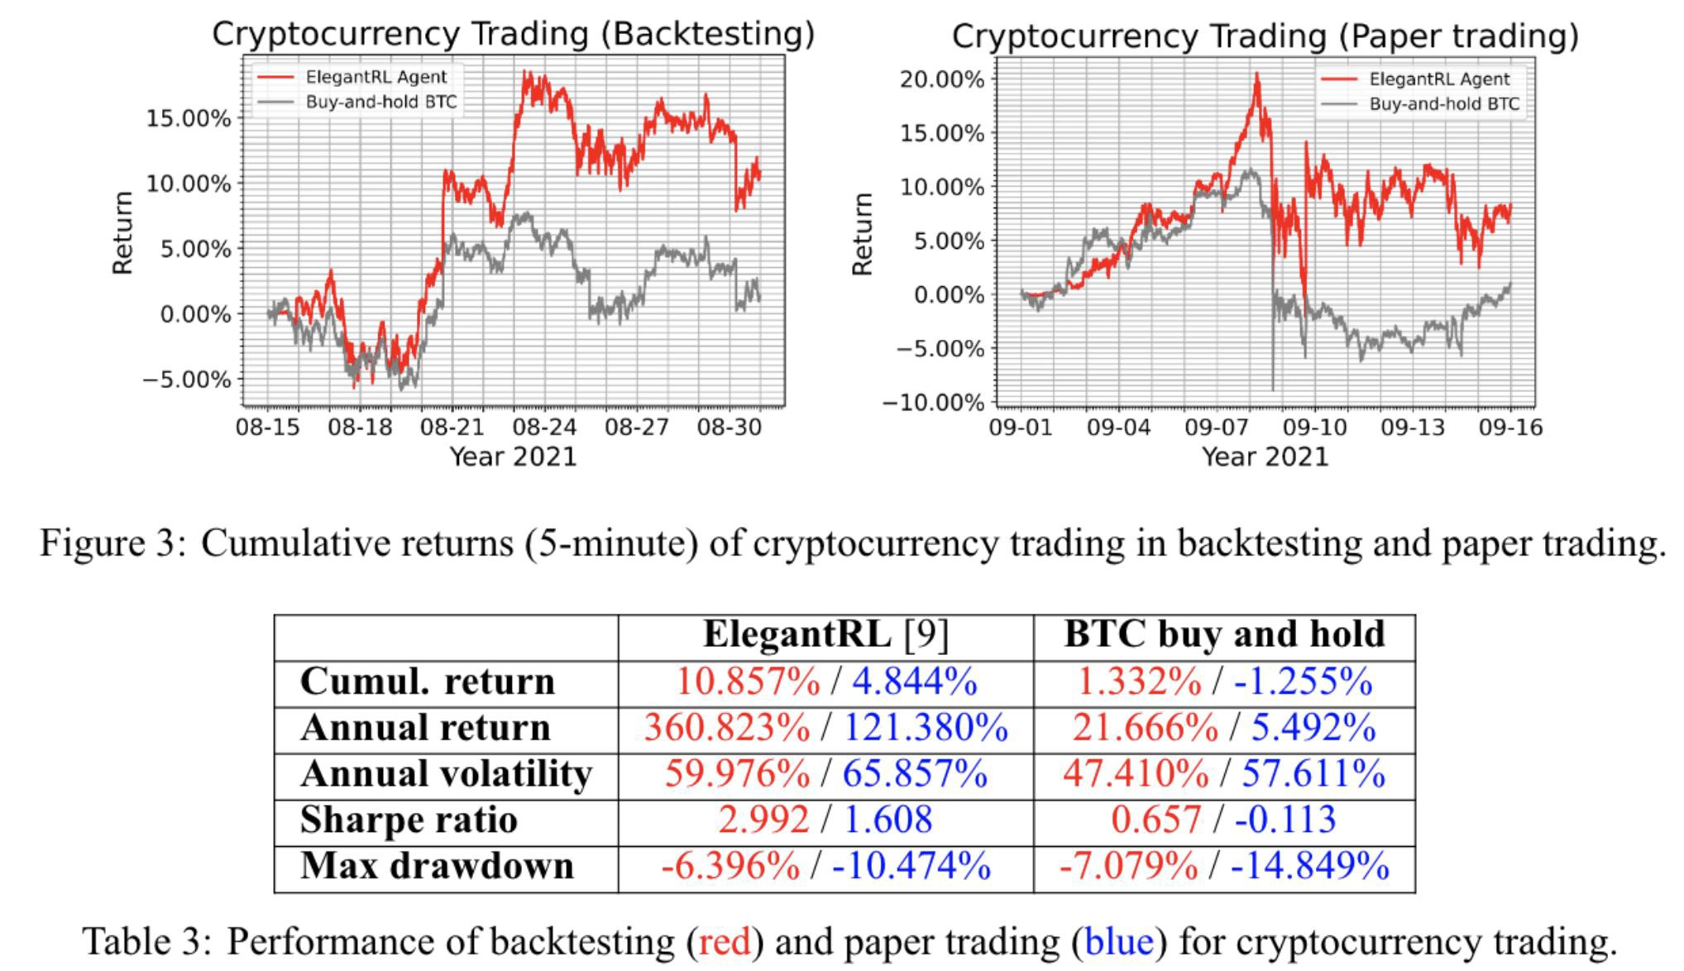

***Cryptocurrency Trading Exercises***

Two colab notebooks are present for the reader to practice on: one with the answers and one without. Try to do the exercises by yourself. This should allow the reader to build a backtested agent.

*Exercises:*

<https://drive.google.com/file/d/17FZCQVHCX57bDHTd7GwD2t74HPDVi2uf/view?usp=sharing>

*Answers:*

<https://drive.google.com/file/d/1R8qKvrXHM81UQp1fRcSvsOf1Ppd27cnh/view?usp=sharing>

***Tra******de Execution and Liquidation***

1. **Introduction**

Trade execution is when a buy or sell order gets fulfilled. In order for a trade to be executed, an investor who trades using a brokerage account would first submit a buy or sell order, which then gets sent to a broker. On behalf of the investor, the broker would then decide which market to send the order to. Once the order is in the market and it gets fulfilled, only then can it be considered executed.

Metrics to measure Trade Execution:

* Profit and Loss (PnL): the overall profit obtained during the transaction;
* Implementation Shortfall: The difference between the total return of the trading algorithm and the total return of all transactions in the first place;
* Sharp ratio: Average return divided by standard deviation of return.

Common trading strategies:

* Time-Weighted Average Price (TWAP): Execute evenly in time;
* Volume-Weighted Average Price (VWAP): It is also a problem worthy of study to execute evenly on the transaction volume, and to obtain the corresponding execution plan accurately;
* Submit and Leave (SnL): place a fixed sell order, and then wait for it to be filled. If the final deal is not completed, sell it at the full market price;
* Almgren-Chriss: Executed according to the optimal analytical strategy under a certain price movement assumption.

1. **Almgren and Chriss model**

The problem of an optimal liquidation strategy is investigated by using the Almgren-Chriss market impact model on the background that the agents liquidate assets completely in a given time frame. The impact of the stock market is divided into three components: unaffected price process, permanent impact, and temporary impact. The stochastic component of the price process exists, but is eliminated from the mean-variance. The price process permits linear functions of permanent and temporary price. Therefore, the model serves as the trading environment such that when agents make selling decisions, the environment would return price information.

* The price process of the Almgren and Chriss model is as follows:

Pk = Pk-1 + σ·τ1/2ξk -τ·g(nk/τ), k = 1,...,N

where σ represents the volatility of the stock, ξk are random variables with zero mean and unit variance, g(v) is a function of the average rate of the trading, v = nk/τ during time interval tk-1 to tk, nk is the number of shares to sell during time interval tk-1 to tk, N is the total number of trades and

τ = T/N.

* Inventory process:

xtk = X - Σj=1 nj,

where xtk is the number of shares remaining at time tk, with xT = 0.

* Linear permanent impact function:

g(v) = γ·v,

where v = nk/τ.

* Temporary impact function:

h(nk/τ) = ε·sgn(nk) +(η/τ)·nk

where a reasonable estimate of ε is the fixed costs of selling, and η depends on internal and transient aspects of the market microstructure.

* Parameters σ, γ, η, ε, time frame T, number of trades N are set at t = 0.

1. **Liquidation as a MDP Problem**

Consider the stochastic and interactive nature of the trading market, we model the stock trading process as a Markov decision process, which is specified as follows:

* State **s = [r,m,l]**: a set that includes the information of the log-return r ∈ R+D, where D

is the number of days of log-return, and the remaining number of trades m normalized by the total number of trades, the remaining number of shares l, normalized by the total number of shares.

The log-returns capture information about stock prices before time tk, where k is the current step. It is important to note that in real world trading scenarios, this state vector may hold more variables.

* Action **a**: we interpret the action ak as a fractional share. In this case, the actions will take continuous values in between 0 and 1.
* Reward **R(s,a)**: to define the reward function, we use the difference between two consecutive utility functions. The utility function is given by:

U(x) = E(x)+λ·V(x),

E(x) = Σk=1τ·xk·g(nk /τ) + Σk=1 nk·h(nk/τ), V(x) = σ2·Σk=1τ·xk2,

where λ is the risk aversion level, and x is the trading trajectory or the vector of shares remaining at each time step k. After each time step, we compute the utility using the equations for E(x) and V(x) from the Almgren and Chriss model for the remaining time and inventory while holding the parameter λ constant. Denotes the optimal trading trajectory computed at time t by xt*, we define the reward as:

Rt = Ut(xt*)-Ut+1(xt+1*).

* Policy π(s): The liquidation strategy of stocks at state s. It is essentially the distribution of selling fraction a at state s.
* Action-value function Qπ(s,a): the expected reward for using action a at state s, following policy π.

1. **Multi-agent deep reinforcement learning for liquidation strategy analysis**

- States **s = [r,m,l]** : in a multi-agent environment, the state vector should have information about the remaining stocks of each agent, the state vector at time tk would be:

[rk-D,...,rk-1,rk,mk,l1,k,...,lN,k]. rk = log(Pk /Pk-1) is the log-return at time tk.

mk = Nk/N is the number of trades remaining at time tk normalized by the total number of trades. lj,k = xj,k /xj is the remaining number of shares for agent j at time tk normalized by the total number of shares.

* Action **a**: using the interpretation in Section \ref{DPL:liquidatoin}, we can determine the number of shares to sell for each agent at every time step using:

nj,k = aj,k ・ xj,k,

where xj,k is the number of remaining shares at time tk for agent j.

* Reward **R(s,a)**: denotes the optimal trading trajectory computed at time t for agent j by xj,k* we define the reward as:

Rj,t = Uj,t(xj,t*)-Uj,t+1(xj,t+1*).

* Observation **O**: Each agent only observes limited state information. In other words, in addition to the environment information, each agent only knows its own remaining shares, but not other agents' remaining shares. The observation vector at time tk for agent j is:

Oj,k = [rk-D,...,rk-1,rk,mk,lj,k].

1. **Demo: Multi-Agent Reinforcement Learning for Liquidation Strategy Analysis**

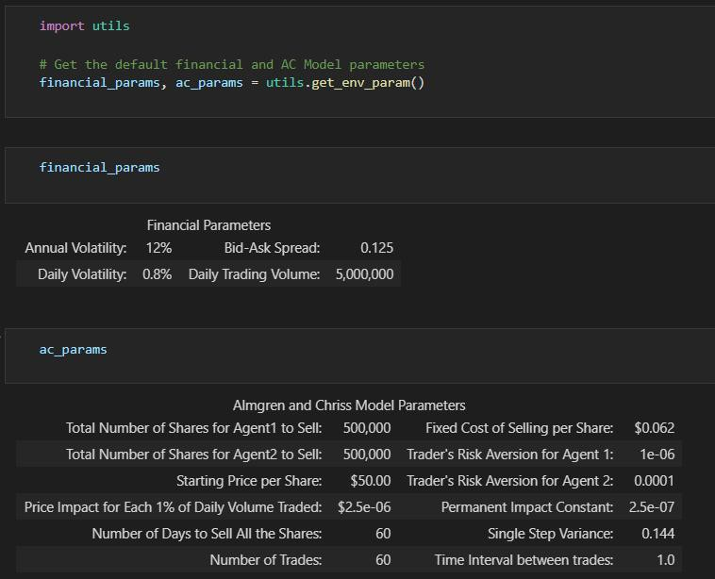

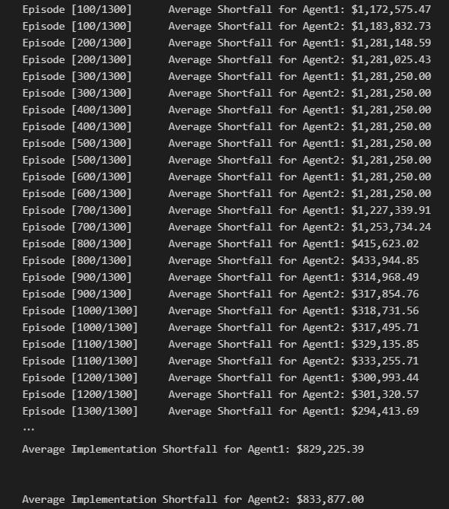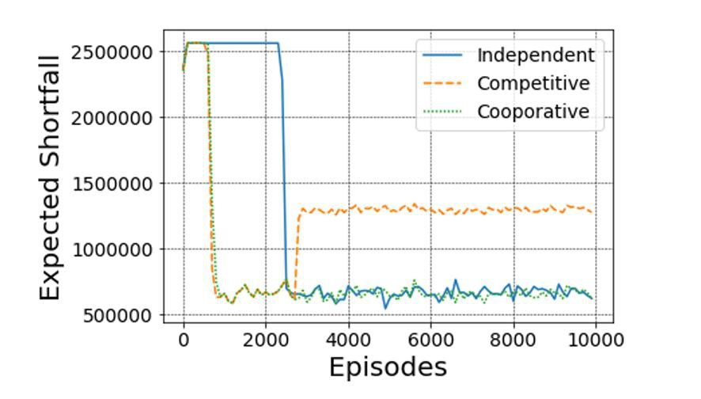

Comparison of expected implementation shortfalls: there are three agents A, B1 and B2. The expected shortfall of agent A is higher than the sum of two expected shortfalls B1 and B2.

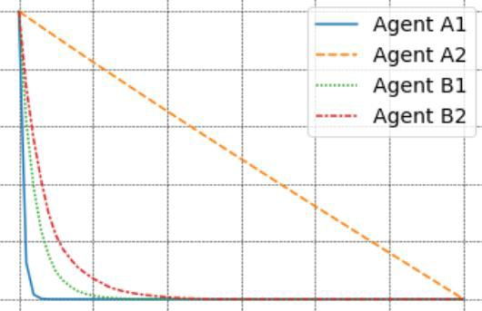

Trading trajectory: comparing to their original trading trajectories, their current trading trajectories are closer to each other when they are trained in a multi-agent environment.

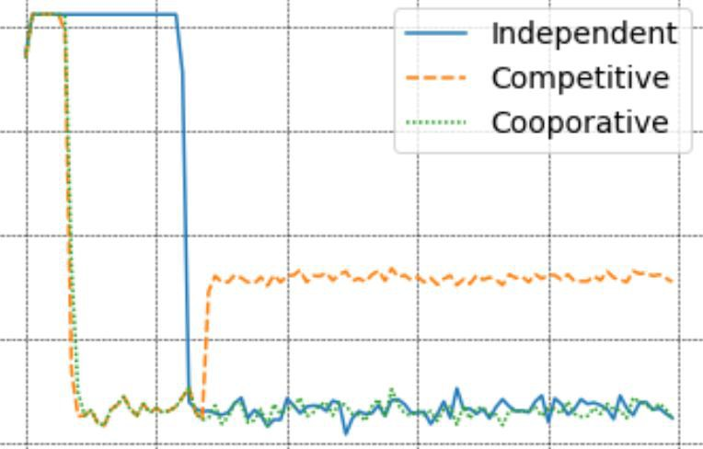

Cooperative and competitive relationships: if two agents are in a cooperative relationship, the total expected shortfall is not better than training with independent reward functions. If two agents are in a competitive relationship, they would first learn to minimize expected shortfall, and then malignant competition leads to significant implementation shortfall increment.

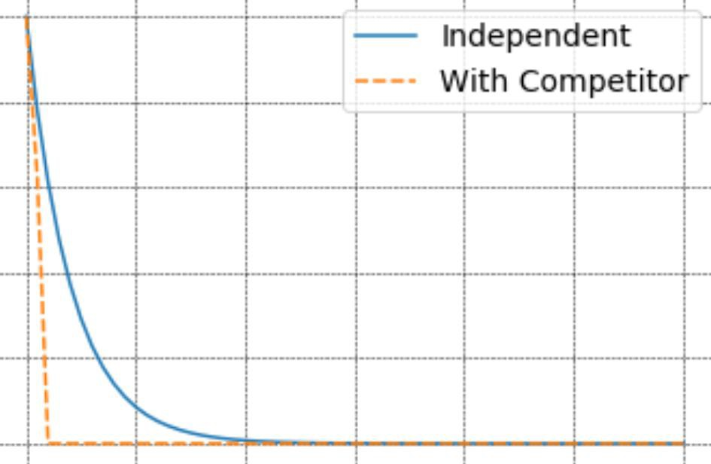

Trading trajectory: comparing to independent training, introducing a competitor makes the host agent learn to adapt to new environment and sell all shares of stock in the first two days

1. **Profit-oriented Trade Execution Methods**

*[1] Jeong G, Kim H Y. Improving financial trading decisions using deep Q-learning: Predicting the number of shares, action strategies, and transfer learning. Expert Systems with Applications, 2019, 117: 125-138.*

*[2] Deng Y, Bao F, Kong Y, et al. Deep direct reinforcement learning for financial signal representation and trading[J]. IEEE transactions on neural networks and learning systems, 2016, 28(3): 653-664.*

*[3] Zhang Z, Zohren S, Roberts S. Deep reinforcement learning for trading. The Journal of Financial Data Science, 2020, 2(2): 25-40.*

*[4] Wei H, Wang Y, Mangu L, et al. Model-based reinforcement learning for predictions and control for limit order books. arXiv preprint arXiv:1910.03743, 2019. Zhang Chuheng: [Reinforcement Learning187]*

*Model-based RL for LOB*

*[5] Shen Y, Huang R, Yan C, et al. Risk-averse reinforcement learning for algorithmic trading. 2014 IEEE Conference on Computational Intelligence for Financial Engineering & Economics (CIFEr). IEEE, 2014: 391-398. Additional Conference Controlling risk, discusses the DQN approach with risk control.*

***Conclusion***

We followed the DataOps paradigm and developed a FinRL-Meta framework. FinRL-Meta provides

open-source data engineering tools and hundreds of market environments with multiprocessing simulation.

###### ElegantRL Overview

ElegantRL is designed for researchers and practitioners with finance-oriented optimizations.

1. ElegantRL implements **state-of-the-art DRL algorithms** from scratch, including both discrete and continuous ones, and provides user-friendly tutorials in Jupyter Notebooks.
2. The ElegantRL performs DRL algorithms under the **Actor-Critic framework**
3. The ElegantRL library enables researchers and practitioners to pipeline the disruptive “design, development and deployment” of DRL technology.

###### ElegantRL Code Structure

**Part 1. Overview: File Structure and Functions**

The file structure of ElegantRL is shown in Fig. 1:

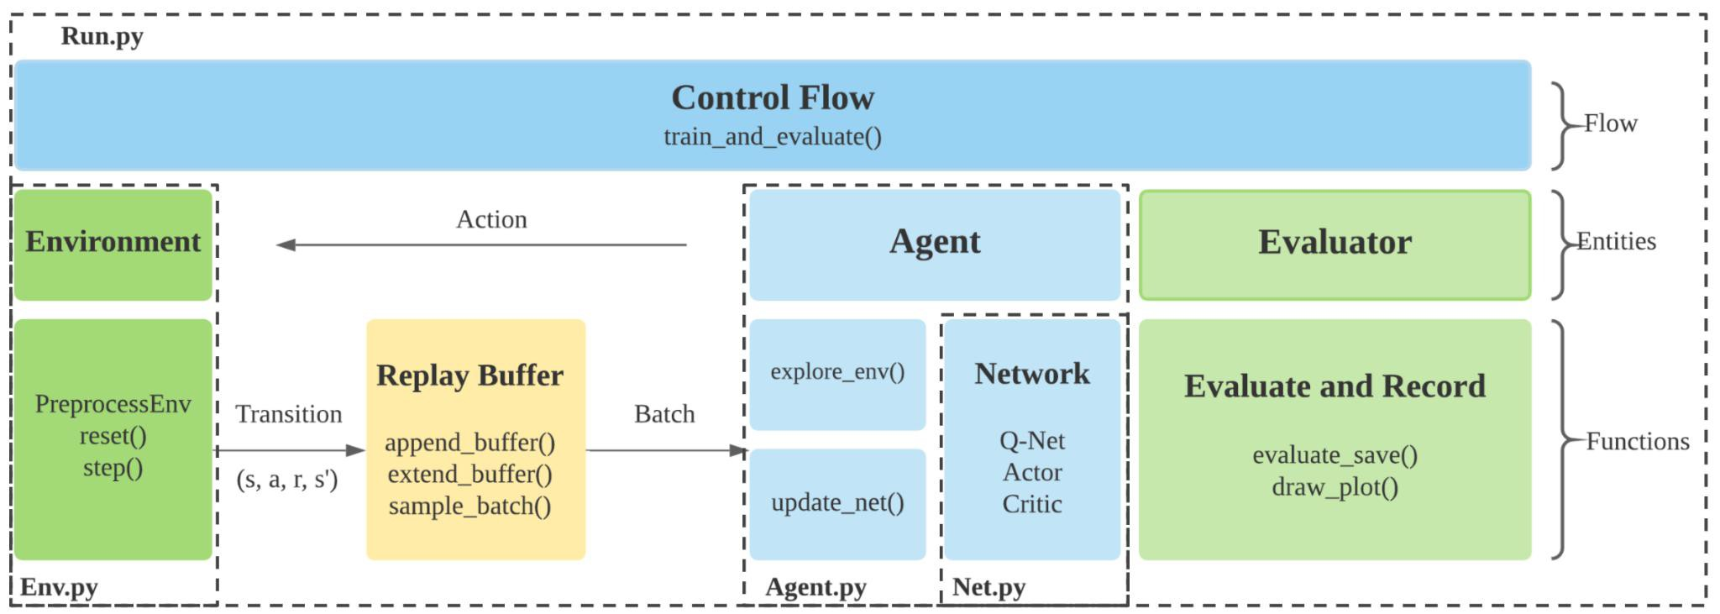

Figure 1. An agent in Agent.py uses networks in Net.py and is trained in Run.py by interacting with an environment in Env.py.

**Env.py:** it contains the environments with which the agent interacts.

* A PreprocessEnv class for gym-environment modification.
* A self-created stock trading environment as an example for user customization.

**Net.py:** There are three types of networks:

* Q-Net,
* Actor Network,
* Critic Network,

Each includes a base network for inheritance and a set of variations for different algorithms.

**Ag****ent.py:** it contains agents for different DRL algorithms.

**Run.py:** it provides basic functions for the training and evaluating process:

* Parameter initialization,
* Training loop,
* Evaluator.

As a high-level overview, the relations among the files are as follows. Initialize an environment in Env.py and an agent in Agent.py. The agent is constructed with Actor and Critic networks in Net.py. In each training step in Run.py, the agent interacts with the environment, generating transitions that are stored into a Replay Buffer. Then, the agent fetches transitions from the Replay Buffer to train its networks. After each update, an evaluator evaluates the agent’s performance and saves the agent if the performance is good.

**Part 2. Implementations of DRL Algorithms**

This part describes **DQN-series algorithms and DDPG-series algorithms**, respectively. Each DRL algorithm agent follows a hierarchy from its base class.

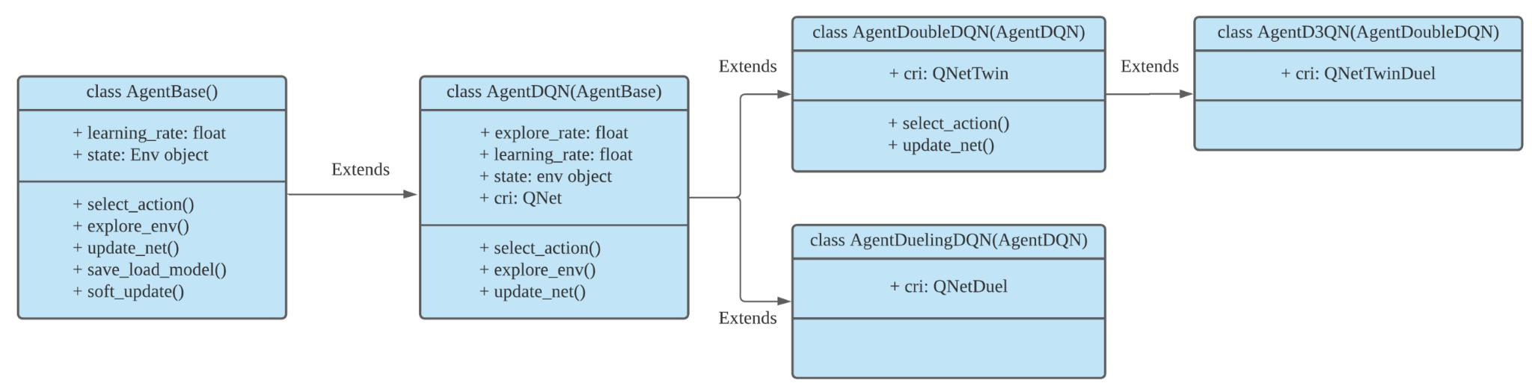

Figure 2. The inheritance hierarchy of DQN-series algorithms.

As shown in Fig. 2, the inheritance hierarchy of the DQN-series algorithms is as follows:

* **AgentDQN:** a standard DQN agent.
* **AgentDoubleDQN:** a Double-DQN agent with two Q-Nets for reducing overestimation, inheriting from AgentDQN.
* **AgentDuelingDQN:** a DQN agent with a different Q-value calculation, inheriting from AgentDQN.
* **AgentD3QN:** a combination of AgentDoubleDQN and AgentDuelingDQN, inheriting from AgentDoubleDQN.

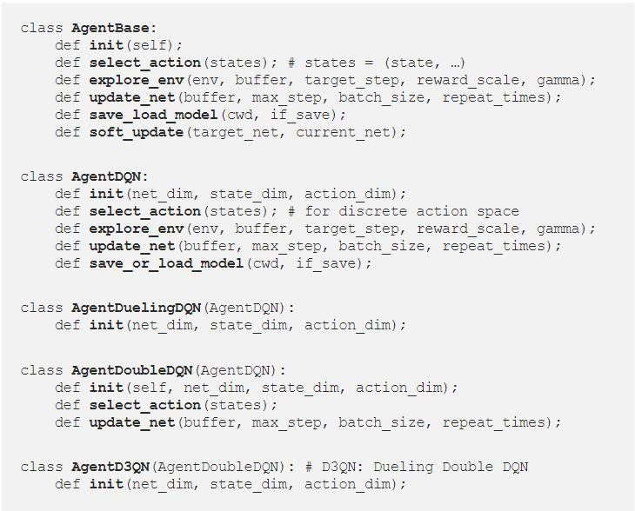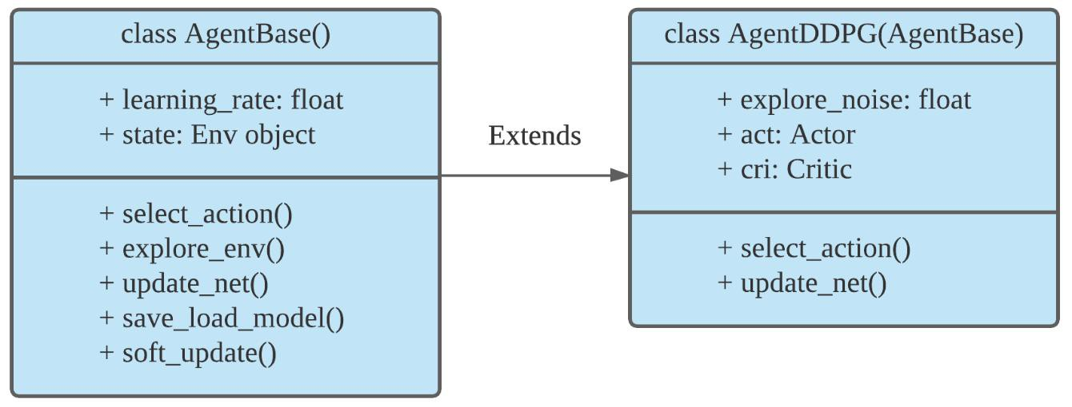

Figure 3. The inheritance hierarchy of DDPG-series algorithms.

As shown in Fig. 3, the inheritance hierarchy of the DDPG-series algorithms is as follows

* **AgentBase:** a base class for all Actor-Critic agents.
* **AgentDDPG:** a DDPG agent, inheriting from AgentBase.

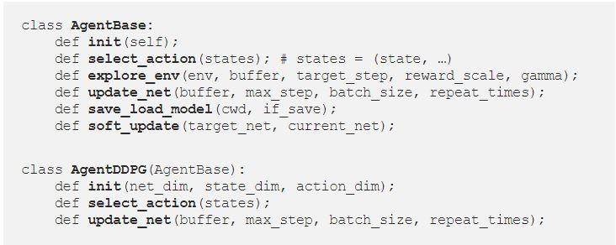

Applying such a hierarchy in building DRL agents effectively improves **lightweightness and effectiveness**. Users can easily design and implement new agents in a similar flow.

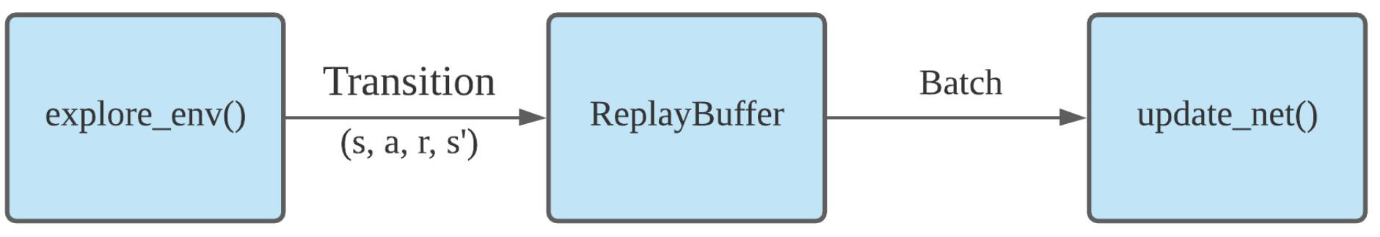

Figure 4. The data flow of training an agent.

Basically, an agent has two fundamental functions, and the data flow is shown in Fig.4:

* **explore_env():** it allows the agent to interact with the environment and generates transitions for training networks.
* **update_net():** it first fetches a batch of transitions from the Replay Buffer, and then train the network with backpropagation.

**Part 3. Training Pipeline**

Two major steps to train an agent:

1. Initialization:

* **hyper-parameters args.**
* **env = PreprocessEnv() :** creates an environment (in the OpenAI gym format).
* **agent = AgentXXX() :** creates an agent for a DRL algorithm.
* **evaluator = Evaluator() :** evaluates and stores the trained model.
* **buffer = ReplayBuffer() :** stores the transitions.

1. Then, the training process is controlled by a while-loop:

* **agent.explore_env(…):** the agent explores the environment within target steps, generates transitions, and stores them into the ReplayBuffer.
* **agent.update_net(…):** the agent uses a batch from the ReplayBuffer to update the network parameters.
* **evaluator.evaluate_save(…):** evaluates the agent’s performance and keeps the trained model with the highest score.

The while-loop will terminate when the conditions are met, e.g., achieving a target score, maximum steps, or manually breaks.

**Part 4. Testing Example: BipedalWalker-v3**

[BipedalWalker-v3](https://gym.openai.com/envs/BipedalWalker-v2/) is a classic task in robotics that performs a fundamental skill: moving. The goal is to get a 2D biped walker to walk through rough terrain. BipedalWalker is considered to be a difficult task in the continuous action space, and there are only a few RL implementations that can reach the target reward.

**Step 1: Install ElegantRL**



**Step 2: Import Packages**

* **ElegantRL**
* **OpenAI Gym:** a toolkit for developing and comparing reinforcement learning algorithms.
* **PyBullet Gym:** an open-source implementation of the OpenAI Gym MuJoCo environments.

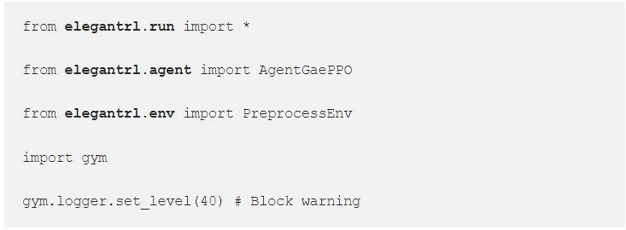

**Step 3: Specify Agent and Environment**

* **args.agent:** firstly chooses a DRL algorithm, and the user is able to choose one from a set of agents in agent.py
* **args.env:** creates and preprocesses an environment, and the user can either customize own environment or preprocess environments from OpenAI Gym and PyBullet Gym in env.py.

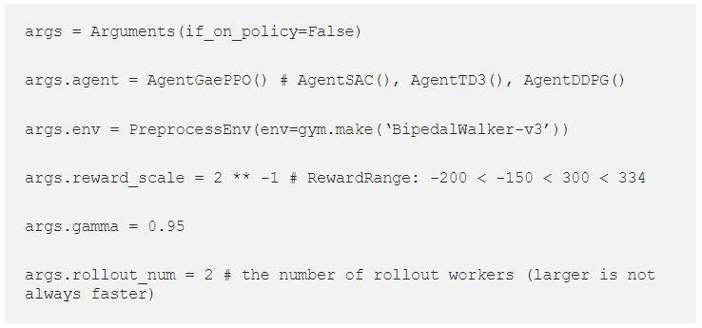

**Step 4: Train and Evaluate the Agent**

The training and evaluating processes are inside the function **train_and_evaluate multiprocessing(args)**, and the parameter is **args**. It includes two fundamental objects in DRL:

* **agent,**
* **environment (env).**

And the parameters for training:

* **batch_size,**
* **target_step,**
* **reward_scale,**
* **learning rate**
* **gamma, etc.**

Also the parameters for evaluation:

* **break_step,**
* **random_seed, etc.**

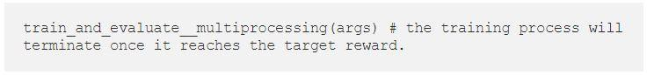

**Step 5: Testing Results**

After reaching the target reward, we generate the frame for each state and compose frames as a video result. From the video, the walker is able to move forward constantly.

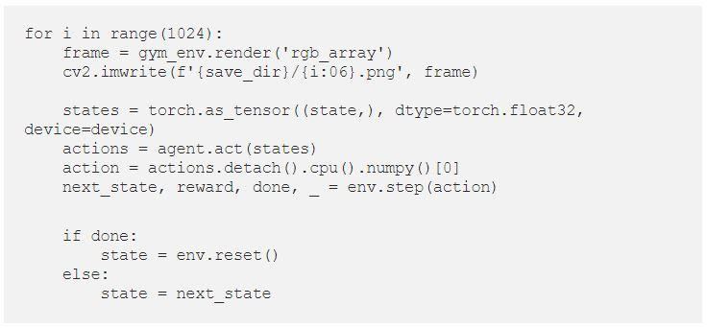



Figure 5. (left) An agent with random actions. (right) A PPO agent in ElegantRL.

Check out the [Colab](https://github.com/AI4Finance-Foundation/ElegantRL/blob/master/tutorial_BipedalWalker_v3.ipynb) codes for this BipedalWalker-v3 demo.

**Conclusion**

[ElegantRL](https://elegantrl.readthedocs.io/en/latest/index.html) is developed for researchers and practitioners with the following advantages:

* Lightweight: the core codes <1,000 lines (check elegantrl/tutorial), using PyTorch (train), OpenAI Gym (env), NumPy, Matplotlib (plot).
* Efficient: in many testing cases, we find it more efficient than [Ray RLlib](https://github.com/ray-project/ray).
* Stable: much more stable than [Stable Baselines 3](https://github.com/DLR-RM/stable-baselines3). Stable Baselines 3 can only use a single GPU, but ElegantRL can use 1~8 GPUs for stable training.

ElegantRL implements the following model-free deep reinforcement learning (DRL) algorithms:

* DDPG, TD3, SAC, PPO, PPO (GAE),REDQ for continuous actions
* DQN, DoubleDQN, D3QN, SAC for discrete actions
* QMIX, VDN; MADDPG, MAPPO, MATD3 for multi-agent environment

For the details of DRL algorithms, please check out the educational webpage [OpenAI Spinning Up](https://spinningup.openai.com/en/latest/).

We also developed demos such as: **ElegantRL Demo: Stock Trading Using DDPG.** For more details about it**,** please visit [**Part 1**](https://medium.com/mlearning-ai/elegantrl-demo-stock-trading-using-ddpg-part-i-e77d7dc9d208) **and** [**Part 2**](https://medium.com/mlearning-ai/elegantrl-demo-stock-trading-using-ddpg-part-ii-d3d97e01999f).

### Senior/Capstone Projects

The questions to answer before embarking on the project: (These are our Interview Screening Questions)

1. What is a Markov Decision Process? Give a definition of MDP. What is a policy? Give a definition of the Bellman Equation. What are some of the ways to learn optimal policy?
2. Can you walk through how to learn optimal policy with MDP through Neural Network? How do we represent those states and policies in terms of NN?
3. What is the difference between Reinforcement learning & Deep Reinforcement Learning? What is the difference between Q-learning & Deep Q-learning?
4. How to implement DQN?
5. We want to apply DRL to finance (FinRL). Can you find some recent applications of deep reinforcement learning in financial markets, for example, automated trading, portfolio allocation, cryptocurrency (BTC), hedging, high-frequency (minute level or tick data)? What are the critic-based approach, actor-based approach, or actor-critic approach algorithms?
6. Can you explain the evolution line of Deep Reinforcement Learning algorithms? DRL is always about coming up with state-of-the-art performance algorithms (DQN, DDPG, Policy Gradient, A2C, PPO, TD3, SAC, etc. the advantages and disadvantages for each algorithm, for example, if you think DQN < DDPG < TD3 < SAC, explain the reasons)

#### *FinRL*

[FinRL](https://finrl.readthedocs.io/en/latest/index.html) is the first open-source framework to demonstrate the great potential of applying deep reinforcement learning in quantitative finance. We help practitioners establish the development pipeline of trading strategies using **deep reinforcement learning (DRL). A DRL agent learns by continuously interacting with an environment in a trial-and-error manner, making sequential decisions under uncertainty, and achieving a balance between exploration and exploitation.**

* 1. **Technical Indicators & Statistical Features**

Using *feature extraction* methods to obtain attributes that can be used in *states*. For example, the TA-Lib library (<https://github.com/mrjbq7/ta-lib>, already used by FinRL) provides standard calculations of technical indicators. The reason classic technical analysis works at all is probably only the self-fulfilling prophecy. From that point of view, it might be a good idea to start with the popular indicators. In trading, candlestick patterns are often used for trading decisions, too. You could define features for those patterns (libraries like TA-lib provide such functions) or provide the model the features that describe those patterns like upper and lower shadow of the candle, real body of the candle and full length of the candle.

Also the so-called hl2, hlc3, ohlc4 prices and orderbook data are typically used in trading and might be valuable features.

Here are some examples about feature extraction methods and indicator groups, you are more than welcome to try other methods as well.

Feature extraction methods: Principal Components Analysis (PCA), Independent Component Analysis (ICA), Linear Discriminant Analysis (LDA), Locally Linear Embedding (LLE), t-distributed Stochastic Neighbor Embedding (t-SNE), Autoencoders

Indicator Groups include: Overlap Studies, Momentum Indicators, Volume Indicators, Volatility Indicators, Price Transform, Cycle Indicators, Pattern Recognition

There are also many statistical & mathematical features that can be considered. Cointegration (between assets / Augmented Dickey–Fuller test, Johansen test, Engle-Granger test), correlation (between assets / Pearson), variance, deviation, entropy, logarithmic return, fast fourier transform and wavelet transform to just name some. You will find more inspiration here:

* <https://tsfresh.readthedocs.io/en/latest/text/list_of_features.html>
* <https://github.com/fraunhoferportugal/tsfel>

Hidden states with Hidden Markov model (<https://hmmlearn.readthedocs.io/en/0.2.0/auto_examples/plot_hmm_stock_analysis.html>)

Another approach to generate features can be clustering. Two examples using clustering:

Ding, Fengqian & Luo, Chao. (2020). An Adaptive Financial Trading System Using Deep Reinforcement Learning With Candlestick Decomposing Features. IEEE Access.

Clustering to find support & resistance levels:

<https://towardsdatascience.com/using-k-means-clustering-to-create-support-and-resistance-b13fdeeba12>

* 1. **Rewards Functions**

*The reward fed to the RL agent is completely governing its behavior, so a wise choice of the reward shaping function is critical for good performance. There are quite a number of rewards one can choose from or combine, from risk-based measures to profitability or cumulative return, number of trades per interval, etc. The RL framework accepts any sort of reward: the denser, the better.* (Millea, A. Deep Reinforcement Learning for Trading—A Critical Survey. Data 2021, 6, 119. <https://doi.org/10.3390/data6110119>)

An overview over certain reward functions can be found in the paper Sadighian, J. (2020). Extending Deep Reinforcement Learning Frameworks in Cryptocurrency Market Making arXiv:2004.06985:

* *PnL-based Rewards (Unrealized PnL, Unrealized PnL with Realized Fills, Asymmetrical Unrealized PnL with Realized Fills, Asymmetrical Unrealized PnL with Realized Fills and Ceiling, Realized PnL Change)*
* *Goal-based Rewards (Trade Completion)*
* *Risk-based Rewards (Differential Sharpe Ratio)*

The Deflated Sharpe Ratio from M López De Prado is worth considering too. It corrects for two leading sources of performance inflation: Non-Normally distributed returns and selection bias under multiple testing.(<https://papers.ssrn.com/sol3/papers.cfm?abstract_id=2465675>)

The reward function is the incentive mechanism for an agent to learn a better action. There are many forms of the reward function. FinRL supports user-defined reward functions to include

risk factor or transaction cost term such as in [Deep hedging](https://papers.ssrn.com/sol3/papers.cfm?abstract_id=3355706), [Deep Direct Reinforcement Learning for](http://cslt.riit.tsinghua.edu.cn/mediawiki/images/a/aa/07407387.pdf) Financial Signal Representation and Trading, and [Deep reinforcement learning for trading](https://arxiv.org/pdf/1911.10107.pdf).

In this section, you are required to try all the above-mentioned reward functions, then compare the results. You are also required to create your own reward function to achieve the best performance as you can. A combination of different reward functions might be a valuable approach. Besides the above-mentioned ideas, you might want to consider:

* The immediate and long-term reward
* Incentivizing actions / Penalizing (too long) holding/time without an open position.
* Optimal total of trades (a rough estimation on how often the model should trade - 1D timeframe vs. 5m timeframe should probably be traded with a different frequency) and penalizing too big deviation from this optimum.
* Reward in relation to buy-and-hold. You could penalize if it doesn't beat buy-and-hold metrics (of the day).
  1. **Alternative Datasets**

**Financial-News / Sentiment analysis.**

Financial news is frequently discussed and plays an important role in evaluating financial markets. In this section, we would like to leverage the financial news datasets and dive deeper into how such information can help FinRL to make better decisions. We provide three financial datasets as follows: [Daily Financial](https://www.kaggle.com/miguelaenlle/massive-stock-news-analysis-db-for-nlpbacktests) News for 6000+ Stocks, [US Financial News Articles](https://www.kaggle.com/jeet2016/us-financial-news-articles), and [Daily News for Stock Market](https://data.world/finance/daily-news-for-stock-market). You are required to add such information as input features into the FinRL model and compare the result. A keyword for this is (News) Sentiment Analysis.

**Company fundamentals**

Company fundamentals can be valuable information sources too. Like financial statements, market capitalization, SEC filings, press releases (dates), etc.

**Social** **Media data/sentiment**

Social media activities can be a valuable indicator for models too. For example Reddit subscribers, Twitter followers, positive/negative mentions of the stock (sentiment analysis), etc. When using these data one should be aware that those activities can be distorted by social media bots. A reliable data source that has measures in place to filter such distortions is important.

**Cryptocurrency specific data**

Cryptocurrencies offer some data that are unique to them. On-Chain data are related to transactions, mining activities, and network stats. Another data point can be developer activity on Github or the number of listings on exchanges for example.

You will find many data aggregator services offering those alternative historical data in real-time. This list could go on forever. The creativity on alternative data used for trading has no limits and you will even find the use of more seemingly unrelated data usage like astrology data, weather data, and sun activity being applied in trading.

* 1. **Seasonality Information**

Providing the model information of seasonality can open up the possibility for the model to discover patterns. Data could be day of the week, day of the month, month, year, week of the year, hour, and holidays (Christmas, Black Friday, etc.)

* 1. **Volatility Features**

There are several established functions to estimate the volatility of an asset:

* Realized
* Parkinson
* Garman-Klass
* Roger-Satchell
* Garman-Klass-Yang-Zhang
* Yang-Zhang

See <https://www.kaggle.com/yamqwe/crypto-prediction-volatility-features>for implementations.

* 1. **Feature Importance / Feature Selection**

To improve performance of the model this part is essential. More input features often make the decision task for the model more challenging. This is known as the curse of dimensionality. So it's essential to only keep important features. There are different techniques that can be applied to determine the right set of features.

Overview of different approaches:

* <https://jundongl.github.io/scikit-feature/algorithms.html>
* <https://www.kdnuggets.com/2021/06/feature-selection-overview.html>
* Solorio-Fernández, S., Carrasco-Ochoa, J.A. & Martínez-Trinidad, J.F. A review of unsupervised feature selection methods. *Artif Intell Rev* **53,** 907–948 (2020). [https://doi.org/10.1007/s10462-](https://doi.org/10.1007/s10462-019-09682-y) 019-09682-y
* Liu, Kunpeng, u. a. *Efficient Reinforced Feature Selection via Early Stopping Traverse Strategy*. 2021. [arXiv:2109.14180](https://arxiv.org/abs/2109.14180)
* Fan, Wei, u. a. *AutoFS: Automated Feature Selection via Diversity-aware Interactive Reinforcement Learning*. 2020. [arXiv:2008.12001](https://arxiv.org/abs/2008.12001)
* Zhao, Xiaosa, u. a. *Simplifying Reinforced Feature Selection via Restructured Choice Strategy of Single Agent*. 2020. [arXiv:2009.09230](https://arxiv.org/abs/2009.09230)
* Wang, Xiaoyang, u. a. *Robusta: Robust AutoML for Feature Selection via Reinforcement Learning*. 2021. [arXiv:2101.05950](https://arxiv.org/abs/2101.05950)
  1. **Cross-Validation**

*"There are many different ways one can do cross-validation, and it is the most critical step when building a good machine learning model which is generalizable when it comes to unseen data."* - Thakur, A. (2020). Approaching (almost) any machine learning problem.

Cross-Validation is essential to prevent overfitting. There are certain techniques suited for time series data

/ financial data explained here:

[https://medium.com/@samuel.monnier/cross-validation-tools-for-time-series-ffa1a5a09bf9](https://medium.com/%40samuel.monnier/cross-validation-tools-for-time-series-ffa1a5a09bf9)

Great library which implements two cross-validation algorithms suitable to evaluate machine learning models based on time series datasets: <https://github.com/sam31415/timeseriescv>

* 1. **Synthetic Price Series for Initial Training and/or Testing**

Training first on rather simple idealized synthetic prices before feeding real data might be beneficial to learn the agent the "basics". Also, it's great for testing functionality.

* Sine wave
* Trend curves
* Random walk
* Different types of autocorrelation
* Adding different degrees of noise/trend
* Recurring patterns

You will find existing libraries/examples available for these tasks. For example:

* <https://github.com/Nike-Inc/timeseries-generator>
* <https://github.com/TimeSynth/TimeSynth>
* <https://github.com/stefan-jansen/synthetic-data-for-finance>
* <https://towardsdatascience.com/time-series-analysis-creating-synthetic-datasets-cf008208e014>
  1. **Different Approaches, Actions and Environments**

Currently, the actions / environments focus on trading actions buy, sell and hold. There are more possibilities to explore:

* Only buy or sell.
* Only day-trading. Two approaches:
  + Force a sell at the end of the day and let the model find just entries
  + Force an open position at the start of the day and let the model find just the exit
* Use classic stop-loss and / or take-profit approaches (trailing, ATR based, etc.) along the model’s trading decisions.
* Risk / volatility based position-sizing along the models decisions.
* Detecting / classifying market regimes / market conditions with DRL (or as feature) (<https://www.twosigma.com/articles/a-machine-learning-approach-to-regime-modeling/>and Horvath, Blanka, u. a. *Clustering Market Regimes using the Wasserstein Distance*. 2021. arXiv:2110.11848)
* Pump and Dump / anomaly detection. (Nilsen, Andreas Isnes. *Limelight: real-time detection of pump-and-dump events on cryptocurrency exchanges using deep learning*. MS thesis. UiT Norges arktiske universitet, 2019.)
* statistical arbitrage also known as pairs trading
* portfolio optimization

Those concepts also reflect trading best practices.

* 1. **Reproduce Experimental Results of Existing Papers**

In the AI for finance society, there are many valuable works we would like you to study as well. Such works will be good assets for you to enhance your basic skills in understanding others’ research work and to inspire your research ideas in future studies. Attached are research papers we recommend you reproduce:

[Cryptocurrency portfolio management with deep reinforcement learning](https://arxiv.org/pdf/1612.01277.pdf)

[A deep reinforcement learning framework for the financial portfolio management problem](https://arxiv.org/pdf/1706.10059.pdf)

*Github repo:* [*https://github.com/ZhengyaoJiang/PGPortfolio*](https://github.com/ZhengyaoJiang/PGPortfolio)

[Deep Reinforcement Learning for Trading](https://arxiv.org/pdf/1911.10107.pdf)

Sun, Shuo, u. a. *DeepScalper: A Risk-Aware Deep Reinforcement Learning Framework for Intraday Trading with Micro-level Market Embedding*. 2021. [arXiv:2201.09058](https://arxiv.org/abs/2201.09058)

Moraes Sarmento, Simão, und Nuno C. G. Horta. *A Machine Learning Based Pairs Trading Investment Strategy*. Springer, 2021.

#### *FinRL-Meta*

FinRL-Meta is a universe of market environments for data-driven financial reinforcement learning. Users can use FinRL-Meta as the metaverse of their financial environments.

Why FinRL-Meta?

* To reduce the simulation-reality gap: existing works use backtesting on historical data, while the real performance may be quite different when applying the algorithms to paper/live trading.
* To reduce the data pre-processing burden, so that quants can focus on developing and optimizing strategies.
* To provide benchmark performance and facilitate fair comparisons, providing a standardized environment will allow researchers to evaluate different strategies in the same way. Also, it would help researchers to better understand the “black-box” nature (deep neural network-based) of DRL algorithms.

Design Principles

* Plug-and-Play (PnP): Modularity; Handle different markets (say T0 vs. T+1)
* Completeness and universal: Multiple markets; Various data sources (APIs, Excel, etc); User- friendly variables.
* Avoid hard-coded parameters
* Closing the sim-real gap using the “training-testing-trading” pipeline: simulation for training and connecting real-time APIs for testing/trading.
* Efficient data sampling: accelerate the data sampling process is the key to DRL training! From the ElegantRL project. We know that multi-processing is powerful to reduce the training time (scheduling between CPU + GPU).
* Transparency: a virtual env that is invisible to the upper layer
* Flexibility and extensibility: Inheritance might be helpful here

We plan to build a **multi-agent based market simulator** that consists of over ten thousands of agents, namely, a FinRL-Meta. First, FinRL-Meta aims to build a universe of market environments, like the [Xland environment](https://arxiv.org/abs/2107.12808) and [planet-scale climate forecast](https://www.nature.com/articles/s41586-021-03854-z) by DeepMind. To improve the performance for large-scale markets, we will employ GPU-based massive parallel simulation as [Isaac Gym](https://arxiv.org/abs/2108.10470). Moreover, it will be interesting to explore the [deep evolutionary RL framework](https://www.nature.com/articles/s41467-021-25874-z) to simulate the markets. **Our final goal is to provide insights into complex market phenomena and offer guidance for financial regulations through FinRL-Meta.**

1. **Momentum Strategy with Deep Learning in Chinese Commodity Market**

**Goal:** Study trading strategies with state-of-the-art DRL techniques trained on the FinRL platform. Specifically we want to improve momentum strategies by detecting trend reversals using deep reinforcement learning techniques.

The student will have the opportunity to gain market insights and real world quant trading experience.

**Market:**

* 1. Daily market data for all futures traded on CFFEX, SHFE, DCE, INE starting 04/01/2020, till now.
  2. Tick-by-tick data for all above futures.

**Both datasets in the period can be shared in** [**FinRL-Meta**](https://github.com/AI4Finance-Foundation/FinRL-Meta)**. Base lines:**

1. A buy-and-hold strategy
2. Traditional momentum strategy

**Key Steps:**

1. Describe the problem in the deep reinforcement learning language
2. Choose the appropriate algorithm
3. Train and test the model, and possibly iterate through 1, 2, 3.

**Performance Backtesting:**

1. For inter-day strategy, the train period will be around 1.5 years, the validation period will be around 0.5 years, and the backtest period will be around 0.5 years.
2. For intraday strategy, the train period will be around 2 months, and the validation period will be about 1 month, and the backtest will be about 1 month, all on rolling windows.
3. We will look at performance on individual assets and performance on asset portfolios based on certain selection.

**References:**

1. “A Trading Strategy Using Deep Learning and Change point Detection”
2. “Deep Direct Reinforcement Learning for Financial Signal Representation and Trading”
3. **Integrate Data Ingestion and Trading Actions**

Open ended questions:

How to integrate data ingestion and trading actions with more popular trading platforms such as Metatrader (<https://www.metatrader5.com/en>)? REST API for prediction endpoint and broker

data ingestion (batch/streaming)? Can the models be utilized by traders in robots (expert advisors) and trading indicators?

We would like you to think about these questions and come up with the implementation plans.

1. **Expand Support for a Number of FinRL Dataprocessors and Brokers for Trading Operations.**

Users can use DataProcessor in data_processor.py. Take **Binance** as an example. DP = DataProcessor('binance')

ticker_list = ['BTCUSDT', 'ETHUSDT', 'ADAUSDT', 'BNBUSDT']

start_date = '2021-09-01'

end_date = '2021-09-20' time_interval = '5m'

technical_indicator_list = ['macd', 'rsi', 'cci', 'dx'] # self-defined technical indicator list is NOT supported yet

if_vix = False

price_array, tech_array, turbulence_array = DP.run(ticker_list, start_date, end_date,

time_interval, technical_indicator_list, if_vix, cache=True)

We would like you to try out other markets and fill out the results.

1. **FinRL-Meta Real-world Enhancement**

In order to achieve the goal of FinRL-Meta, a universe of market environments for data-driven financial reinforcement learning. We encourage you to explore the following questions and add the corresponding features:

**Provide signals to the traders**

In real-world implementation, traders need to track FinRL’s performance with certain instruments over time. Providing valid signals is a key enhancement for FinRL-Meta.

**Millisecond data frequency support**

Some brokers provide data at tick or millisecond frequency - how can FinRL be scaled to be able to provide trading operations at this frequency?

**Futures contracts support**

As a universe of market environments, FinRL-Meta will take the Futures contracts into account. How to manage Futures contracts and calculation of variation margin at the end of each trading day?

1. **Incorporate the real-world market environment**
   1. How to incorporate the real-world market environment such as dealing with bid-ask spreads, slippage, etc. and providing trading operations to limit risk e.g. fixed and trailing loss-stops, take profit, pending and limit orders?
   2. How to manage orders after it has been formed and sent to a trade server, e.g. the order can undergo the following stages:
      1. Started — the order correctness has been checked, but it hasn't been yet accepted by the broker;
      2. Placed — a dealer has accepted the order;
      3. Partially filled — the order is filled partially;
      4. Filled — the entire order is filled;
      5. Canceled — the order is canceled by the client;
      6. Rejected — the order is rejected by a dealer;
      7. Expired — the order is canceled due to its expiration.
   3. How can FinRL enable Netting (single open positions on a symbol) or Hedging (multiple open positions), with trades in the same direction or opposite.
   4. How to incorporate fundamental analysis in FinRL?
   5. How to conduct various experiments, record them, and systematically compare and contrast the results, and then fine tune the models?
   6. How to determine whether technical indicators help or hinder FinRL predictions?

Users can set the technical indicator list as an empty list, train the model, and test the performance. If the return is higher than that case with a defined list, it helps, otherwise, no help.

1. **Technical enhancement for FinRL-Meta**
   1. To support the model for different traders, transfer learning can certainly help to make it happen. How to transfer learning between models run by different traders?

Some hands on examples for transfer learning: <https://www.tensorflow.org/tutorials/images/transfer_learning>

* 1. How to scale data ingestion, cleansing, transformation to features using DataOps?
  2. Enable Fin-RL to use a data lake and data pipeline to be able to ingest batch or streaming data, and structured or unstructured data e.g. social media sentiment. Incorporate a data pipeline with

e.g. bronze, silver, gold zones for data cleansing, transformation, feature creation etc.

* 1. How to scale ML model management, through development, testing, preproduction and production, whilst managing continuous training in production to cope with data drift/concept drift?
  2. The success of FinRL in the financial markets depends on its reliability, predictability and of course profitability. How can FinRL be provided as a robust live service to traders (albeit in pilot mode), whilst allowing development to proceed in parallel? How to monitor and classify events as incidents? How to do root cause analysis? How to manage resultant change of FinRL,

automated testing, and release of that change? How to roll back any changes that are not working? How to manage capacity? How to manage the financial performance of FinRL-as-a-Service?

How to manage security of the service? What are the KPIs that would be involved in creating a live service? How to manage requests from users into development?

* 1. How to enable the trader to measure, display and evaluate, and optimise performance of FinRL? Presume all measurements need to be against a baseline? All in terms the trader, not just data scientist, can understand.

A trader’s dashboard and reporting might include:

* + 1. Gross Profit — the sum of all profitable trades in terms of money;
    2. Gross Loss — the sum of all losing trades in terms of money;
    3. Total Net profit — the financial result of all trades;
    4. Profit Factor — the ratio of gross profit and gross loss in percents;
    5. Expected Payoff — average return of one deal.
    6. Balance Drawdown Absolute — difference between the initial deposit and the minimal level below initial deposit throughout the whole history of the account.

AbsoluteDrawDown = InitialDeposit - MinimalBalance

* + 1. Balance Drawdown Maximal — difference in deposit currency between the highest local balance value and the next lowest account balance value. MaximumDrawDown = Max[Local High - Next Local Low]
    2. Balance Drawdown Relative — difference in percentage terms between the highest local balance value and the next lowest account balance value. RelativeDrawdown = Max[(Local High - Next Local Low)/Local High * 100)]
    3. Total trades — the total amount of executed trades (the trades that resulted in a profit or loss);
    4. Short Trades (won %) — number of trades that resulted in profit obtained from selling a financial instrument, and percentage of profitable short trades;
    5. Long Trades (won %) — number of trades that resulted in profit obtained from purchasing a financial instrument, and percentage of profitable long trades;
    6. Profit Trades (% of total) — the amount of profitable trades and their percentage in the total trades;
    7. Loss trades (% of total) — the amount of losing trades and their percentage in the total trades;
    8. Largest profit trade — the largest profit of all profitable trades;
    9. Largest loss trade — the largest loss of all loss-making trades;
    10. Average profit trade — the average profit value per a trade (the total of profits divided by the number of winning trades);
    11. Average loss trade — the average loss value per a trade (the total of losses divided by the number of losing trades);
    12. Maximum consecutive wins ($) — the longest series of winning trades and their total profit;
    13. Maximum consecutive losses ($) — the longest series of losing trades and their total loss;
    14. Maximal consecutive profit (count) — the maximum profit of a series of profitable trades and the amount of profitable trades in this series;
    15. Maximal consecutive loss (count) — the maximum loss of a series of losing trades and the amount of losing trades in this series;

1. Average consecutive wins — the average number of winning trades in profitable series;
2. Average consecutive losses — the average number of losing trades in losing series.

**7. Cloud solution for FinRL**

To improve the performance for large-scale markets, we will employ GPU-based massive parallel simulation as [Isaac Gym](https://arxiv.org/abs/2108.10470). Moreover, it will be interesting to explore the [deep evolutionary RL](https://www.nature.com/articles/s41467-021-25874-z) framework to simulate the markets. For more information, please visit [FinRL_Podracer](https://github.com/AI4Finance-Foundation/FinRL_Podracer).

#### *ElegantRL*

ElegantRL is lightweight, efficient and stable, for researchers and practitioners.

* Lightweight: The core codes <1,000 lines (check elegantrl/tutorial), using PyTorch (train), OpenAI Gym (env), NumPy, Matplotlib (plot).
* Efficient: performance is comparable with [Ray RLlib](https://github.com/ray-project/ray).
* Stable: as stable as [Stable Baseline 3](https://github.com/DLR-RM/stable-baselines3).

Currently, model-free deep reinforcement learning (DRL) algorithms: DDPG, TD3, SAC, A2C, PPO, PPO(GAE) for continuous actions DQN, DoubleDQN, D3QN for discrete action

1. **Mastering PPO Algorithms**

PPO algorithms are widely used deep RL algorithms nowadays and are chosen as baselines by many research institutes and scholars. In this section, we would like you to get hands-on experience in PPO algorithms. We prepared the documentation [Mastering PPO Algorithms](https://elegantrl.medium.com/elegantrl-mastering-the-ppo-algorithm-part-i-9f36bc47b791) for you to understand the concept of PPO and how we implement PPO in our ElegantRL framework. Your job in this section will be to try to fully understand the PPO concept and reproduce PPO algorithms.

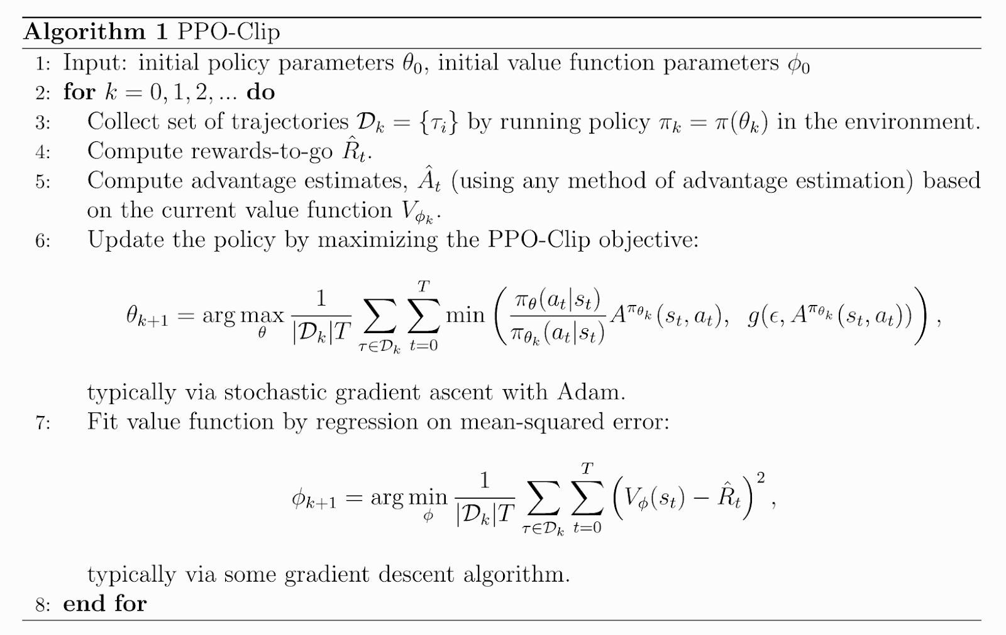

Alg. 1: The PPO-Clip algorithm.

1. **RL for MILP with Applications in Finance**

Besides existing RL methods used in the financial area, there are many other functional methods which can be applied in the financial market as well. Here we take one example:

[Reinforcement learning for integer programming: Learning to cut](https://arxiv.org/pdf/1906.04859.pdf). We believe that such a method has the potential to achieve better performance if applied to the financial market as well.

In this section, the project can be divided into two phases: 1. Reproduce RL for MILP. 2. Apply RL for MILP into the ElegantRL framework.

**You are also welcome to implement other works that you may think it’s a good fit for financial tasks. You will need to indicate the reason you select it as well.**

1. **High-Performance RL for Finance**

In this section, we would like you to try different datasets and illustrate the result.

NASDAQ-100 index constituents: Its 100 constituents are characterized by high technology, high growth and non-financial. Training in such an environment gets agents to capture the financial trends of technology.

Dow Jones Industrial Average (DJIA) index constituents: DJIA is the most cited market indicator for overall market performance. It is made up of 30 constituents that best represent their industries respectively.

Standard & Poor’s 500 (S&P 500) index constituents: The S&P 500 index consists of 500 largest U.S. publicly traded companies.

HSI Index constituents: Hang Seng Index (HSI) is the most widely quoted indicator of the performance of the Hong Kong stock market. HSI constituent securities are grouped into Finance,Utilities, Properties and Commerce & Industry.

SSE 180 Index constituents: SSE 180 Index includes constituents with best representation of A shares listed at Shanghai Stock Exchange (SSE) with considerable size and liquidity. Listed companies are classified into 10 industries.

CSI 300 Index constituents: CSI 300 Index consists of the 300 largest and most liquid A-share stocks listed on Shenzhen Stock Exchange or on SSE; the performance of constituents very much reflect the overall performance of China A-share market.

A recent paper for reference:

Li, Zechu, Xiao-Yang Liu, Jiahao Zheng, Zhaoran Wang, Anwar Walid, and Jian Guo. "FinRL-Podracer: High performance and scalable deep reinforcement learning for quantitative finance." ACM International Conference on AI in Finance (ICAIF), 2021.

1. **Including Human Knowledge**

Combining human knowledge and RL might be a valuable approach to improve the algorithms: Zhang, Peng, u. a. *KoGuN: Accelerating Deep Reinforcement Learning via Integrating Human Suboptimal Knowledge*. 2020. [arXiv:2002.07418](https://arxiv.org/abs/2002.07418) / Annabestani, Mohsen, u. a. *A new soft computing method for integration of expert’s knowledge in reinforcement learning problems*. 2021. [arXiv:2106.07088](https://arxiv.org/abs/2106.07088)

1. **Hyperparameter Tuning of RL Algorithms**

**What are hyperparameters?**

A machine learning or deep learning model has parameters and hyperparameters to aid the learning process. Parameters are the entities that build the model and hyperparameters are the entities that control the learning process. Hyperparameters also play a role in data augmentation. Like in Convolutional Neural networks, the rotation angle can be treated as a hyperparameter to optimize.

In linear regression, the weight (W) and biases (B) are parameters of the model as they build the model Y = WX + B. Hyperparameters like learning rate, batch size etc. aid in learning. In neural networks, each neuron has a weight and bias which are its parameters. So in vanilla models, the hyperparameters are

generally hard-coded and stationary throughout the training process and parameters by gradient descent get updated in each iteration. But hyperparameters can also be part of the learning process. Like in [SAC](https://medium.com/analytics-vidhya/soft-actor-critic-algorithms-in-deep-reinforcement-learning-a11bedd9aa20) (Soft-Actor Critic method Version-3), the entropy factor α is learnt from the data by specifying an objective function to tune it. This is called end-to-end training, as no external efforts are necessary, everything solely depends on the data after model instantiation.

Hyperparameters are the variables that control the learning process. In deep reinforcement learning (DRL), the common hyperparameters are learning rate, batch size, number network layers, exploration factor, clipping rate, etc. These hyperparameters are initialized at the beginning of the training process and can be dynamically controlled using a scheduler or else remain constant.

FinRL currently offers three DRL agents, [RLlib](https://docs.ray.io/en/releases-1.5.1/rllib.html) from Ray, [Stable Baselines3](https://stable-baselines3.readthedocs.io/en/master/) and in-house package [ElegantRL](https://elegantrl.readthedocs.io/en/latest/). We have separate Hyperparameter Optimization (HPO) pipelines for all three agents. All HPO pipelines consists of the following steps:

1. Pick training, validation and testing periods
2. Pick hyperparameters that you want to tune for your algorithm and define their domain space for example, loguniform, categorical, uniform

def sample_ddpg_params(trial:optuna.Trial):

# Size of the replay buffer

buffer_size = trial.suggest_categorical("buffer_size", [int(1e4), int(1e5), int(1e6)]) learning_rate = trial.suggest_loguniform("learning_rate", 1e-5, 1)

batch_size = trial.suggest_categorical("batch_size", [32, 64, 128, 256, 512])

return {"buffer_size": buffer_size, "learning_rate":learning_rate, "batch_size":batch_size}

1. Define a metric for Bayesian optimization methods. In our testing we picked Sharpe ratio in the validation period to tune our hyperparameters
2. Define a searching technique. Some basic ones are Grid Search and Random. Other advanced methods are Tree-Parzen Estimator, Bayesian optimization, Population-Based methods. You can find more information about them here on [Ray tune](https://docs.ray.io/en/latest/tune/api_docs/suggestion.html) and [Optuna](https://optuna.readthedocs.io/en/stable/reference/samplers.html).
3. Define a scheduler or pruner. These discard unpromising trials based on the chosen metric
4. Tune the hyperparameters and retrieve the best configuration

**Tutorial and Guides:**

* RLlib:
  + Ray tune
    - [Blog post](https://medium.com/mlearning-ai/hyperparameter-optimization-using-ray-tune-for-finrl-models-42df2937d53d)
    - [Notebook](https://github.com/AI4Finance-Foundation/FinRL/blob/master/FinRL_Raytune_for_Hyperparameter_Optimization_RLlib%20Models.ipynb)
* Stable Baselines3
  + Optuna
    - [Blog post](https://medium.com/analytics-vidhya/hyperparameter-tuning-using-optuna-for-finrl-8a49506d2741)
    - [Notebook](https://github.com/AI4Finance-Foundation/FinRL/blob/master/tutorials/FinRL_Hyperparameter_tuning_using_Optuna.ipynb)

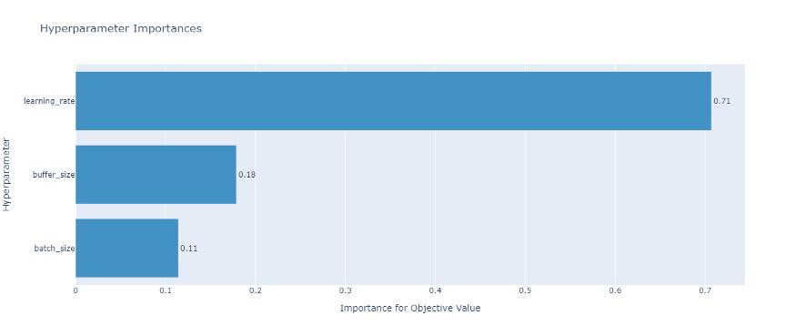

Hyperparameter Feature Importance in Optuna

* + Hyperparameter Sweep (Weights & Biases)
    - [Blog post](https://medium.com/analytics-vidhya/weights-and-biases-ify-stable-baselines-models-in-finrl-f11b67f2a6a7?source=user_profile---------2-------------------------------)
    - [Notebook](https://github.com/AI4Finance-Foundation/FinRL/blob/master/FinRL_Weights_and_Biasify_FinRL_for_Stable_Baselines3_models.ipynb)
    - [W&B report](https://wandb.ai/athe_kunal/finrl-sweeps-sb3/reports/FinRL-hyperparameter-Sweep--VmlldzoxMTkzNzQ2)

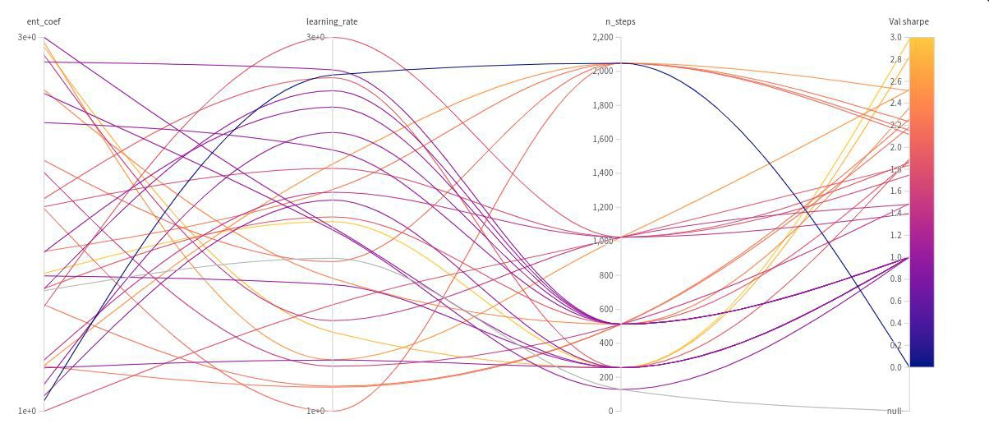

Hyperparameter Sweep in Weights and Biases

* ElegantRL: not yet developed

**Further Improvements**

* Choosing an optimal metric apart from validation Sharpe ratio for sampler and scheduler
* Data augmentation in the training phase to account for changing distribution in testing phase and building robust models
* Population-Based methods for algorithms

**Conclusion**

DRL algorithms are sensitive to hyperparameters and seed values too. So proper tuning of hyperparameters can help us to squeeze out as much performance as possible from these algorithms. It comes with extra computation overhead, yet it is necessary to build robust trading agents.

#### *End2end Proof-of-Concept (PoC) of DataOps and MLOps*

Next, we present a proposal for a Proof-of-Concept of a production platform for the AI4Finance community. The target platform will support continuous data ingestion (batch/streaming and structure/unstructured), data transformation, feature creation, integration (CI), continuous delivery (CD), and continuous learning (CT) for machine learning (ML) systems in the AI4Finance ecosystem.

We will described the proposal in three aligned levels or architectures: conceptual (what are we proposing as a concept and why do we need it?), logical (process - how will it work?), physical (what technologies). Finally, we also describe the implementation plan.

Conceptual Architecture - Data and ML Operations

Machine learning has traditionally been approached from the perspective of individual scientific experiments performed by data scientists in isolation. However, as machine learning models become part of critical real-world solutions, we will need to change our perspective, not to recycle scientific principles, but to make them more accessible, reproducible, and collaborative. to recycle scientific principles, but to make them more accessible, reproducible, and collaborative. to recycle scientific principles, but to make them more accessible, reproducible, and collaborative.

In most real-world applications, the underlying data is constantly changing and therefore models need to be retrained or rebuilt to cope with feature drift. Business and regulatory business requirements and regulations can change rapidly, requiring a release cycle. This is where MLOps comes in to combine operational knowledge with machine learning and data science insights.

**The aim of MLOps is to reduce technical friction so that the model moves from idea to production in the shortest possible time to market with the lowest possible risk.**

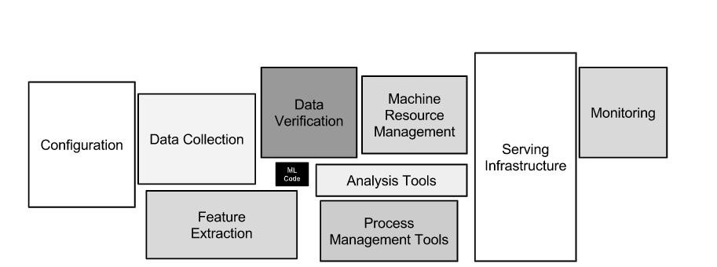

Figure X: Only a small fraction of real-world ML systems are composed of ML code, as the small black

box in the center shows. The surrounding infrastructure required is extensive and complex (Sculley et al.

#).

Important notes about MLOps:

* The pipeline is the product, not only the model. Do not deploy the model, deploy the entire pipeline.
* To build the pipeline, split the system down into small and well-defined components.
* Model metrics will eventually degrade as the world changes, the pipeline must be ready for these changes.

Non-functional Requirements

Scalabilty? Yes.

Security? Yes, at least reserve APIs; keep it in mind when doing design. Others? Cloud-native, MLOps, GPU Optimization

## Logical Architecture

##### Pipeline

The proposed approach allows data scientists and ML engineers to quickly explore new solutions around feature engineering, model configuration and architecture, and hyperparameter selection, following CI/CD methodologies (Google). This pipeline contains different elements: source control, test and builds

services, deployment services, model registry, feature store, ML metadata store, ML pipeline orchestrator. Need to also how DataOps pipeline

Figure X: CI/CD and automated ML pipeline (Google).

Characteristics

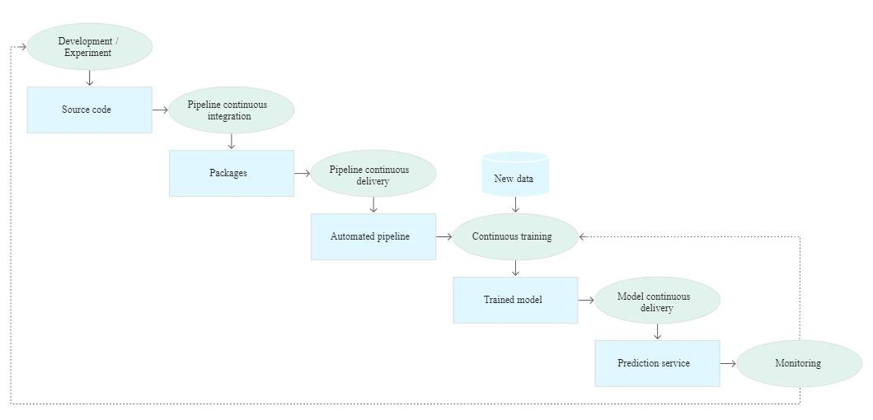

Figure X. Stages of the CI/CD automated ML pipeline (Google). The process consists of the following stages

1. Development and experimentation: New ML algorithms and new modeling in which the experimentation steps are orchestrated are tested iteratively. The result of this stage is the source code of the ML pipeline steps which is then pushed to a source repository.
2. Continuous pipeline integration: Source code is built and various tests are run. The results of this stage are the pipeline components (packages, executables, and artefacts) that will be deployed at a later stage.
3. Continuous pipeline delivery: The artifacts produced by the CI stage are deployed to the target environment. The result of this stage is a deployed pipeline with the new model implementation.
4. Automatic activation: The pipeline is automatically executed in production based on a schedule or in response to a trigger. The result of this stage is a trained model that is sent to the model registry.
5. Continuous model delivery: The trained model is served as a prediction service for forecasts. The output of this stage is a prediction service of the deployed model.
6. Monitoring: Statistics are collected on model performance based on real data. The output of this stage is a trigger to run the pipeline or to run a new cycle of experiments.
7. The data analysis stage is still a manual process for data scientists before the pipeline starts a new iteration of the experiment. The model analysis stage is also a manual process.

**Challenges**

# Please *check this paper: https://arxiv.org/pdf/2011.09926.pdf*

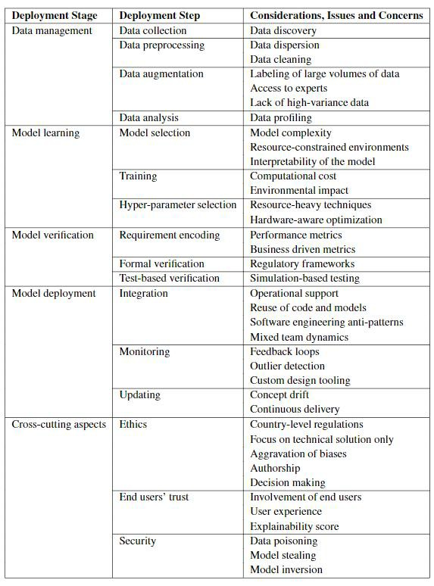

Figure X: Challenges in MLops for different stages. Source: (Paleyes et al.)

## Physical Architecture

##### Microservices and Machine Learning Models

As opposed to developing most or all of the application code in one place (monolith approach). Microservices-style development packages each application component into an individual piece, usually with a RESTful API endpoint for access. A production application developed as Microservices has communicating components, all developed and maintained separately. (Gage and Science #).

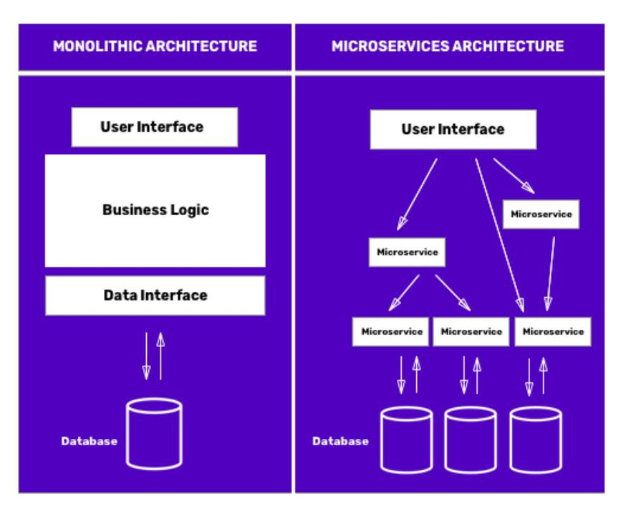

##### Tooling

To implement the pipeline, we will use a variety of tools that work independently of each other, and all of them will be implemented based on microservices, and each one will have a Docker image that will be realized and will only need to know what its inputs and outputs are, so that we can scale both horizontally and vertically.

Data Extraction

* Custom data loaders in Python
* ExampleGen (Tensorflow Extended). It consumes external files/services to generate Examples that will be read by other TFX components. It also provides consistent and configurable partition and shuffles the dataset for ML best practice.
* Custom Module in PyTorch (to explore yet)

Data Validation

* Custom modules in Python
* StatisticsGen (Tensorflow Extended). Generates feature statistics over both training and serving data, which can be used by other pipeline components. StatisticsGen uses Beam to scale to large datasets.
* SchemaGen (Tensorflow Extended). A SchemaGen pipeline component will automatically generate a schema by inferring types, categories, and ranges from the training data.
* ExampleValidator (Tensorflow Extended). The ExampleValidator pipeline component identifies anomalies in training and serving data. It can detect different classes of anomalies in the data.
* Custom Module in PyTorch (to explore yet)

Data Preparation

* Custom modules in Python.
* Transform (Tensorflow Extended). Run on top of ApacheBeam/Spark. It performs feature engineering on tf. Examples emitted from an [ExampleGen](https://www.tensorflow.org/tfx/guide/examplegen) component, using a data schema created by a [SchemaGen](https://www.tensorflow.org/tfx/guide/schemagen) component, and emits both a SavedModel as well as statistics on both pre-transform and post-transform data
* Custom Module in PyTorch (to explore yet)

Model Training

* Trainer (Tensorflow Extended)
* Tuner (Tensorflow Extended). It is in charge of the hyperparameters tuning for the model.
* PyTorch
* RayTune (Tensorflow Extended)
* Katib (Kubeflow)

Model Evaluation

* Custom modules in Python.
* Evaluator (Tensorflow Extended). It performs deep analysis on the training results for your models, to help you understand how your model performs on subsets of your data. The Evaluator also helps you validate your exported models, ensuring that they are "good enough" to be pushed to production.
* PyTorch (to explore yet)

Model Validation

* InfraValidator (Tensorflow Extended). It is used as an early warning layer before pushing a model into production. The name "infra" validator came from the fact that it is validating the model in the actual model serving "infrastructure".
* Custom python modules

Model Deploy

* Pusher (Tensorflow Extended). The Pusher component is used to push a validated model to a [deployment target](https://www.tensorflow.org/tfx/guide#deployment_targets) during model training or re-training. Before the deployment, Pusher relies on one or more blessings from other validation components to decide whether to push the model or not.
  + [Evaluator](https://www.tensorflow.org/tfx/guide/evaluator) blesses the model if the newly trained model is "good enough" to be

pushed to production.

* + (Optional but recommended) [InfraValidator](https://www.tensorflow.org/tfx/guide/infra_validator) blesses the model if the model is mechanically servable in a production environment.

A Pusher component consumes a trained model in [SavedModel](https://www.tensorflow.org/guide/saved_model) format, and produces the same SavedModel, along with versioning metadata.

* Tensorflow Serving - Tensorflow (REST and gRPC)
* TorchServe - PyTorch
* Seldon (to explore yet)
* KFserving - Kubeflow (to explore yet)

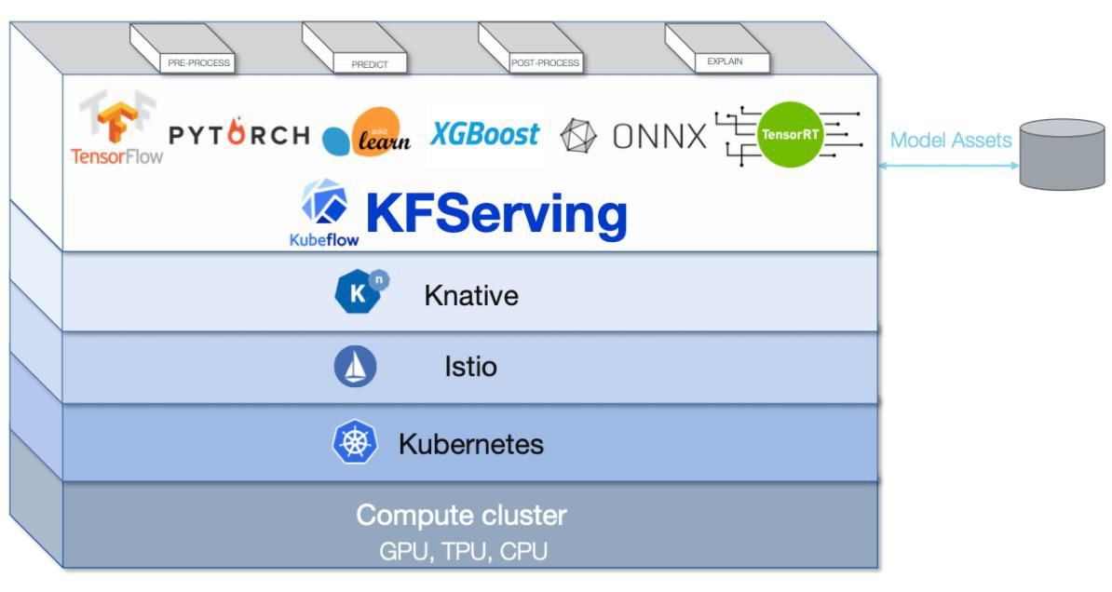

**Monitoring (Time series Database + Dashboards)**

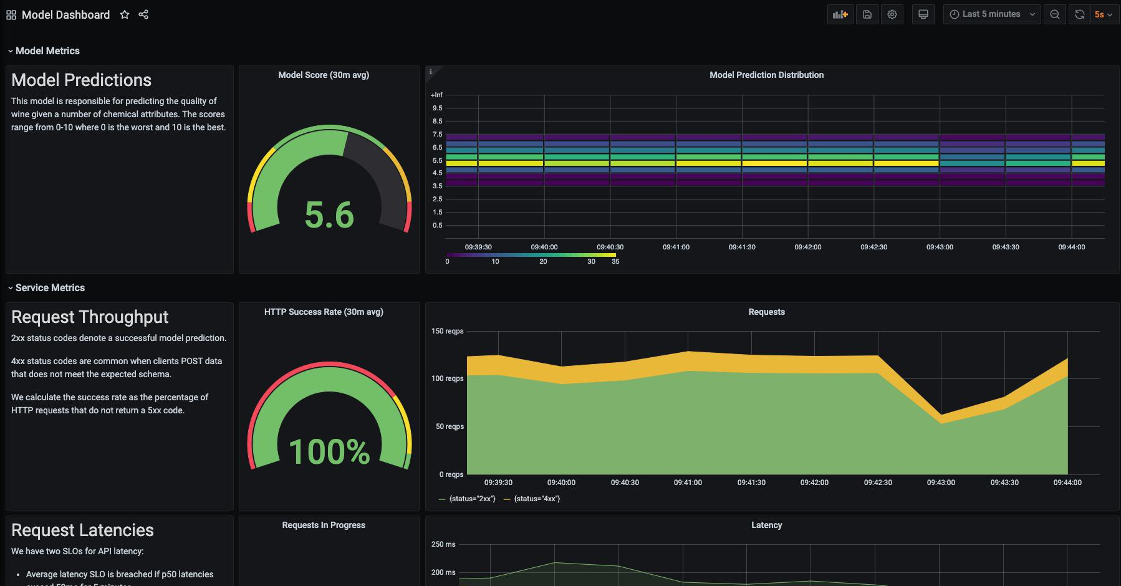

* Prometheus + Grafana
* InfluxDB + Grafana

Pipeline Orchestration: **Kubeflow**

[Kubeflow](https://www.kubeflow.org/) is an open source Kubernetes-native platform for developing, orchestrating, deploying, and running scalable and portable machine learning (ML) workloads. It is a cloud native platform based on Google’s internal ML pipelines. The project is dedicated to making deployments of ML workflows on Kubernetes simple, portable, and scalable.

Kubernetes is an orchestration system for containers that is meant to coordinate clusters of nodes at scale, in production, in an efficient manner. Kubernetes works around the idea of Pods which are scheduling units (each pod containing one or more containers) in the Kubernetes ecosystem. These pods are distributed across hosts in a cluster to provide high availability. Kubernetes itself is not a complete solution and is intended to integrate with other tools such as Docker. A container image is a lightweight, standalone, executable package of a piece of software that includes everything needed to run it.

The goal of Kubeflow is to simplify the deployment of machine learning workflows to Kubernetes. The issue with using the Kubernetes API directly is that it is too low-level for most data scientists. A data scientist already has to know a number of techniques and technologies without the necessity of adding the complexities of the Kubernetes API to the list. The issues Kubeflow solves beyond just the core Kubernetes API are:

* Faster and more consistent deployment
* Better control over ports and component access for tighter security
* Protection against over-provisioning resources, saving costs
* Protection against tasks not being deallocated once complete, saving costs
* Workflow orchestration and metadata collection
* Centralized monitoring and logging
* Infrastructure to move models to production, securely and at scale

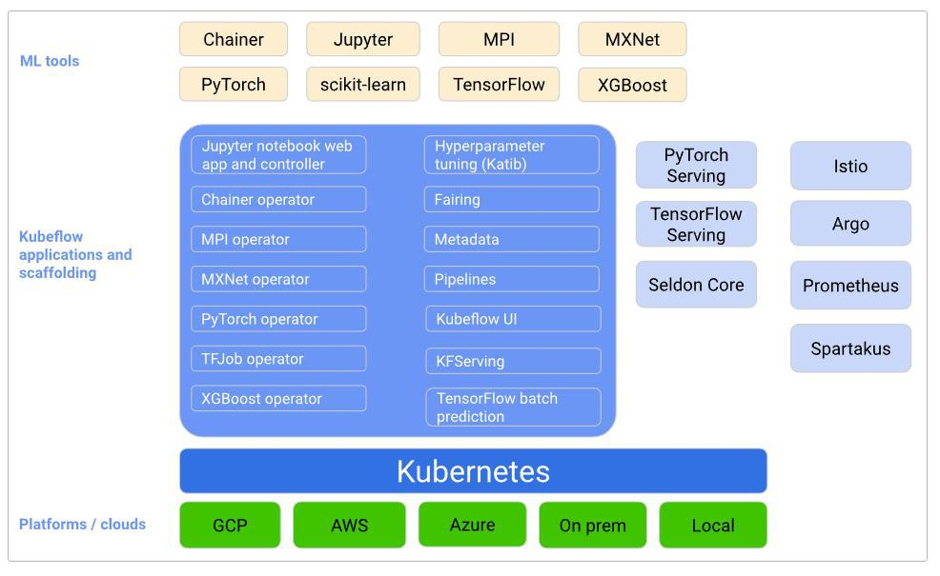

Figure X. Conceptual Overview of Kubeflow (<https://www.kubeflow.org/docs/started/architecture/>)

These components work together to provide a scalable and secure system for executing machine learning jobs (notebook-based jobs as well as non-notebook jobs). Given the rise of Kubernetes as an enterprise platform management system, it makes a lot of sense to have a way of managing our makes a lot of sense to have a way to manage our machine learning workloads in a similar way.

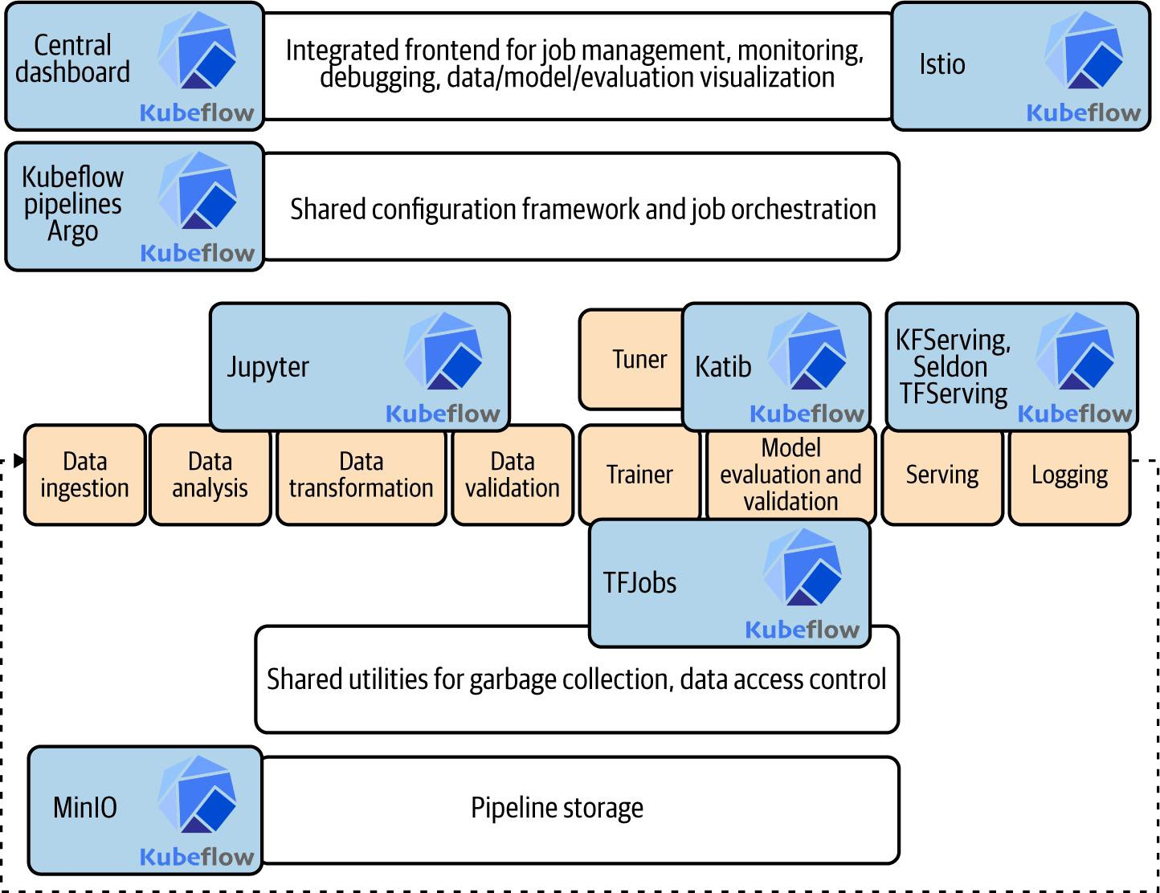

Figure X. Kubeflow components in the ML workflow (https://[www.oreilly.com/library/view/kubeflow-for-machine/9781492050117/ch03.html)](http://www.oreilly.com/library/view/kubeflow-for-machine/9781492050117/ch03.html))

The high-level architecture of Kubeflow is presented in the next image. Kubeflow is built from multiple separate components in a service mesh to provide the full machine learning platform. Istio supports operations of the Kubeflow distributed microservice architecture by providing features such as secure communications, discovery, load balancing, failure recovery, metrics, and monitoring.

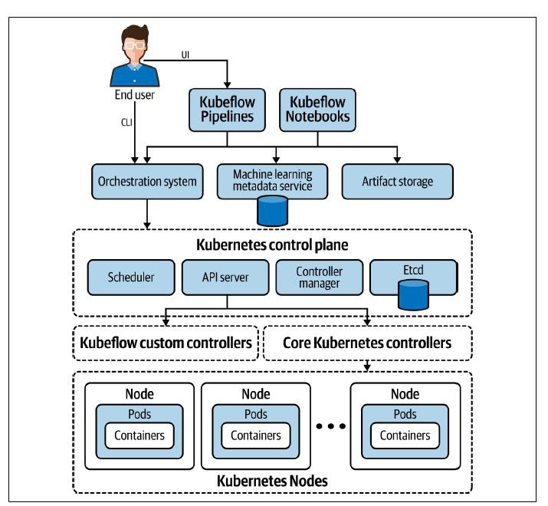

**References**

Google. “MLOps: Continuous delivery and automation pipelines in machine learning.” Google Cloud, 7 January 2020, https://cloud.google.com/architecture/mlops-continuous-delivery-and-

automation-pipelines-in-machine-learning. Accessed 30 January 2022.

Paleyes, Andreis, et al. “Challenges in Deploying Machine Learning: a Survey of Case Studies.” arXiv, 18 November 2020, https://arxiv.org/abs/2011.09926. Accessed 30 January 2022.

Sculley, D., et al. “Hidden technical debt in machine learning systems.” Advances in Neural Information Processing Systems, 2015, pp. 2503-2511. NeurIPS.

# Appendix I. Common Pitfalls to Avoid in Financial Machine learning

###### Look-ahead bias (future information)

Look-ahead bias is one of the big problems in financial deep learning. It occurs by the use of information or data in training or backtesting that would not have been known or available during the period being analyzed. It is always important to double-check whether future data will leak into the decision. This often happens when not being careful creating the features. A classic example is using the daily low or high as a feature in an intraday trading strategy. In reality, the daily low is not known until the end of the day.

Another example frequently introducing look-ahead is the VWAP technical indicator which is based on the volume of the day, this again changes during the day till it reaches its final value at the end of the day. If one is not careful implementing it, future data is being used. Another situation that might cause a look- ahead can be the selection of certain financial instruments based on your “now-knowledge”. For example, selection of the current best performing instruments for your portfolio to train or backtest, can already introduce look-ahead and cause the model being biased to (long-term) uptrends. The best antidote is being careful and using forward-testing / paper-trading with live data. When working with missing-data, always forward fill.

###### Data-snooping bias / Overfitting

This is really hard to avoid, especially with DL. We won’t go into detail here, as overfitting should be basic knowledge in the DL world. The best antidote is using a big enough sample and out-of-sample testing. Working with DL, you should already be familiar with the Training-Validation-Testing split. In the case of financial instruments, you also should additionally be aware of market regimes though. For example, cryptocurrencies have limited historic data available due to being relatively new instruments. The first bitcoin transaction was in 2009 and many cryptocurrencies were born even later. Having such little data increases the danger of overfitting. Certain time periods are affected by different market regimes like bull-market, bear-market and ranging / sideways-market. If you create your sample, you need to be aware of that. Otherwise, your model might be overfitted to those certain market conditions and fail in the other. There also can be overfitting to certain instruments, exchanges and timeframes. In theory, the perfect model would work similarly well when switching the traded instruments, used exchange or trading timeframes. In reality, it’s often observed that this is not the case. This doesn’t necessarily mean the model is bad. One might theorize that the model exploits certain market situations that only occur on those instruments, exchanges or timeframes. With Algorithmic trading accounting for around 60-73% of the overall United States equity trading (see <https://www.mordorintelligence.com/industry-reports/algorithmic-trading-market>) our model just might exploit another automatic trading systems trading decisions, with this other automatic trading system only being active on certain instruments. A model heavily depending on volume for its decision only might

work on the exchange it was trained on, as volume / liquidity / (automated) market-makers behind the scene differ from exchange to exchange. You see, overfitting is a hard topic to evaluate.

###### Transaction Costs & Slippage

No backtest performance is realistic without transaction costs and slippage. Depending on the financial instrument and trading exchange, those can be fixed transaction costs and / or percentages. Slippage can vary a lot. It differs from exchange to exchange and the instrument traded. Often, instruments with very low volume have bigger slippage.

###### Understanding performance measurement

It’s important you make yourself familiar with the performance metrics. One common mistake is just looking at profit and not comparing the metrics to the buy-and-hold / equally-weighted benchmark. A successful trading system should always beat the benchmark. In what way depends on the investor’s preferences. For example, not beating the buy-and-hold return, but having way less drawdown / risk can be totally fine and wanted by investors, while others prefer big gains accepting more risk. This part also is essential for the reward function of the model. Reading the above, you might already realize that just rewarding profit percentage might not be enough. The most popular ratio is the Sharpe ratio. While it already gives you substantially more information as it incorporates risk, it also has its downsides. Make yourself familiar with all the different metrics and what they can give you for information and what information about the performance they don’t provide. A good starting point is understanding the difference between Sharpe, Sortino and Calmar Ratio. Quantstats (<https://github.com/ranaroussi/quantstats>) and Pyfolio (<https://github.com/quantopian/pyfolio>) are great tools for performance and risk analysis, providing you many metrics and graphs. Consider the right Annualization Factor for your metrics. Cryptocurrency is traded 24/7, so you need to use 365, while the stock market is closed on certain days.

This is a great paper extending and enlarging upon the above-mentioned pitfalls:

López de Prado, Marcos, The 10 Reasons Most Machine Learning Funds Fail (January 27, 2018). Journal of Portfolio Management, Forthcoming, Available at SSRN: [https://ssrn.com/abstract=3104816](https://ssrn.com/abstract%3D3104816) or [http://dx.doi.org/10.2139/ssrn.3104816](https://dx.doi.org/10.2139/ssrn.3104816)

# Appendix II. FinRL Frequently Asked Questions

###### [FAQ document](https://finrl.readthedocs.io/en/latest/index.html)

This document contains the most frequently asked questions related to the FinRL Library, based on questions posted on the slack channels and Github issues.

###### Outline

* **Section 1 Where to start?** → what you should do before using the library
* **Section 2 What to do when you experience problems?** → sequence of actions to avoid rework from our part (repeatedly answer the same/very similar questions)
* **Section 3 Most frequently asked questions related to the FinRL Library**
  + **Subsection 3.1 Inputs and datasets**
  + **Subsection 3.2 Code and implementation**
  + **Subsection 3.3 Model evaluation**
  + **Subsection 3.4 Miscellaneous**
* **Section 4 References for diving deep into Deep Reinforcement Learning (DRL) for finance**
  + **Subsection 4.1 General resources**
  + **Subsection 4.2 Papers for the implemented DRL models**

**Section 1 Where to start?**

* Read the paper that describes the FinRL library: Liu, X.Y., Yang, H., Chen, Q., Zhang, R., Yang, L., Xiao, B. and Wang, C.D., 2020. FinRL: A Deep Reinforcement Learning Library for Automated Stock Trading in Quantitative Finance. Deep RL Workshop, NeurIPS 2020. [paper](https://arxiv.org/abs/2011.09607) [video](https://www.youtube.com/watch?v=ZSGJjtM-5jA)
* Read the post related to the type of environment you want to work on (multi stock trading, portfolio optimization)

<https://github.com/AI4Finance-Foundation/FinRL>, Section "News"

* Install the library following the instructions at the official Github repo: <https://github.com/AI4Finance-Foundation/FinRL>
* Run the Jupyter notebooks related to the type of environment you want to work on

notebooks folder of the library ： [https://github.com/AI4Finance-](https://github.com/AI4Finance-Foundation/FinRL/tree/master/tutorials) Foundation/FinRL/tree/master/tutorials

* Enter on the AI4Finance slack:

[https://join.slack.com/t/ai4financeworkspace/shared_invite/zt-kq0c9het-](https://join.slack.com/t/ai4financeworkspace/shared_invite/zt-kq0c9het-FCSU6Y986OnSw6Wb5EkEYw) FCSU6Y986OnSw6Wb5EkEYw

**Section 2 What to do when you experience problems?**

* If any questions arise, please follow this sequence of activities (it allows us to focus on the main issues that need to be solved, instead of repeatedly answering the same questions):
  1. Check if it is not already answered on this FAQ
  2. Check if it is not posted on the Github repo issues: [https://github.com/AI4Finance-Foundation/FinRL-Library/issues](https://github.com/AI4Finance-LLC/FinRL-Library/issues)
  3. Use the correct slack channel on the AI4Finance slack.

**Section 3 Most frequently asked questions related to the FinRL Library**

**Subsection 3.1 Inputs and datasets**

* Can I use FinRL for crypto? → We're developing this functionality
* Can I use FinRL for live trading? → We're developing this functionality
* Can I use FinRL for forex? → We're developing this functionality
* Can I use FinRL for futures? → not yet
* What is the best data source for free daily data → Yahoo Finance (through the

yfinance library)

* What is the best data source for minute data → Yahoo Finance (only up to last 7 days), through the yfinance library. It is the only option besides scraping (or paying for a service provider)
* Does FinRL support trading with leverage? → no, as this is more of an execution strategy related to risk control. You can use it as part of your system, adding the risk control part as a separate component
* Can a sentiment feature be added to improve the model's performance? → yes, you can add it. Remember to check on the code that this additional feature is being fed to the model (state)
* Is there a good free source for market sentiment to use as a feature? → no, you'll have to use a paid service or library/code to scrape news and obtain the sentiment from them (normally, using deep learning and NLP)

**Subsection 3.2 Code and implementation**

* Does FinRL support GPU training? → yes, it does
* The code works for daily data but gives bad results on intraday frequency → yes, because the current parameters are defined for daily data. You'll have to tune the model for intraday trading
* Are there different reward functions available? → not yet, but we're working on providing different reward functions and an easy way to code your own reward function
* Can I use a pre-trained model? → yes, but none is available at the moment. Sometimes in the literature you'll find this referred to as transfer learning
* What is the most important hyperparameter to tune on the models? → each model has its own hyperparameters, but the most important is the total_timesteps (think

of it as epochs in a neural network: even if all the other hyperparameters are

optimal, with few epochs the model will have a bad performance). The other important hyperparameters, in general, are: learning_rate, batch_size, ent_coef, buffer_size, policy, and reward scaling

* What are some libraries I could use to better tune the models? → there are several, such as: ray rllib and optuna. You'll have to implement them by yourself on the code, as this is not supported yet
* What DRL models can I use with FinRL? → all the DRL models on Stable Baselines

3. We tested the following models with success: A2C, A3C, DDPG, PPO, SAC, TD3, TRPO. You can also create your own model, using the OpenAI Gym structure

* The model is presenting strange results OR is not training → Please update to latest version (<https://github.com/AI4Finance-Foundation/FinRL>), check if the hyperparameters used were not outside a normal range (ex: learning rate too high), and run the code again. If you still have problems, please check Section 2 (What to do when you experience

problems)

**Subsection 3.3 Model evaluation**

* The model did not beat buy and hold (BH) with my data. Is the model or code wrong?

* not exactly. Depending on the period, the asset, the model chosen, and the hyperparameters used, BH may be very difficult to beat (it's almost never beaten on stocks/periods with low volatility and steady growth). Nevertheless, update the library and its dependencies (the github repo has the most recent version), and check the example notebook for the specific environment type (single, multi, portfolio optimization) to see if the code is running correctly

* How does backtesting work in the library? → we use the Pyfolio backtest library from Quantopian ( https://github.com/quantopian/pyfolio ), especially the simple tear sheet and its charts. In general, the most important metrics are: annual returns, cumulative returns, annual volatility, sharpe ratio, calmar ratio, stability, and max drawdown
* Which metrics should I use for evaluating the model? → there are several metrics,

but we recommend the following, as they are the most used in the market: annual returns, cumulative returns, annual volatility, sharpe ratio, calmar ratio, stability, and max drawdown

* Which models should I use as a baseline for comparison? → we recommend using buy and hold (BH), as it's a strategy that can be followed on any market and tends to provide good results in the long run. You can also compare with other DRL models and trading strategies such as the minimum variance portfolio

**Subsection 3.4 Miscellaneous**

* What is the development roadmap for the library? → this is available on our Github repo ( <https://github.com/AI4Finance-Foundation/FinRL>)
* How can I contribute to the development? → participate on the slack channels, check the current issues and the roadmap, and help any way you can (sharing the library with others, testing the library of different markets/models/strategies, contributing with code development, etc)
* What are some good references before I start using the library? → please read Section 1 (Where to start?)
* What are some good RL references for people from finance? What are some good finance references for people from ML? → please read Section 4 (References for diving deep into Deep Reinforcement Learning (DRL) for finance)
* What new sota models will be incorporated on FinRL? → please check our development roadmap at our Github repo

<https://github.com/AI4Finance-Foundation/FinRL>

**Section 4 References for diving deep into Deep Reinforcement Learning (DRL)**

**Subsection 4.1 General resources**

* + OpenAI Spinning UP DRL, educational page for DRL: <https://spinningup.openai.com/en/latest/>
  + Awesome-ai-in-finance <https://github.com/georgezouq/awesome-ai-in-finance>
  + Curated list of practical financial machine learning tools and applications <https://github.com/firmai/financial-machine-learning>
  + OpenAI Gym
  + <https://github.com/openai/gym>
  + Stable Baselines 3

contains the implementations of all models used by FinRL <https://github.com/DLR-RM/stable-baselines3>

* + Ray RLlib <https://docs.ray.io/en/master/rllib.html>
  + Policy gradient algorithms

<https://lilianweng.github.io/lil-log/2018/04/08/policy-gradient-algorithms.html>

* Fischer, T.G., 2018. Reinforcement learning in financial markets-a survey (No. 12/2018). **FAU Discussion Papers in Economics**. → a survey on the use of RL for finance
* Li, Y., 2018. Deep reinforcement learning. **arXiv preprint arXiv:1810.06339**. → an in-depth review of DRL and its main models and components
* Charpentier, A., Elie, R. and Remlinger, C., 2020. Reinforcement learning in economics and finance. **arXiv preprint arXiv:2003.10014.** → an in-depth review of uses of RL and DRL

in finance

* Kolm, P.N. and Ritter, G., 2020. Modern perspectives on reinforcement learning in finance. Modern Perspectives on Reinforcement Learning in Finance (September 6, 2019). **The Journal of Machine Learning in Finance**, 1(1) → an in-depth review of uses of RL and DRL in

finance

* Practical Deep Reinforcement Learning Approach for Stock Trading, [**paper**](https://arxiv.org/abs/1811.07522)and [**codes**](https://github.com/AI4Finance-LLC/Deep-Reinforcement-Learning-for-Stock-Trading-DDPG-Algorithm-NIPS-2018), Workshop on Challenges and Opportunities for AI in Financial Services, NeurIPS 2018.
* Hambly, B., Xu, R. and Yang, H., 2021. Recent Advances in Reinforcement Learning in Finance.

**arXiv preprint arXiv:2112.04553**.

**Subsection 4.2 Papers related to the implemented DRL models**

Check the website: <https://elegantrl.readthedocs.io/en/latest/index.html>

* Mnih, V., Kavukcuoglu, K., Silver, D., Graves, A., Antonoglou, I., Wierstra, D. and Riedmiller, M., 2013. Playing atari with deep reinforcement learning. ICLR 2013→ the first paper that

proposed (with success) the combination of deep neural neworks and RL.

* Mnih, V., Kavukcuoglu, K., Silver, D., Rusu, A.A., Veness, J., Bellemare, M.G., Graves, A., Riedmiller, M., Fidjeland, A.K., Ostrovski, G. and Petersen, S., 2015. Human-level control through deep reinforcement learning. **Nature**, 518(7540), pp.529-533 → an excellent

review paper of important concepts on DRL

* Lillicrap, T.P., Hunt, J.J., Pritzel, A., Heess, N., Erez, T., Tassa, Y., Silver, D. and Wierstra, D., 2015. Continuous control with deep reinforcement learning. ICLR 2015 → paper that

proposed the DDPG algorithm.

* Fujimoto, S., Hoof, H. and Meger, D., 2018, July. Addressing function approximation error in actor-critic methods. ICML **(**pp. 1587-1596). PMLR → paper that proposed the TD3

model

* Schulman, J., Wolski, F., Dhariwal, P., Radford, A. and Klimov, O., 2017. Proximal policy optimization algorithms. **arXiv preprint arXiv:1707.06347** → paper that proposed the

PPO model

* Mnih, V., Badia, A.P., Mirza, M., Graves, A., Lillicrap, T., Harley, T., Silver, D. and Kavukcuoglu, K., 2016, June. Asynchronous methods for deep reinforcement learning. In **International conference on machine learning** (pp. 1928-1937). PMLR → paper that

proposed the A3C model

* <https://openai.com/blog/baselines-acktr-a2c/>--> description of the implementation of the A2C model
* Schulman, J., Levine, S., Abbeel, P., Jordan, M. and Moritz, P., 2015, June. Trust region policy optimization. **ICML** (pp. 1889-1897). PMLR → description of the implementation of

the TRPO model.

**Challenges of DataOps and MLOps**

* Paleyes, A., Urma, R.G. and Lawrence, N.D., 2020. Challenges in deploying machine learning: a survey of case studies. arXiv preprint arXiv:2011.09926.